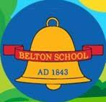**Belton C of E Primary School**

**RE Policy**

INTRODUCTION

This policy is intended to ensure that we provide the statutory learning and teaching expectations of Religious Education as set out in the Leicestershire Agreed Syllabus. Religious Education enables children to investigate and reflect on some of the most fundamental questions asked by people. At Belton C of E Primary School, we develop the children’s knowledge and understanding of the major world faiths, and we address the fundamental questions in life, for example, the meaning of life and the existence of a divine spirit. We enable children to develop a sound knowledge of Christianity and other world religions. Children reflect on what it means to have a faith and to develop their own spiritual knowledge and understanding. We help the children learn from religions as well as about religions. Religious Education is unique in the school curriculum in that it is neither a core subject nor a foundation subject but the 1988 Education Act states that ‘Religious Education has equal standing in relation to core subjects of the National Curriculum in that it is compulsory for all registered pupils.’

AIMS AND OBJECTIVES

The aims of Religious Education are to help children:

* develop an awareness of spiritual and moral issues in life experiences;
* develop knowledge and understanding of Christianity and other major world religions and value systems found in Britain;
* develop an understanding of what it means to be committed to a religious tradition;
* be able to reflect on their own experiences and to develop a personal response to the fundamental questions of life;
* develop an understanding of religious traditions and to appreciate the cultural differences in Britain today;
* develop investigative and research skills and to enable them to make reasoned judgements about religious issues;
* have respect for other peoples’ views and to celebrate the diversity in society.

THE LEGAL POSITION OF RELIGIOUS EDUCATION (RE)

Our school curriculum for Religious Education meets the requirements of the 1988 Education Reform Act (ERA). The ERA stipulates that Religious Education is compulsory for all children, including those in the reception class who are less than five years old. The ERA allows parents to withdraw their child from Religious Education classes if they so wish, although this should only be done once the parents have given written notice to the school governors. The ERA also allows teachers to refuse to teach Religious Education, but only after they have given due notice of their intention to the school governors. The Religious Education curriculum forms an important part of our school’s spiritual, moral and social teaching. It also promotes education for citizenship and core British Values. Our school RE curriculum is based on the Local Authority Agreed Syllabus for Leicestershire 2021 and it meets all the requirements set out in that document. The ERA states that the RE syllabus should reflect the fact that the religious traditions in Great Britain are in the main Christian and that it should, at the same time, take account of the teachings and practices of other major religions.

TEACHING AND LEARNING STYLE

We base our teaching and learning style in RE on the key principle that good teaching in RE allows children both to learn about religious traditions and to reflect on what the religious ideas and concepts mean to them. Our teaching enables children to extend their own sense of values and promotes their spiritual growth and development. We encourage children to think about their own views and values in relation to the themes and topics studied in the RE curriculum.

Our teaching and learning styles in RE enable children to build on their own experiences and extend their knowledge and understanding of religious traditions. Teaching and learning is planned in order to make Religious Education a lively, active subject. We employ a variety of teaching methods including discussion, the development of thinking skills, drama, the use of artefacts, pictures, stories, and the use of periods of stillness and reflection to engage the learners and enhance delivery. We use their experiences at religious festivals such as Easter, Diwali, Hannukah etc. to develop their religious thinking. We organise visits to local places of worship and invite representatives of local religious groups to lead assemblies and come into school and talk to the children.

Children carry out research into religious topics. They study particular religious faiths and also compare the religious views of different faith groups on topics such as rites of passage or festivals. Children discuss religious and moral issues using computers and working individually or in groups.

We recognise the fact that all classes in our school have children of widely differing abilities, and so we provide suitable learning opportunities for all children by matching the challenge of the task to the ability of the child.

We achieve this in a variety of ways, for example, by:

* setting common tasks which are open-ended and can have a variety of responses;
* grouping the children by ability in the room and setting different tasks for each ability group;
* providing resources of different complexity, adapted to the ability of the child, and
* using teaching assistants to support the work of individuals or groups of children

CURRICULUM PLANNING IN RELIGIOUS EDUCATION

We plan our Religious Education curriculum in accordance with the Leicestershire LA’s Agreed Syllabus. We ensure that the topics studied in Religious Education build upon prior learning. We offer opportunities for children of all abilities to develop their skills and knowledge in each unit, and we ensure that the planned progression built into the scheme of work offers the children an increasing challenge as they move through the school. The long-term plan maps the Religious Education topics studied in each term during each key stage following our two-year cycle plan. The RE subject leader works out this plan in conjunction with teaching colleagues in each year group.

To support staff in school we use the NATRE Primary Curriculum resources. These progressive and insightful lesson allow the children to retain the sticky knowledge of a topic whilst still giving time to contemplate to role of religion in their own lives. These lessons ensure the subject knowledge and the skills are taught to a high level. Staff have found these resources very useful and has allowed the children to retain more information as it has a spiral approach where children regularly repeat the sticky knowledge.

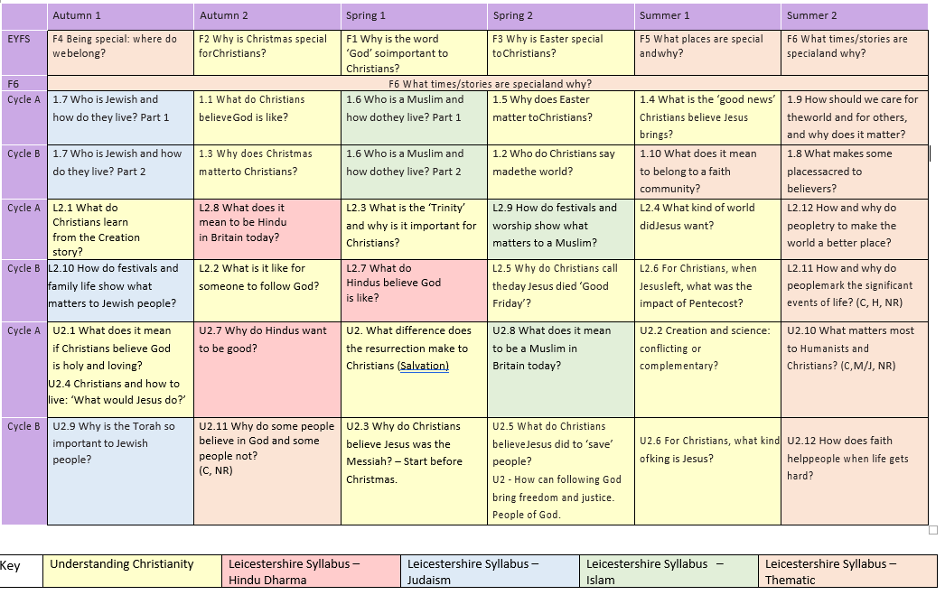Our Curriculum Overview

Progression Maps

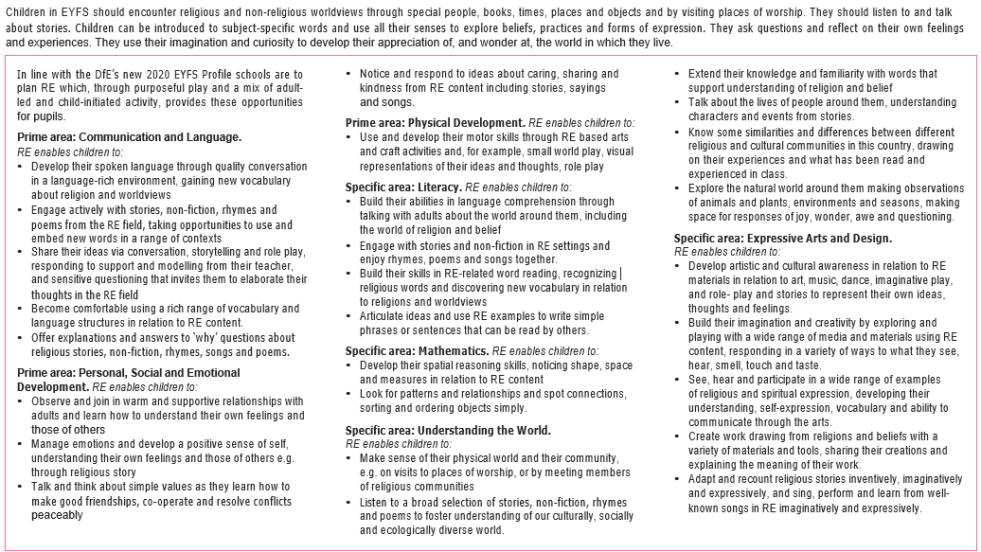EYFS

We teach Religious Education to all children in the school, including those in EYFS. In EYFS, Religious Education is an integral part of the topic work covered during the year. As the reception class is part of the Foundation Stage of the National Curriculum, we relate the Religious Education aspects of the children’s work to the objectives set out in the Early Learning Goals which underpin the curriculum planning for children aged three to five.

KS1 and KS2

|  |  |  |  |
| --- | --- | --- | --- |
| **Teaching and learning approach** | **End KS1 Pupils can …** | **End lower KS2 Pupils can …** | **End upper KS2 Pupils can …** |
| **Element 1:**  **Making sense of beliefs**  Identifying and making sense of religious and non-religious beliefs and concepts; understanding what these beliefs mean within their traditions; recognising how and why sources of authority (such as texts) are used, expressed and interpreted in different ways, and developing skills of interpretation. | * identify core beliefs and concepts studied and give a simple description of what they mean * give examples of how stories show what people believe (e.g. the meaning behind a festival) * give clear, simple accounts of what stories and other texts mean to believers | * identify and describe the core beliefs and concepts studied * make clear links between texts/ sources of authority and the core concepts studied * offer informed suggestions about what texts/sources of authority can mean and give examples of what these sources mean to believers | * identify and explain the core beliefs and concepts studied, using examples from texts/sources of authority   in religions   * describe examples of ways in which people use texts/sources of authority to make sense of core beliefs   and concepts   * give meanings for texts/sources of authority studied, comparing these ideas with some ways in which believers interpret texts/sources   of authority |
| **Element 2:**  **Understanding the impact**  Examining how and why people put their beliefs into practice in diverse ways, within their everyday lives, within their communities and in the wider world. | * give examples of how people use stories, texts and teachings to guide their beliefs and actions * give examples of ways in which believers put their beliefs into practice | * make simple links between stories, teachings and concepts studied and how people live, individually and in communities * describe how people show their beliefs in how they worship and in the way they live * identify some differences in how people put their beliefs into practice | * make clear connections between what people believe and how they live, individually and in communities * using evidence and examples, show how and why people put their beliefs into practice in different ways, e.g. in different communities, denominations or cultures |
| **Element 3:**  **Making connections**  Evaluating, reflecting on and connecting the beliefs and practices studied; allowing pupils to challenge ideas studied, and the ideas studied to challenge pupils’ thinking; discerning possible connections between these and pupils’ own lives and ways of understanding the world. | * think, talk and ask questions about whether the ideas they have been studying, have something to say to them * give a good reason for the views they have and the connections they make | * make links between some of the beliefs and practices studied and life in the world today, expressing some ideas of their own clearly * raise important questions and suggest answers about how far the beliefs   and practices studied might make a difference to how pupils think and live   * give good reasons for the views they have and the connections they make | * make connections between the beliefs and practices studied, evaluating and explaining their importance to different people (e.g. believers and atheists) * reflect on and articulate lessons people might gain from the beliefs/ practices studied, including their own responses, recognising that others may think differently * consider and weigh up how ideas studied in this unit relate to their own experiences and experiences of the world today, developing insights of their own and giving good reasons for the views they have and the connections they make |

EQUAL OPPORTUNITIES AND INCLUSION

We aim to give all our children the opportunity to succeed and reach the highest level of personal achievement; to promote the individuality of all our children, irrespective of ethnicity, attainment, age, disability, gender or background. Our RE provision enables our children to develop values and attitudes that support our school aims. In particular children work both independently, encouraging them to be independent learners, and with others, listening to others’ ideas and treating these with respect. They take pride in, and celebrate their achievements and the achievements of others by reviewing their work, experiences and knowledge, and recognising the progress made in reaching that result.

The subject enables children to develop a respect for each other, to develop their own cultural awareness and understanding, and appreciate the value of differences and similarities. They develop an understanding that all people are equal regardless of age, race, gender or ability.

TEACHING RELIGIOUS EDUCATION TO CHILDREN WITH SPECIAL EDUCATIONAL NEEDS

The vision of this agreed syllabus is of RE for all. Every pupil can achieve and benefit from their RE, including all pupils with Special Educational Needs and Disabilities (SEND).

RE is a statutory part of the core curriculum for all pupils, including those with learning difficulties. Pupils with SEND are found in all contexts, and all teachers are teachers of pupils with SEND. Good-quality teaching in RE will tailor the planning of the syllabus carefully to the special needs of all pupils. RE provision for different groups of pupils will vary but all pupils should be included in RE.

TEACHING RELIGIOUS EDUCATION TO THE MORE ABLE

For pupils whose attainments significantly exceed the expected level of attainment within one or more subjects during a particular key stage, teachers will need to plan suitably challenging work. As well as drawing on work from later key stages or higher levels of study, teachers may plan further differentiation by extending the breadth and depth of study within individual subjects or by planning work which draws on the content of different subjects. More Able pupils can be easily stimulated by RE, through critical analysis, interpretation and evaluation of their work. Higher order thinking skills fit easily alongside the RE curriculum.

ASSESSMENT AND RECORDING

We assess children’s work in Religious Education by making informal judgements as we observe them during lessons. We mark a piece of work once it has been completed and we comment as necessary. On completion of a unit of work, we make a summary judgement about the work of each pupil in relation to the expectations of the unit. The children complete a whole class Sticky Knowledge Quiz and complete a more formal writtern assessment to capture their substantive knowledge. Outcomes of all assessments inform the summative judgements reported in the end of year Individual Pupil Reports. There are also opportunities throughout the school year for parents to discuss with the class teacher the progress their child is making within R.E.

MONITORING AND REVIEW

The RE subject leader is responsible for monitoring the standards of the children’s work and the quality of the teaching in Religious Education. She is also responsible for supporting colleagues in the teaching of Religious Education, for being informed about current developments in the subject, and for providing a strategic lead and direction for the subject in the school. The R.E. subject leader prepares an annual action plan that evaluates the strengths and weaknesses of the subject.