As a Belton Primary Musician, I:
Will rapidly widen my understanding of music which they use to create compositions that they can perform.
Get the chance learn a musical instrument and have the opportunity to progress further.

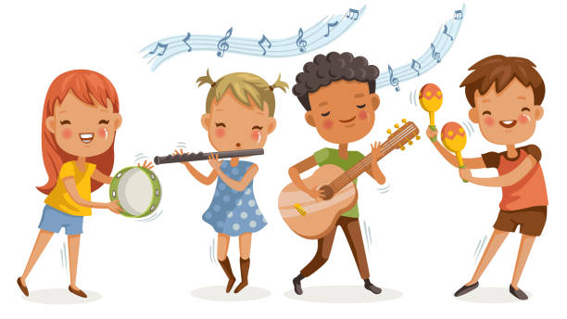
Will have a very good awareness and appreciation of different musical traditions and genres.
Have a passion for and commitment to a diverse range of musical activities.
Will develop a musical understanding through listening to, discussing and evaluating how music is created.
Gain an excellent understanding of the historical, social and cultural origins of music.

Our children participate in a range of musical experiences, building up their confidence at the same time. They develop their understanding of pulse, voice, rhythm, pitch, technology, 20th Century music and music from different cultures as well as learning technical vocabulary for these elements. As children’s confidence builds, they enjoy the performance aspect of music, promoting individual talents, wellbeing and confidence and links with the local community.

