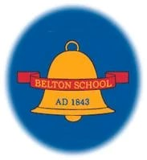

**Belton Church of England Primary School**

MUSIC CURRICULUM STATEMENT

Achieving the Best Together

I have come that they may have life in all its fullness – John 10:10

# Curriculum Vision

**Music enables children to express their creativity, learn music theory and appreciate the art form. We enable children to develop a sound knowledge of pulse, voice, rhythm, pitch, music technology and 20th Century Music. Children have the chance to not only to learn substantive knowledge but specific skills such as how to appreciate and evaluate the work of themselves and their peers. Music is very important to the school’s curriculum as it gives children the opportunity to learn something creative and artistic moreover build confidence through composition and performance**

# Intent

At Belton CE Primary School we want children to be the best they can be. We do this through our curriculum which is designed to promote high outcomes in all areas and ignite the curiosity and enthusiasm for learning. Our music curriculum is no exception to this. Our children participate in a range of musical experiences, building up their confidence at the same time. They develop their understanding of pulse, voice, rhythm, pitch, technology, 20th Century music and music from different cultures as well as learning technical vocabulary for these elements. As children’s confidence builds, they enjoy the performance aspect of music, promoting individual talents, wellbeing and confidence and links with the local community.

# Implementation

Music is taught as a discrete subject but also across the curriculum. Areas of learning such as in phonics, times tables in maths and movement in dance can all incorporate different elements of music. Performances such as Christmas plays and nativities and end of year shows demonstrate that music is important to the life of the school. Extracurricular activities such as peripatetic music lessons also provide children with experience of making music.

Through the Early Years Foundation Stage, the prerequisite skills for music are obtained. The children are encouraged to sing songs, make music, dance and experiment with ways of changing them. The genres of music focused on throughout the EYFS will be Country Music, Big Band and Michael Jackson. In years one to six, this solid foundation is quickly built upon through fun and engaging structured weekly lessons supported by the Leicestershire Schools Music Service. The music curriculum is taught to our mixed age classes from year one through to year six in a rolling two year program. Not only do we cover the set syllabus but children in Year 3 and 4 take part in whole school Instrument t Tuition in Ukulele for an entire year.

# Impact

The impact of teaching music will be seen across the school with an increase in the profile and enjoyment of music. Participation in music develops wellbeing, promotes listening and develops concentration. We want to ensure that music is loved by teachers and children across school, encouraging them to want to continue building on this wealth of musical ability, now and in the future. Our extracurricular response to piano lessons and young voices has also been impacted by the strength of our music provision.

# SEN Statement

Music is for everyone; however, an important role of teachers is to take steps to remove barriers to music making for those children with SEND.

Teachers assess the potential barriers and make plans for adaptations when required. Examples of adaptations include creating smaller chunks when learning and reading words to a song, considering language development, call and response with increased use of “I do – you do”, more repetition, adaptations to instruments (including providing quieter instruments), adaptation of rhythms and notes and ensuring a consistent structure and routine to lessons is maintained throughout school.

# British Values

|  |  |  |  |
| --- | --- | --- | --- |
| Democracy | Rule of Law | Respect and Tolerance | Individual Liberty. |
| Lessons provide opportunities for pupils to express themselves freely, forming opinions about music they will listen to, in composition and performing tasks. Within lessons students have the opportunity to express their opinions and these are respected by others. There may be votes to verify which piece of music they wish to listen to, or which song pupils wish to perform in lessons, assemblies or concerts. | Teachers will focus on rewards to reinforce high expectations of behavior and approach to study. Children  will look at peaceful, lawful protest through the study of Industrial Folksong and Protest songs, and reflect on the reasons for relevant and topical issues. Pupils are taught how to be an appreciative and supportive audience who listen attentively whilst others perform. We will think about responsibilities of adults and children. | Individuals are encouraged to make sensible and informed choices in lessons and to take ownership and  leadership for this. This is demonstrated through ensuring the working environment is safe. They are  encouraged to respect everyone’s abilities and performances during lessons and give feedback sensitively. Children develop respect and greater understanding of differences. In music, our pupils listen to and learn about the music of other faiths and cultures and how music is used in different cultures and faiths. They are able to compare similarities and differences between music in a variety of times and cultures and to reflect on and celebrate differences between themselves and others. Children are taught to understand and respect other cultures and beliefs | Within our lessons students are taught about self-discipline and that to be successful you must work hard,  show resilience and have a growth mind-set that anything can be achieved if you put your mind to it. Lessons provide opportunities for pupils to express themselves freely in composition and performing tasks. |
|
|
|



**Belton Church of England Primary School**

Music PROGRESSION STATEMENT

Achieving the Best Together

I have come that they may have life in all its fullness – John 10:10

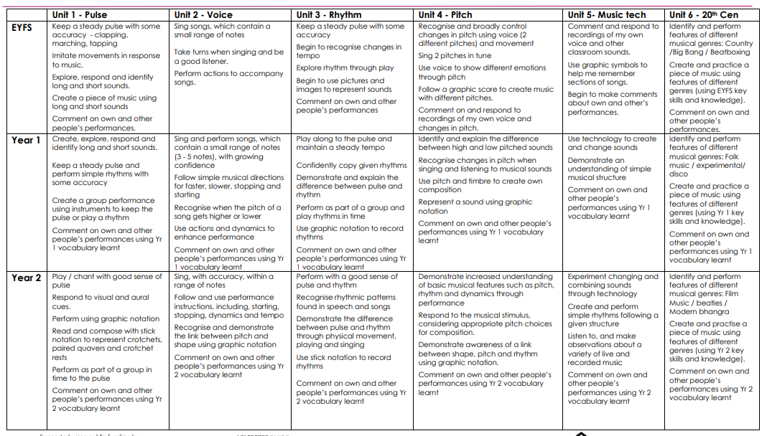Substantive Knowledge (Facts) and Disciplinary Knowledge (Skills)

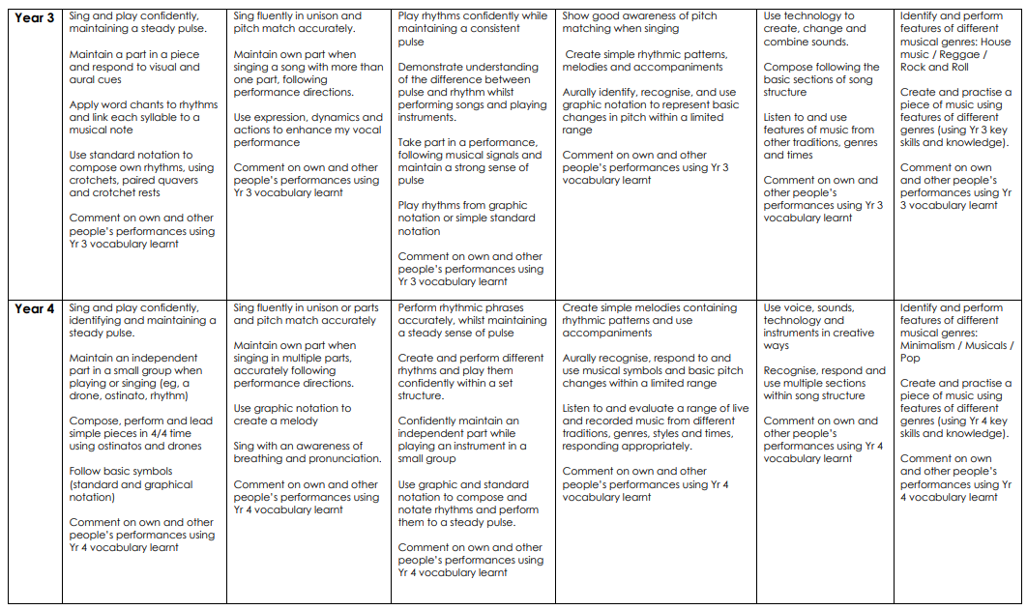

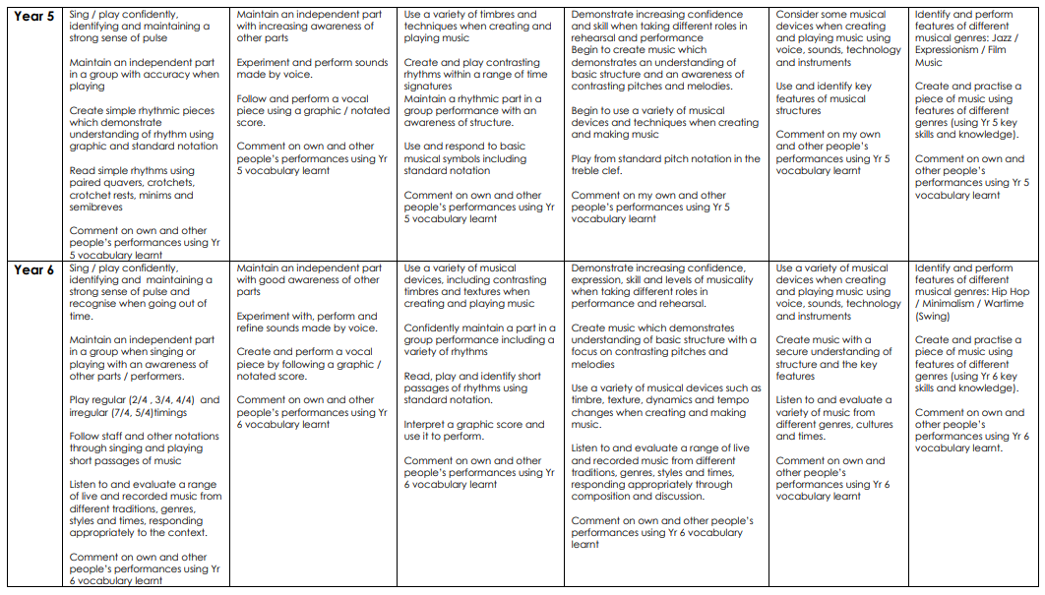

Vocabulary Progression





**Belton Church of England Primary School**

Music Rolling Programme

|  |  |
| --- | --- |
| EYFS |  |
| Autumn term | Unit 1 Pulse Unit 2 Voice |
| Spring term | Unit 3 Rhythm Unit 4 Pitch |
| Summer term | Unit 5 Technology, Structure and Form Unit 6 20th Century Music |

|  |  |
| --- | --- |
| Year 1/2 Cycle A |  |
| Autumn term | Unit 1 Pulse |
| Spring term | Unit 3 Rhythm |
| Summer term | Unit 5 Technology, Structure and Form |

|  |  |
| --- | --- |
| Year 1/2 Cycle B |  |
| Autumn term | Unit 2 Voice |
| Spring term | Unit 4 Pitch |
| Summer term | Unit 6 20th Century Music  Genres: Folk music, Experimental, disco and film music |

|  |  |
| --- | --- |
| Year 3/4 Cycle A |  |
| Autumn term | Unit 1 Pulse |
| Spring term | Unit 3 Rhythm |
| Summer term | Unit 5 Technology, Structure and Form |

|  |  |
| --- | --- |
| Year 3/4 Cycle B |  |
| Autumn term | Unit 2 Voice |
| Spring term | Unit 4 Pitch |
| Summer term | Unit 6 20th Century Music  Genres: House, Rock and Roll / Blues, Reggae, Musicals, minimalism (Steve Riech/Kraftwork), rap (JayZ, Beyonce). |

|  |  |
| --- | --- |
| Year 5/6 Cycle A |  |
| Autumn term | Unit 1 Pulse |
| Spring term | Unit 3 Rhythm |
| Summer term | Unit 5 Technology, Structure and Form |

|  |  |
| --- | --- |
| Year 5/6 Cycle B |  |
| Autumn term | Unit 2 Voice |
| Spring term | Unit 4 Pitch |
| Summer term | Unit 6 20th Century Music  Genres: Jazz, expressionism, film music (Jurassic Park), Hip Hop, minimalism (Philip Glass), war time music. |

**Achieving the Best Together**

I have come that they may have life in all its fullness – John 10:10

