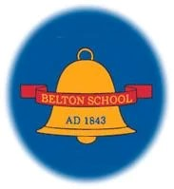

**Belton Church of England Primary School**

RELIGIOUS EDUCATION CURRICULUM STATEMENT

Achieving the Best Together

I have come that they may have life in all its fullness – John 10:10

# Curriculum Vision

***I have come that they may have life, and have it to the full. – John 10:10***

At Belton C of E Primary School we aim to provide a loving Christian environment where Jesus is our model and worship and prayer are central to our daily lives. We will deliver high quality learning opportunities, inside and outside the classroom. We provide a welcoming, safe and nurturing environment where everyone is able to learn and grow as a unique individual and encourage and support each other to be ambitious, resilient and independent lifelong learners.

We believe Religious Education for children and young people provokes challenging questions about the meaning and purpose of life. It develops pupils’ knowledge and understanding of Christianity amongst other religion and religious traditions. RE enables pupils to build their sense of identity and belonging, which helps them flourish within their communities and as citizens in a diverse society. It teaches pupils to develop respect for others, including people with different faiths and beliefs and helps to challenge prejudice. RE prompts pupils to consider their responsibilities to themselves and to others and to explore how they might contribute to their communities and to the wider society. It encourages empathy, generosity and compassion.

# Intent

At Belton C of E Primary School, our religious education provokes challenging questions about the meaning and purpose of life.  It develops all pupils’ knowledge and understanding of Christianity amongst other religions and religious traditions.  RE enables pupils to build their sense of identity and belonging, which helps them flourish within their communities and as citizens in a diverse society.  Religious Education teaches pupils to develop respect for others, including people with different faiths and beliefs and helps to challenge prejudice.  RE prompts pupils to consider their responsibilities to themselves and to others and to explore how they might contribute to their communities and to the wider society.  It also encourages our Christian values of hope, peace, forgiveness, love, friendship and trust.

# Implementation

Belton C of E Primary School follows the NATRE Scheme for RE it focuses on the deepening children’s understanding of the Christian faith and shares a breadth of knowledge about different faiths.

Regardless of ability, from EYFS to Key Stage 2 pupils are taught knowledge, skills and understanding through developing an understanding of the principal religions represented in the UK, in line with the law. These are Islam, Hinduism, Buddhism and Judaism. Furthermore, children from families where non-religious worldviews are held are represented in almost all of our classrooms. These worldviews, including for example Humanism, will also be the focus for study in thematic units.

The Understanding Christianity syllabus aims to enable children to understand Christianity as a living world faith, by exploring theological concepts through biblical texts. Over the course of study, the teaching is designed to help learners to remember in the long term the content they have been taught and to integrate new knowledge into larger concepts. Moreover, it aids the development of their own reflective skills to help them grow in their understanding of religion, beliefs and the human experience. As a school we also use the Leicestershire Agreed Syllabus to support the children’s understanding of a range of religious practices or world views. The impact of this resource aims that children will apply their knowledge of a variety of religions to explain their significance and ask questions.

RE in our school is enhanced by the use of floor books and individual child books to collate information that captures the discussion and pupil voice aspect of teaching RE. It allows us to retain those key questions and share the discussions we have. Moreover, these are great resources for the children to look back on and remind them of the things we have learnt about. As well as recording our work it allows us to look back at the end of a topic to help with assessment and deciding how to keep our children progressing. At Belton we have whole school and individual class displays designed to aid children through each key question we are looking at. These can be interactive to allow children to respond to the questions and be guided by key vocabulary and imagery. It also reflects the Understanding Christianity Big Frieze Timeline and our religious key information.

# Impact

The children at Belton C of E Primary enjoy learning about other religions and why people choose, or choose not to follow a religion. The work completed is of a high quality across the school no matter their ability or background. Through our teaching we continuously monitor children’s progress against expected attainment for their age, making formative and summative assessment where appropriate. The main purpose of all assessment is to always ensure that we are providing excellent provision for every child and elaborate or differentiate where necessary. Through their R.E. learning, the children are able to make links between their own lives and those of others in their community and in the wider world, developing an understanding of other people’s cultures and ways of life. As such, R.E. is invaluable in an ever changing and shrinking world where are children emerge as enthusiastic and confident learners.

# SEN Statement

At Belton we believe Religious Education opens the door for all pupils to understanding and appreciating the richness of our diverse world, world religions and their own spirituality.

•We believe that all pupils have the right to explore, understand and celebrate the rich diversity and cultures of our world, whilst learning the skills required to make connections and seek to promote a sense of togetherness which values the beliefs of all people.

•We believe there are two main strands to Religious Education, learning about religion and learning from religion. All pupils should be given the opportunities to express their own ideas and feelings in a variety of ways.

•To ensure that learning within RE is accessible for all we use a multi-sensory approach, with the implementation and purposeful use of visual, tactile, auditory and kinesthetic approaches. These can include, but are not limited to: drama, role-play, visits to places of worship, or sharing special meals.

•We provide alternatives to written recording such as drawing, scribing, word processing, mind maps, digital images, video and voice recording to allow participation and contributions from all pupils and avoid cognitive overload.

•We give our pupils a voice and value their opinions through the use of pupil surveys to ascertain the level of support they require.

•We provide support through planned scaffolding to allow pupils to increasingly work independently.

•We recognise that the language of RE may be challenging for some pupils, so we plan to teach new

vocabulary explicitly to ensure teaching is clear, unambiguous and accessible to all.

•We ensure lesson objectives are made clear in pictures/symbols and writing as appropriate and that objectives are challenging yet achievable to promote self-esteem and enable all pupils to achieve success.

# British Values

|  |  |  |  |  |
| --- | --- | --- | --- | --- |
| **Democracy** | **The Rule of Law** | **Individual Liberty** | **Mutual Respect** | **Tolerance of those of different faiths and**  **beliefs** |
| **The RE classroom** must be a **democratic** classroom where all pupils have an equal right to be heard and democracy is modelled by the teacher and expected of every pupil. | In RE pupils examine different codes for living and consider the value of the **rule of law** where all people are equal before the law. | Children will learn that Religion is a good case study of the balance between **individual liberty** and the greater good.  It is the right of the parent to withdraw their child from RE. | Children learn about the main religions and are taught respect and understanding for the cultures, beliefs, opinions and traditions or others.  Mutual respect is taught and given when children are expressing their opinions and beliefs.  Children are taught and encouraged to show respect to each other’s beliefs, feelings and opinions by given each child a forum to share these on and an expectation that these must be  listened to. | Children consider questions about identity and belonging. Children learn about the main religions and are taught respect and understanding for the cultures, beliefs, opinions and traditions or others.  Class assemblies also help to contribute to the knowledge of special occasions, beliefs and customs. RE can challenge pupils to be increasingly **respectful** and to celebrate diversity of **different cultures, faiths and beliefs.** |



**Belton Church of England Primary School**

_________ PROGRESSION STATEMENT

Achieving the Best Together

I have come that they may have life in all its fullness – John 10:10

Substantive Knowledge (Facts)

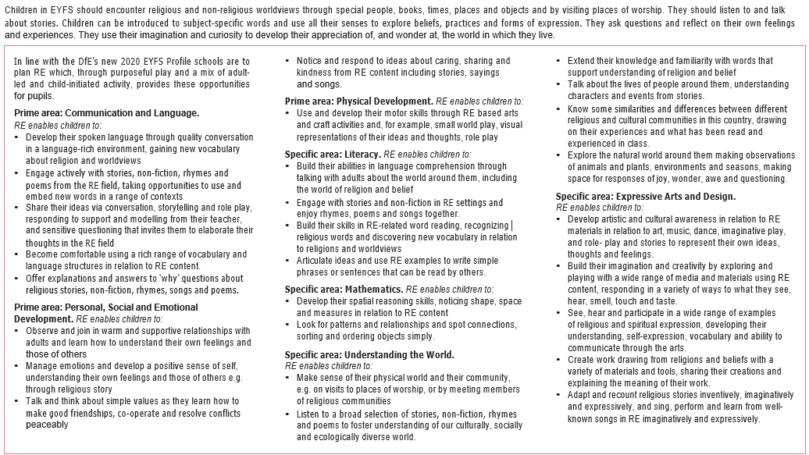***EYFS***

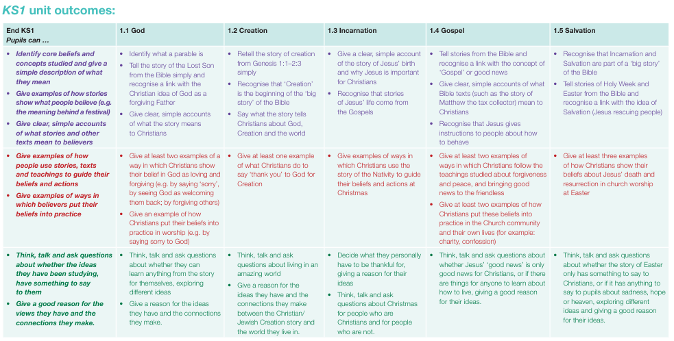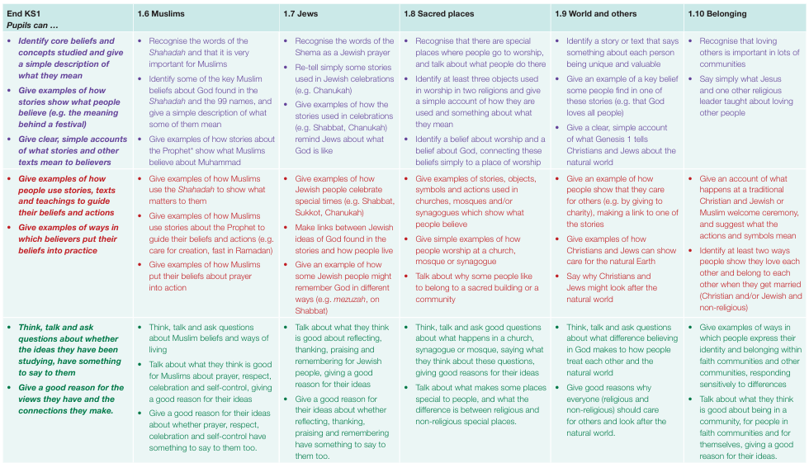

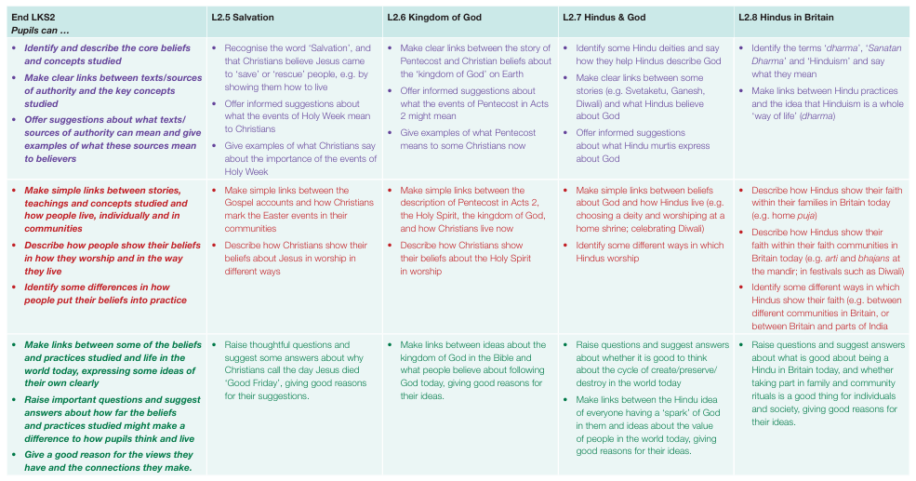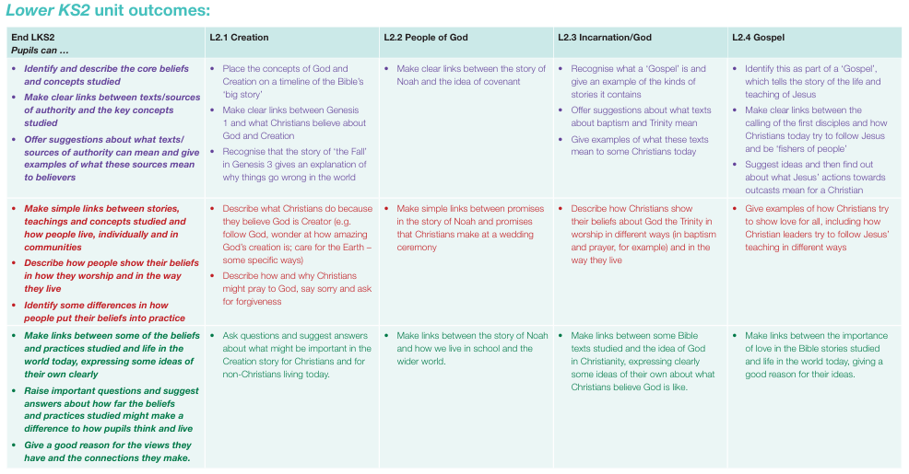

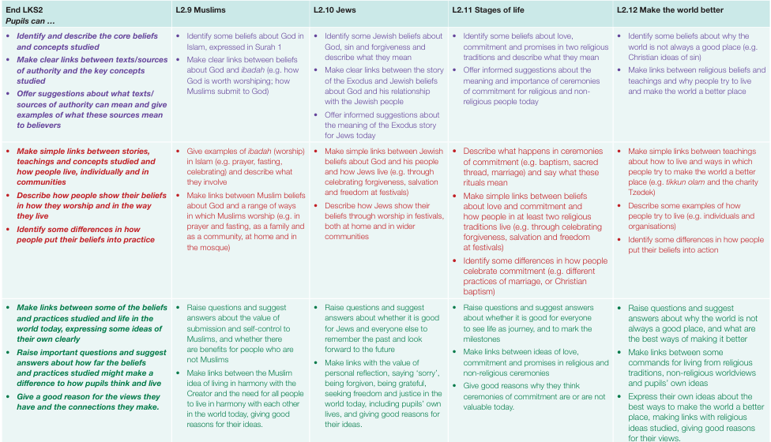

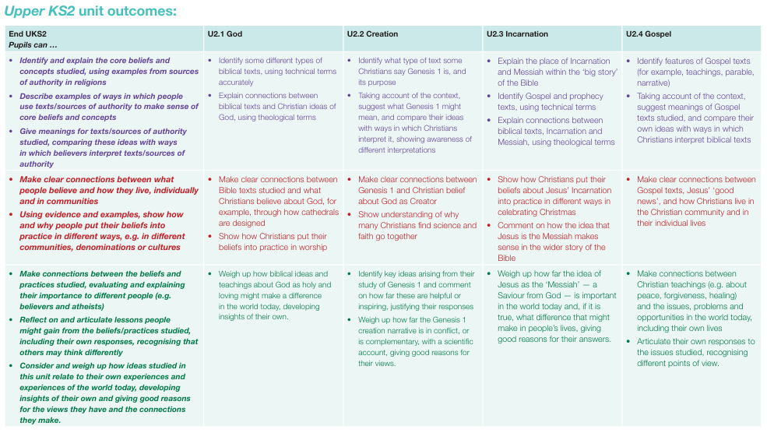

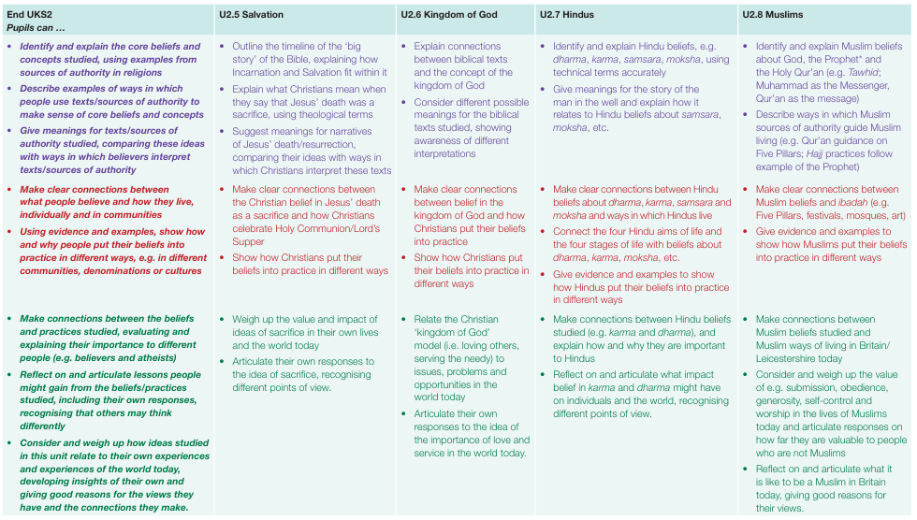

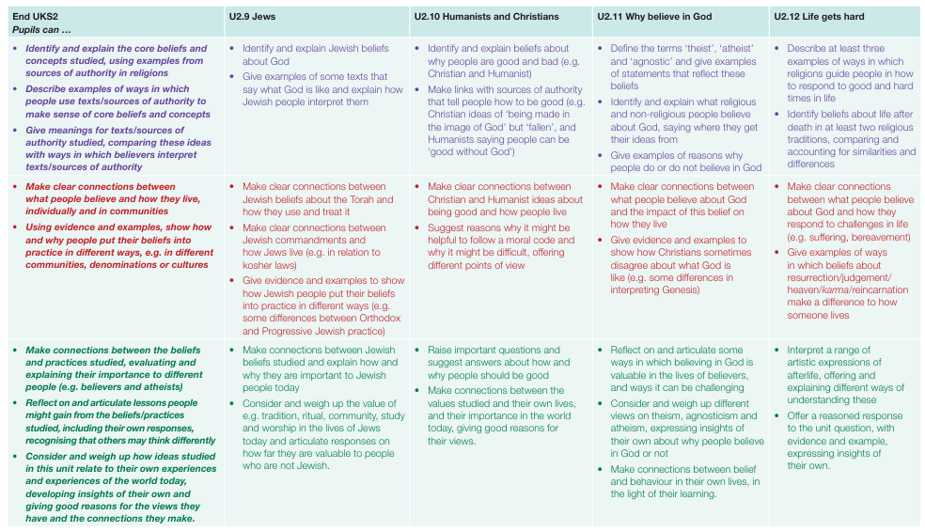

Disciplinary Knowledge (Skills)



Vocabulary Progression

|  |  |  |  |  |
| --- | --- | --- | --- | --- |
|  | **EYFS**  **Discovering** | **KS1**  **Exploring** | **LKS2**  **Connecting** | **UKS2**  **Connecting** |
| The general language of religious study. | Religion, special books, special places, special stories, prayer. | celebration, festival, symbol, thankful, faith, belief, wise sayings, rules for living, cooperation, belonging, worship, holiness, sacred, Creation Story, signs, symbols, artefacts, actions, belonging, communities, | spiritual, commitment,  values, prayer, pilgrim, pilgrimage, ritual, devotion, life after death, destiny, soul, inspiration, role-model, reflection, charity, | harmony, respect, justice, faith, interfaith, tolerance, moral values, religious plurality, moral codes, holiness, spiritual, inspiration, vision, symbol, community, sources of wisdom, spiritual, Golden Rule, place of worship, sacred text, devotion, prayer, worship, compassion, prejudice, persecution, utopian, monotheistic |
| Christianity | Christmas, Bible, Church, Jesus, baptism, Christian. | Christian, God, Creator, Creation,  Easter, altar, font, Bible, gospel, Bethlehem, advent, Nazareth, Gabriel, angels, shepherds, Incarnation, Salvation, Resurrection, heaven, forgiveness, peace, community, worship, sacred, holy, special, crucifixion, altar, cross, font, lectern, vestments, pulpit, psalms, prayer, hymns, baptism, hymns, prayers, loving, Lord, King, unique, valuable, | Pentecost, Harvest Festival, Messiah, liturgy, church,  Gospel, Holy Spirit, God  the Creator, Trinity, Heaven, ‘ Father, Son and Holy Spirit’ Gospel, Jerusalem, resurrection, Pentecost, kingdom, love, commitment, salvation, ceremonies, Genesis, Creation, covenant, ceremony, Israel, disciples,  clergy, neighbour, | Letters of Saint Paul, Trinity, Incarnation, Holy Spirit, resurrection, Eucharist, Kingdom of Heaven, Old Testament, New Testament, parable, sacrifice, Communion, Mass, Eucharist, Omnipotent, Omniscient, Eternal, forgiving, faithful, Ten Commandments, Messiah, theology, Jewish ‘rescuer’ ‘annotated’ Saviour, prophecies, advent,  Community praise, confession, asking, thanksgiving, |
| Judaism | Moses, Passover, Torah, Synagogue | Jewish, synagogue, Torah, bimah, Chanukah/Hanukkah, Ark, Judaism, Shabbat, mezuzah, Tenakh., Talmud, scroll, tzitzit, tefillin, tallit, kippah,  Shema, Sukkoth, Chanukah, mezuzah, | Moses, Exodus, Lawgiver, Ten Commandments, Star of David, Passover/Pesach, Shabbat, Shema, Torah. Bar and Bat Mitzvah, sin, forgiveness, Exodus, Rosh Hashanah and Yom Kippur, Talmud, Shabbat,  Jonah, | schul, Jerusalem, Western, Wall, Orthodox, Reform, Tu, B’Shevat, tzedakah, tikkun, olam, kosher, Orthodox, Progressive, Shema, mezuzah. Almighty, King, Father, Lord, King of Kings) siddur, Exodus, Passover, |
| Islam | Allah, Prophet, Muhammad, Qur’an, Mosque. | Muslim, Islam, Allah, Prophet, mosque, Eid, Qur’an, moon and star, Ramadan, Tawhid. Shahadah, 99 names of Allah, Muhammad, Salah, Five Pillars, prayer, PBUH (Peace Be Upon Him), calligraphy, prayer mat, minbar, mihrab, muezzin, calligraphy, Ka’aba, Kiddush cup, | moon and star, paradise., Surah, Ibadah, fasting, submission, Arabic, peace, harmony, rak’ah, sawm, Ramadan, ritual prayer, | Prophethood, Ummah, Iman, akhlaq (character or moral conduct), Hadith, Mosque, Hajj, Submission, Obedience, Shahadah (belief in one God and his Prophet); salat (daily prayer); sawm (fasting); and zakah (almsgiving).  Introduce Hajj (pilgrimage): Eid-ul-Adha: Sunnah Hadith (sayings and actions of the Prophet Muhammad) |
| Hinduism |  |  | Hindu, mandir, murtis, gods, goddesses, Diwali, Aum, Trimurti, dharma, Ramayana  Brahman, deities, Svetaketu, Ganesh, shrine, cycle of life, puja, Atman, rebirth, Vishnu and Shiva, rituals, | ahimsa, karma, Brahman, mandir, shrines, Mahatma, samsara, moksha, reincarnations, |
| Worldviews |  |  |  | Humanism, theist, atheist, cosmology, evolution, moral code, fairness, freedom, truth, honesty, kindness, peace conscience fairness, justice,  forgiveness and freedom. |

Vocabulary Progression



**Belton Church of England Primary School**

RE Rolling Programme



**Achieving the Best Together**

I have come that they may have life in all its fullness – John 10:10

