Progression
We teach Religious Education to all children in the school, including those in EYFS. In EYFS, Religious Education is an integral part of the topic work covered during the year. As the reception class is part of the Foundation Stage of the National Curriculum, we relate the Religious Education aspects of the children’s work to the objectives set out in the Early Learning Goals which underpin the curriculum planning for children aged three to five.

EYFS
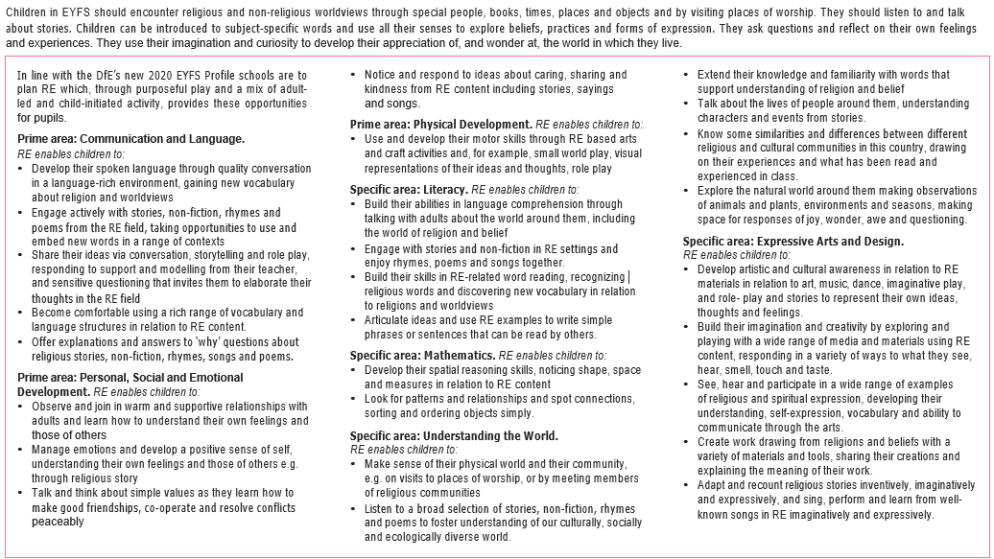

KS1 and KS2
Teaching and learning approach | End KS1 Pupils can … | End lower KS2 Pupils can … | End upper KS2 Pupils can …
Element 1:  Making sense of beliefs  Identifying and making sense of religious and non-religious beliefs and concepts; understanding what these beliefs mean within their traditions; recognising how and why sources of authority (such as texts) are used, expressed and interpreted in different ways, and developing skills of interpretation. | - identify core beliefs and concepts studied and give a simple description of what they mean  - give examples of how stories show what people believe (e.g. the meaning behind a festival)  - give clear, simple accounts of what stories and other texts mean to believers | - identify and describe the core beliefs and concepts studied  - make clear links between texts/ sources of authority and the core concepts studied  - offer informed suggestions about what texts/sources of authority can mean and give examples of what these sources mean to believers | - identify and explain the core beliefs and concepts studied, using examples from texts/sources of authority  in religions  - describe examples of ways in which people use texts/sources of authority to make sense of core beliefs  and concepts  - give meanings for texts/sources of authority studied, comparing these ideas with some ways in which believers interpret texts/sources  of authority
Element 2:  Understanding the impact  Examining how and why people put their beliefs into practice in diverse ways, within their everyday lives, within their communities and in the wider world. | - give examples of how people use stories, texts and teachings to guide their beliefs and actions  - give examples of ways in which believers put their beliefs into practice | - make simple links between stories, teachings and concepts studied and how people live, individually and in communities  - describe how people show their beliefs in how they worship and in the way they live  - identify some differences in how people put their beliefs into practice | - make clear connections between what people believe and how they live, individually and in communities  - using evidence and examples, show how and why people put their beliefs into practice in different ways, e.g. in different communities, denominations or cultures
Element 3:  Making connections  Evaluating, reflecting on and connecting the beliefs and practices studied; allowing pupils to challenge ideas studied, and the ideas studied to challenge pupils’ thinking; discerning possible connections between these and pupils’ own lives and ways of understanding the world. | - think, talk and ask questions about whether the ideas they have been studying, have something to say to them  - give a good reason for the views they have and the connections they make | - make links between some of the beliefs and practices studied and life in the world today, expressing some ideas of their own clearly  - raise important questions and suggest answers about how far the beliefs  and practices studied might make a difference to how pupils think and live  - give good reasons for the views they have and the connections they make | - make connections between the beliefs and practices studied, evaluating and explaining their importance to different people (e.g. believers and atheists)  - reflect on and articulate lessons people might gain from the beliefs/ practices studied, including their own responses, recognising that others may think differently  - consider and weigh up how ideas studied in this unit relate to their own experiences and experiences of the world today, developing insights of their own and giving good reasons for the views they have and the connections they make

