# Welcome to



**Belton C of E Primary School**

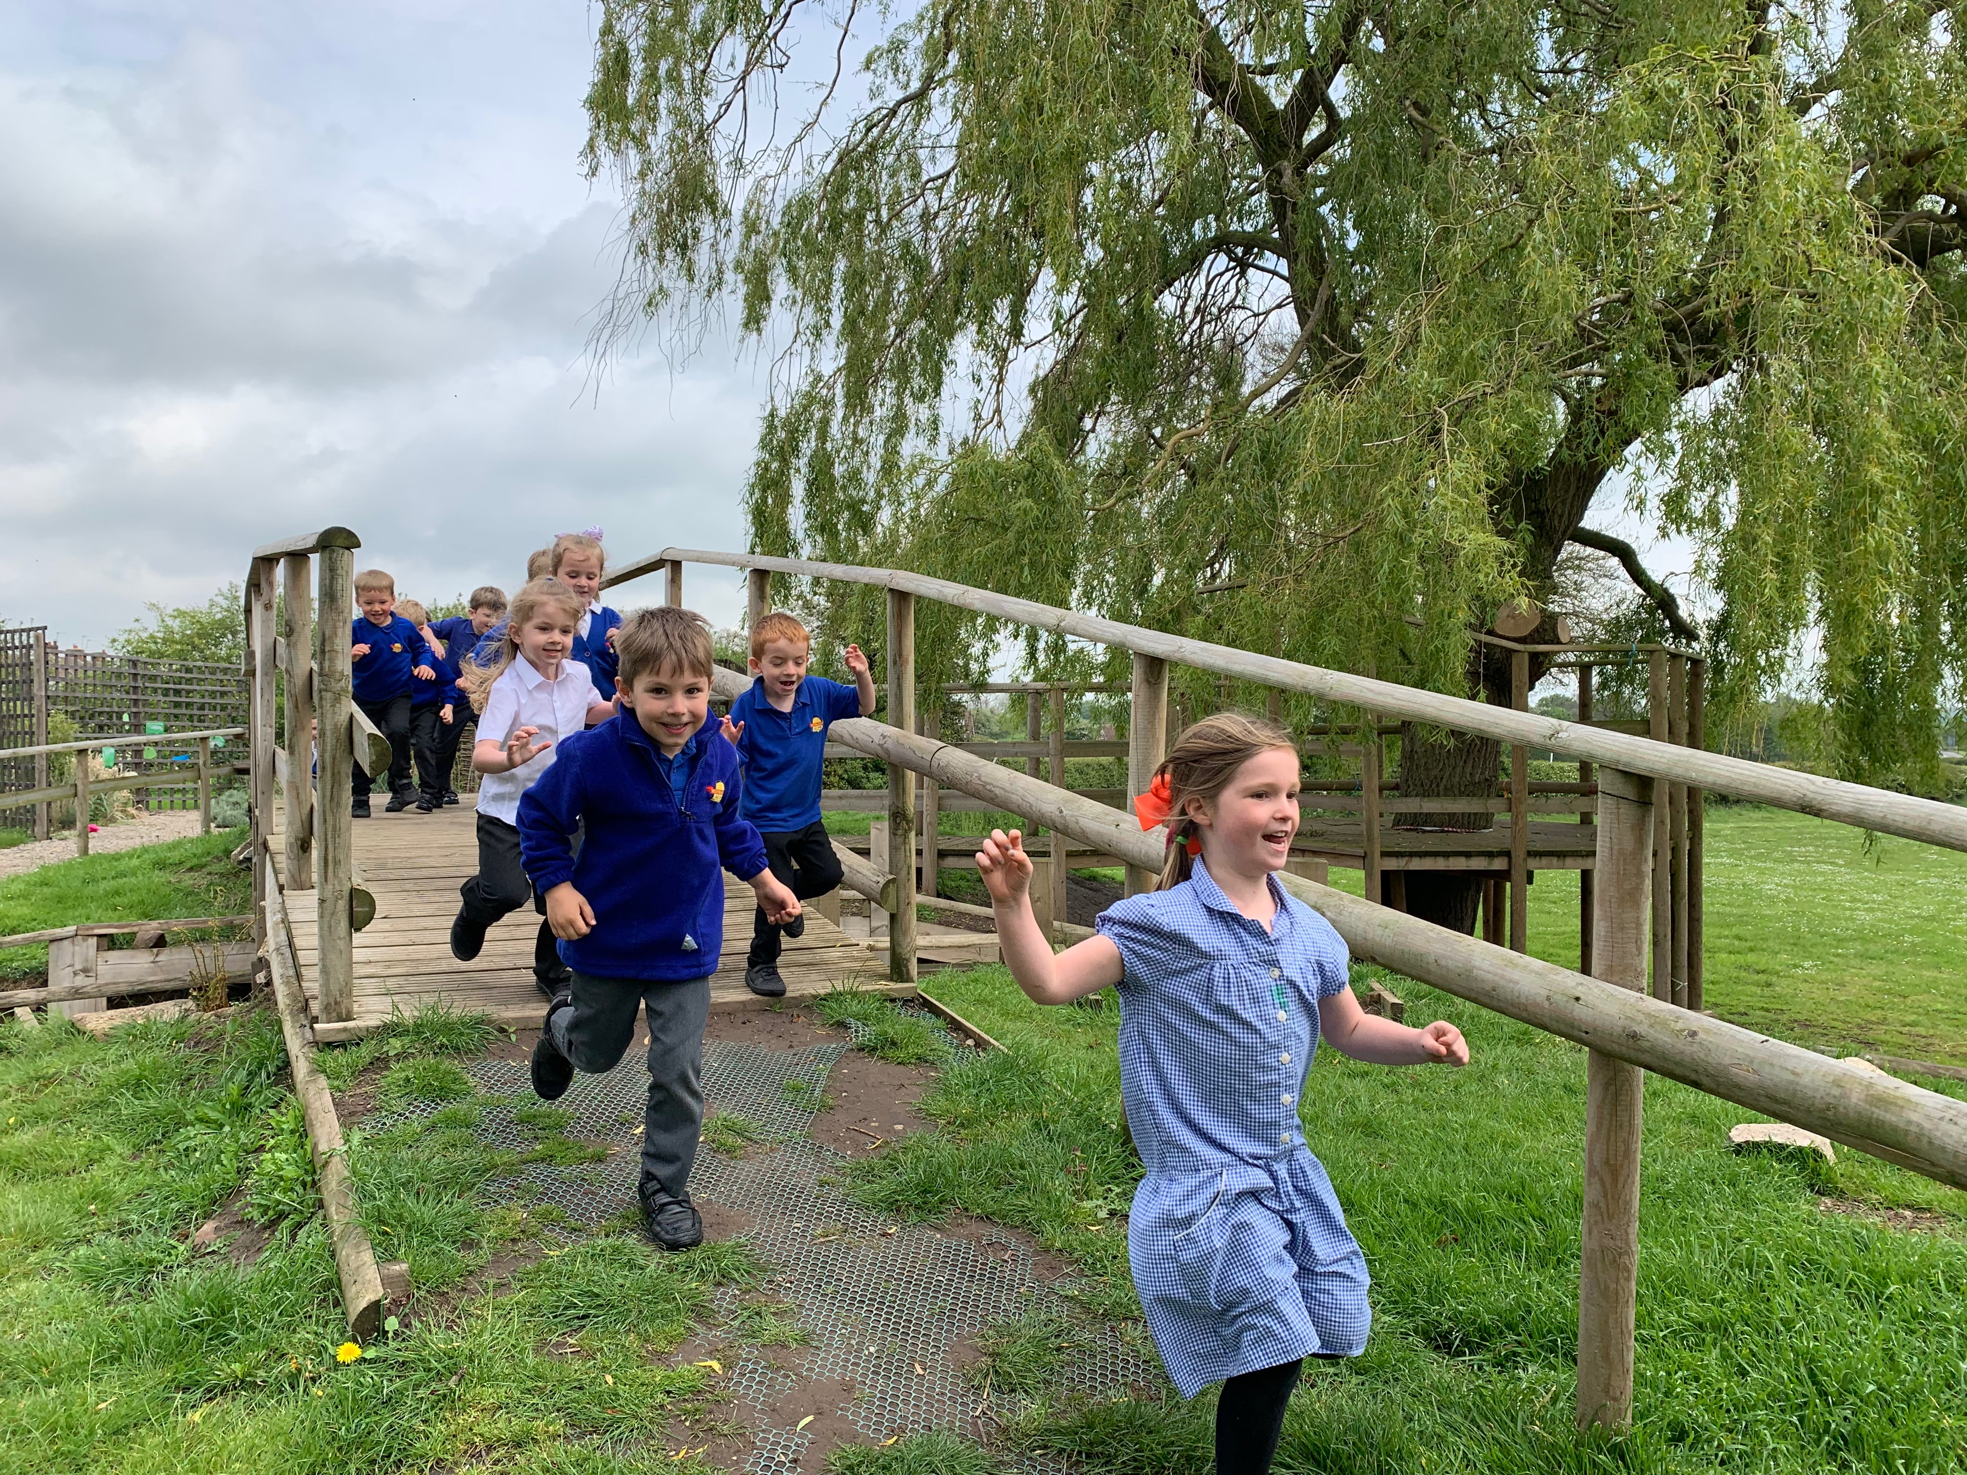

Information book for parents and carers

September 2023

Sadlers Wells, Belton, Leicestershire LE12 9TS

[office@beltonprimary.org](mailto:office@beltonprimary.org)

Telephone: 01530 222304

[www.belton.leics.sch.uk](http://www.belton.leics.sch.uk)

Dear Parent/Carer

This booklet has been written to help you prepare your child for school and to give you information you may require.

It is very important that your child’s transition is planned both at home and with the school and that your child feels happy and secure. Please let us know if there is any other information you require.

I look forward to working with you.

Miss Ebbs

Preparing your child for school

There are many ways in which you can help to make sure that your child has the skills which make starting school easier. Many of these are the things that your child will be doing at home or at pre-school, already.

* Put on a coat
* Put on socks
* Put on school clothes
* Tie a bow (if their shoes have laces)
* Do up zips and buttons
* Use the toilet and flush it
* Wash hands
* Cover mouth when coughing
* Use a handkerchief effectively
* Tidy up after using toys or equipment
* Use scissors and cutlery
* Sit comfortably on a chair at a table to write and draw
* Sing/recite nursery rhymes and songs
* Share books and stories
* Counting – steps, cutlery, food etc.

Hedgehogs Timetable

8.35 am Doors open to come in to school

8.35 am Registration and settling activity

8.45 am Phonics / Literacy activities

9.30 am Children play inside and outside accessing a range of curriculum activities

10.00 am Assembly

10.15 am Break time

10.30 am Mathematics activities

11.15 am Children play inside and outside accessing a range of curriculum activities

11.50 am Story and prepare for lunch

12 noon Lunch time

1.00 pm Handwriting

1.15pm Children play inside and outside accessing a range of curriculum activities

2.00pm Fruit, milk and circle time

2.15 pm Children play inside and outside accessing a range of curriculum activities

2.50 pm Tidy time and story

3.10 pm Home time

What to do when you first come to school

The classroom door opens at 8.35am and I will meet the children at the gate to the Hedgehogs classroom. For the first few days if it helps your child, come in and help them to hang up their coat but it is preferable for children to say goodbye at the gate as soon as they can.

There will be activities out in the classroom for your child to take part in before registration.

It is very helpful if all uniform and belongings are labelled with your child’s name as there can be frequent mix ups.

Please make sure that every time you send money to school, it is in a sealed envelope and that it has the following information written on:

* Name of child and class
* The amount enclosed and reason for sending money e.g. trip, contribution

Morning Break

While your child is in the Hedgehogs class, the children will have milk and a piece of fruit (the fruit is provided free for your child as part of a government scheme up to the age of 7). A carton of milk is provided free until your child’s fifth birthday. When they have turned five they can continue to receive milk upon payment of a termly fee. Details on how to order the milk are in the pack. (Note: you are required to order the milk even if your child is under five and entitled to it free of charge).

At 10.15 am the children go out to play on the playground. Playtime ends at 10.30am.

Your child will be provided with a named water bottle which is to be brought to school each day filled with fresh water. The children are encouraged to drink regularly throughout the day to remain hydrated.

Lunchtime

Lunchtime is from 12 noon to 1 pm and during this time your child will eat a school dinner in the school hall. As a Reception pupil, your child is entitled to a free school dinner. When your child has finished their lunch, they are escorted to the playground where they are supervised for the remainder of the lunch hour.

Home Time

The school day ends at 3.10 pm. The children will be let out of the door and walked down to the gate on the Hedgehogs playground. Children will only be dismissed when I have seen the parent and watched the child go to the parent/carer. It makes it easier to do this if you stand in a visible place.

If you need to change the way your child goes home for any reason, please let me know or alternatively telephone the school office: 01530 222304 and leave a message. (Please see our arrival and collection policy on the website for further details.)

Writing

If your child shows an interest in writing, give them opportunities to write for real purposes and to see you and your family writing. Children will ‘write’ in their own time. We call early writing mark making. Hand writing and correct formation of letters will be taught throughout the year. Sing nursery rhymes with actions to get fingers and hands active. Use short, wide pencils, chalks or crayons to encourage children to hold them between the thumb pad and index finger in the ‘tripod grip’. More suggestions for activities can be found on [www.stabilo.co.uk](http://www.stabilo.co.uk)

Reading and Phonics

Your child will be taught to read using a phonic scheme (phonics is about learning the sounds that make up words). E.g. c-a-t is cat.

There will be a phonics meeting for parents in the Autumn term.

Mathematics

We will be approaching Mathematics in a practical manner which will involve counting, real life maths stories and role play. Your child will use lots of hands on equipment including Numicon, Unifix, counting bears and everyday objects like pine cones, stones, buttons etc. They will use language to talk about size, weight, capacity, position, distance, time and money to compare quantities and objects and to solve problems. This will be explained further once your child has started school.

Illness or injury

Occasionally children become unwell whilst at school. Please make sure that we have up-to-date contact details so that we can get hold of you as soon as possible. We also require details of other people who we may contact if you are unavailable.

Please do not send your child to school if you think they are unwell. If your child has vomited and/or had diarrhoea then they need to be kept off school for the following 48 hours, (this is to guard against the spread of the illness).

If your child has a bump during the day we will administer first aid and inform you at the end of the day. If your child bumps their head we take this very seriously and a letter will be sent home informing you of the injury.

Once your child has started school

After your child has started school it is helpful if you try and do the following:

* Make sure that you are on time to drop off and collect your child
* Talk to your child and show an interest in what they have been doing each day
* Read **with** and **to** your child each day. It may be a book they’ve brought home, a game to play to learn sounds or words, or a favourite book at home. Reading with your child shows your child that you value reading and also that you value their efforts at becoming a reader.