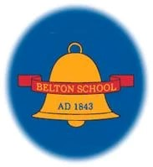

**Belton Church of England Primary School**

GEOGRAPHY CURRICULUM STATEMENT

Achieving the Best Together

I have come that they may have life in all its fullness – John 10:10

# Curriculum Vision

**“The study of geography is about more than just memorizing places on a map. It’s about understanding the complexity of our world, appreciating the diversity of cultures that exists across continents. And in the end, it’s about using all that knowledge to help bridge divides and bring people together.”**

**–President Barack Obama**

**We aim to ensure that our pupils understand the relationship between the Earth and its people and are provided a means of exploring, appreciating and understanding the modern world in which they live, how it has evolved and the challenges it faces.**

# Intent

**At Belton, we believe that children need to have an in-depth Knowledge and Understanding of the world, through which we aim to inspire children’s natural curiosity about the diverse world in which we live. Through their growing knowledge and understanding of human geography, children gain an appreciation of life in other cultures and, in so doing, learn a respect and understanding of what it means to be a positive citizen in a multicultural country. Therefore, pupils are encouraged to celebrate diversity and feel confident to challenge diversity. Through our Geography curriculum, we aim to provide pupils with the knowledge and understanding of physical and human influences and their effects on the planet over time, promoting an understanding of their roles and responsibilities as members of a global community. Geography at Belton plays a significant role in educating the children about citizenship and both supports and promotes British values. At Belton, we aim to develop children’s’ geographical skills in order to prepare them for a future in an ever-changing world.**

# Implementation

**Our Early Years Foundation Stage pupils will experience provision linked to Understanding of the World. Learning will include the use of simple maps, exploring the natural world as well as learning about people, culture and communities. Pupils will learn Geography through playing, exploring, active learning, creating and thinking critically (the Characteristics of Effective Learning). There are many opportunities for cross curricular learning, such as linking Geography to Science when learning about the seasons.**

**From Year 1 to Year 6, staff at Belton C of E Primary School teach the aims and subject content of the National Curriculum 2014. Geography is taught discretely once per week in alternate terms (a total of 3 enquiries per academic year). To support our young Geographers, we have used Connected Geography as a basis of our Geography curriculum; adapting it for the needs of our school. This ensures coverage and progression in all skills and knowledge relating to Geography. We plan an opportunity within each session to revisit geographical knowledge, skills and understanding that may need further consolidation or to use new knowledge to enforce prior skills. Through the enquiries within the scheme the children develop an understanding of the world as a whole and this can be seen through our knowledge maps which are stuck in children's books.**

**In every Geography lesson, it is made explicit to pupils that they are being taught Geography. Specifically named Geography knowledge, skills and understanding are also referred to throughout the enquiries: locational knowledge, place knowledge, human features, physical features and geographical skills which include map skills, compass skills and fieldwork skills. It is expected that the pupils will become familiar with these terms as they progress through the school. In addition to this, staff understand that the pupils will progress through transferable learning skills in order to develop as Belton geographers. For example, pupils in Year 1 will be expected to identify, locate and name. Year 2 will describe and begin to explain. A Geographer in Year 6 will compare, contrast and give reasons in their lessons.**

**Through the use of the Geography triaged curriculum, teachers can become familiar with previous and subsequent year groups’ content in order to link learning, close gaps and build on previous knowledge.**

**Due to the numbers on roll, we use a rolling programme of planning as we have mixed age classes. When planning each enquiry, teaching staff ensure that the outcome for each year group is pedagogically appropriate, taking all of the above into consideration.**

**Where possible, field trips are used to enhance cultural capital, particularly around the local area**

# Impact

When our children leave us at Belton, they will have a growing knowledge and understanding of their place in the world, how they interact with the world and the impact that they make around them. Our children leave Belton as confident geographers, with the ability to discuss their learning from past and current topics, as well as explain their next steps. Each enquiry which forms our programme of learning and teaching in geography sets clear objectives and outcomes for the pupils in terms of knowledge and understanding and skills acquisition. They demonstrate their skills of map reading, data analysis, and critical thinking to new situations, enabling them to make sense of complex information and draw their own conclusions. Every pupil is challenged to achieve their Geographical potential through carefully planned, motivating enquiries based on a mastery approach.

Pupil’s understanding in geography will be assessed through low stakes quizzes and retrieval practise linked to the ‘sticky knowledge’, this will be supplemented with an assessment of skills using our tracking system. Through fieldwork children will gain skills which will be useful in later life.

# SEN Statement

At Belton we believe geography stimulates an interest and develops a sense of wonder about places. It helps

children make sense of a complex and dynamically changing world.

• We understand that some learning may be appropriate to chunk into smaller steps to achieve the learning goal

or to provide additional resources which will help children achieve their learning goal.

• We consider what makes a topic difficult for certain pupils and anticipate what barriers there may be in order to

take part and learn in activities. We address any misconceptions that may arise as a barrier to children’s learning.

• Learning is done in a multi-sensory way to enable all learners to achieve. A mix of Visual, tactile, auditory and kinaesthetic approaches are used, such as supporting teacher talk with visual aids and artefacts.

• We recognise that the language of geography may be challenging for some pupils,

These include:-

- Specific geographical use of everyday words such as ‘mouth of the river’

- Terms specific to geography, such as ‘oktas’, ‘erosion’ and

- Terms like ‘climate’, ‘gradient’, ‘height’ or ‘distance’,

which can create barriers for many pupils because of their abstract nature. Key words, meanings and symbols

are highlighted, explained and displayed.

• We will allow for a range of opportunities for SEND pupils to demonstrate what they know and can do in a safe and supportive environment.

• When planning staff ensure that questions are prepared in different styles/levels for different pupils, careful preparation ensures all pupils have opportunities to answer open-ended questions.

# British Values

|  |  |  |  |  |
| --- | --- | --- | --- | --- |
|  | Democracy | Rule of Law | Respect and Tolerance | Individual Liberty. |
| EYFS | Our geography units encourage pupils to think about their place in the world, how they can become the best possible citizens of tomorrow and create change for the better. | Our pupils think about moral law and the consequences of their actions on future generations. We discuss why rules and laws are put into place and what impact they may have. | Pupils compare similarities and differences between their lives and those of others around the world. We aim to disband stereotypes and foster a common respect for different countries and cultures by learning about them. | Pupils think about how their actions can impact their own community. Moving beyond the classroom, several of our geography units require pupils to think about how they can live responsibly. Through debate and discussion pupils learn how to voice their opinion in a safe and supportive environment. |
| KS1 | Our geography units encourage pupils to think about their place in the world, how they can become the best possible citizens of tomorrow and create change for the better.  Units include:  -Where I live? (changes in the local area)  - Kampong Ayer (protecting the Rainforests, climate change)  - What makes Antarctica stand out to explorers? (climate change) | Our pupils think about moral law and the consequences of their actions on future generations. We discuss why rules and laws are put into place and what impact they may have.  KS1 areas of discussion may include:  - Where does our food come from? (laws to protect animals, trade, standards)  - Kampong Ayer,  - What makes Antarctica stand out to explorers?  - How does the weather affect our lives? (present and future laws to prevent climate change) | Pupils compare similarities and differences between their lives and those of others around the world. We aim to disband stereotypes and foster a common respect for different countries and cultures by learning about them.  - Kampong Ayer  - What makes Antarctica stand out to explorers?  - How does the weather effect our lives? | Pupils think about how their actions can impact their own community. Moving beyond the classroom, several of our geography units require pupils to think about how they can live responsibly. Through debate and discussion pupils learn how to voice their opinion in a safe and supportive environment.  KS1 Units include:  - Where I live (changes in the local area)  - Kampong Ayer (protecting the Rainforests, climate change)  - What makes Antarctica stand out to explorers? (climate change, adaptation)  - What do we find when land meets the sea? (caring for the coral reef) |
| LKS2 | Our KS2 geography units have a focus on how pupils can be active citizens and implement current and future change. Physical geography encourages children to think what impact their actions on the environment and human geography promote moral discussions about economy, poverty and human impact on the world  Pupils look at different perspectives and respect the views of others. They think about local, national and global issues.  Units include:  - Megacities (trade, migration, economy, employment, homelessness, congestion)  - Sustainability (living sustainably, renewable and non-renewable resources, global perspective, green procurement, carbon footprint, habitats, pollution etc)  - Beyond the magic kingdom (endangered species) | Our pupils think about moral law and the consequences of their actions on future generations. We discuss why rules and laws are put into place and what impact they may have.  KS2 areas of discussion may include:  - Megacities (crime)  - Beyond the magic kingdom, Jungles and deserts, What is it like to live in a national park? (laws to protect the environment and animals)  - How and why is my local area changing? (investigate laws at a local and global scale can influence both the physical and human layout of the landscape and contribute towards population decline and growth in certain areas)  - | Pupils compare similarities and differences between their lives and those of others around the world. We aim to disband stereotypes and foster a common respect for different countries and cultures by learning about them.  - Megacities (Baghdad, Brasilia)  - Sustainability (Kenya)  - Volcanoes, earthquakes – empathise with those that have been affected  Pupils are able to use different sources and can reflect upon why accounts may differ (eye-witness, newspaper reports etc) and are able to see the value in each account and are encouraged to explore the views of opposing sides  Pupils are encouraged to explore the different views through narrative, debate and discussion. They begin to think about why people make life choices (where to live, how to support themselves). The feel empathy for others. | Pupils think about how their actions can impact their own community. Moving beyond the classroom, several of our geography units require pupils to think about how they can live responsibly. Through debate and discussion pupils learn how to voice their opinion in a safe and supportive environment.  KS2 Units include:  - Megacities (trade, migration, economy, employment, homelessness, congestion)  - Sustainability (living sustainably, renewable and non-renewable resources, global perspective, green procurement, carbon footprint, habitats, pollution etc)  - Beyond the magic kingdom (endangered species)  paid for the goods) |
| UKS2 | Our KS2 geography units have a focus on how pupils can be active citizens and implement current and future change. Physical geography encourages children to think what impact their actions on the environment and human geography promote moral discussions about economy, poverty and human impact on the world  Pupils look at different perspectives and respect the views of others. They think about local, national and global issues.  Units include:  - What is it like to live in a national park? (caring for our area, cultural heritage)  - How is climate change effecting the world?  - Why is fair trade fair? | Our pupils think about moral law and the consequences of their actions on future generations. We discuss why rules and laws are put into place and what impact they may have.  KS2 areas of discussion may include:  - What is it like to live in a national park? (laws to protect the environment and animals) | Pupils compare similarities and differences between their lives and those of others around the world. We aim to disband stereotypes and foster a common respect for different countries and cultures by learning about them.  - Rivers and mountains (Bangladesh, London)  - Climate Change (The Gambia, Australia, Greenland)  - Volcanoes (Heimaey – Iceland)  Why is fairtrade fair? – Know about the others in our global community and how they should be treated fairly.    Pupils are able to use different sources and can reflect upon why accounts may differ (eye-witness, newspaper reports etc) and are able to see the value in each account and are encouraged to explore the views of opposing sides  Pupils are encouraged to explore the different views through narrative, debate and discussion. They begin to think about why people make life choices (where to live, how to support themselves). The feel empathy for others. | Pupils think about how their actions can impact their own community. Moving beyond the classroom, several of our geography units require pupils to think about how they can live responsibly. Through debate and discussion pupils learn how to voice their opinion in a safe and supportive environment.  KS2 Units include:  - What is it like to live in a national park? (caring for our area, cultural heritage)  - How is climate change effecting the world?  - Why is fairtrade fair? (explore around the issue of the right to be paid for the goods) |

# Spirituality

The Self

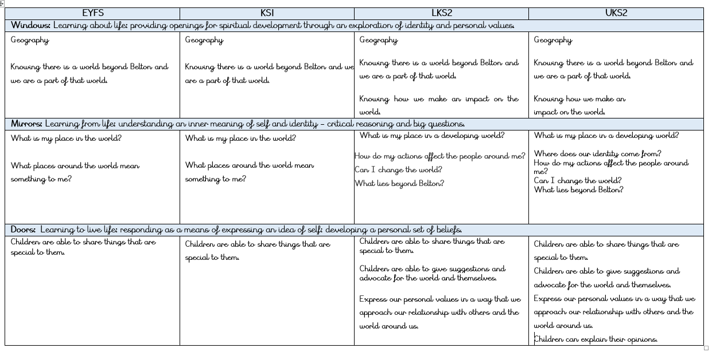

Other People

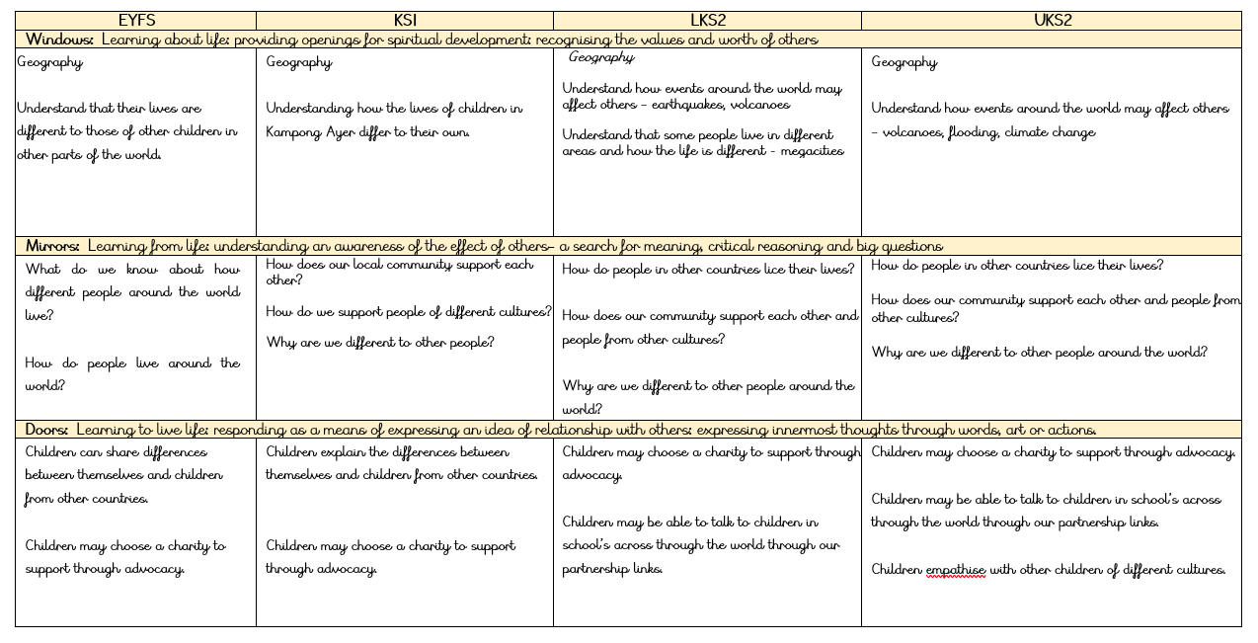

Beauty of the World

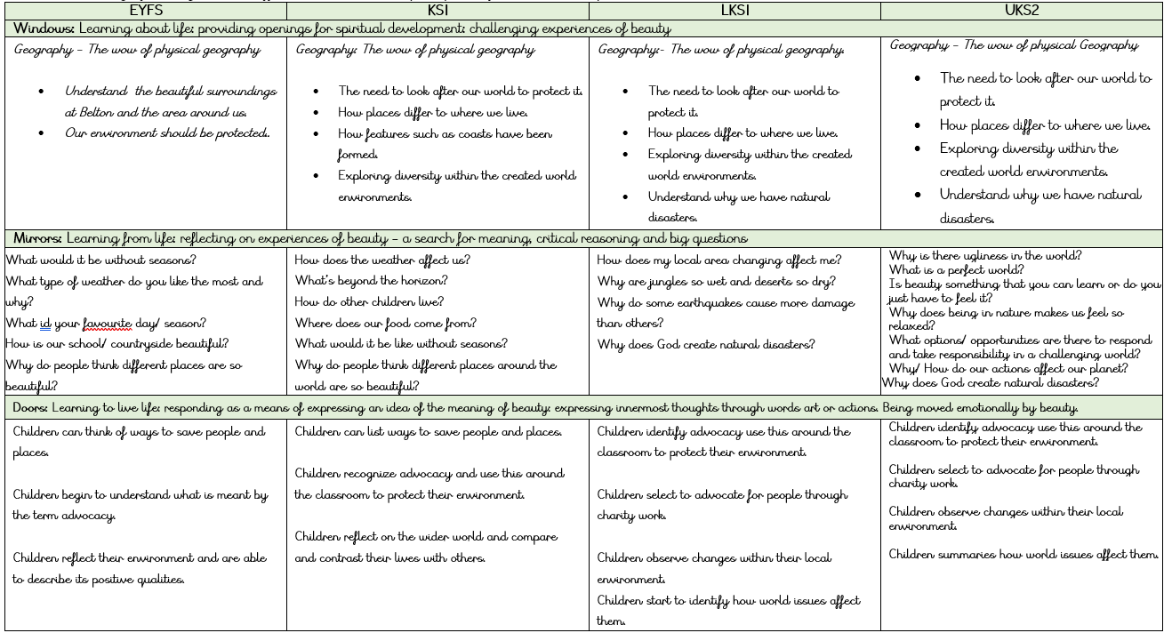

Beyond

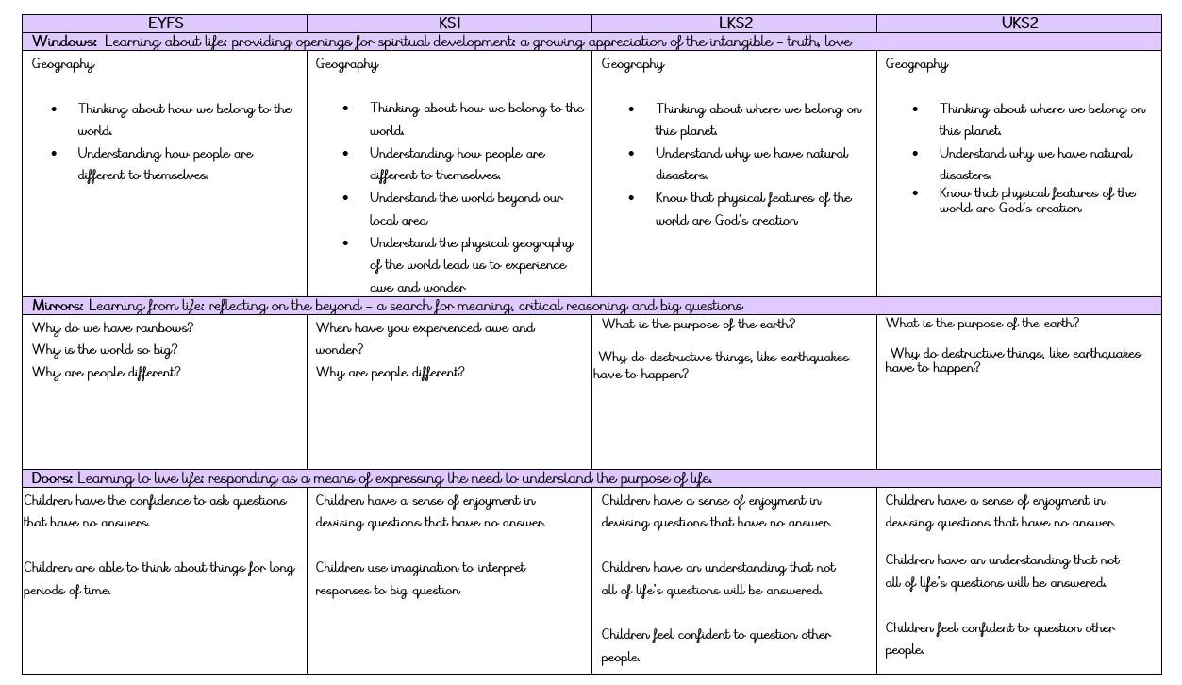



**Belton Church of England Primary School**

GEOGRAPHY PROGRESSION STATEMENT

Achieving the Best Together

I have come that they may have life in all its fullness – John 10:10

Substantive Knowledge (Facts)

|  |  |  |  |  |
| --- | --- | --- | --- | --- |
|  | Place and Locational Knowledge | Human Processes | Physical Processes | Mapskills and Fieldwork |
| A1  What is the geography like where I live? | Name the four nations if the UK and their capitals  Know where you live in the UK and locate it on a map.  Know that we are part of the continent of Europe. | Know some human features of their local areas  Know the different land uses around our village | Know some physical features of their local areas.  Know the different land uses around our village | Label the four nations of the UK on a map  Label Belton on a map of the UK  Create a simple map of the local area after going on a walk |
| A2  How does the geography of  Kampong Ayer compare with my locality? | Understand that UK is part of the continent of Europe.  Know that Bandar Seri Begawan is the capital of Brunei.  Know where Europe & Asia are on a map of the world.  Know where they live on a world map and where Kampong Ayer. | Know how homes, transport & school differ between the UK and Kampong Ayer. | Know that the temperature decreases towards the North & South Poles and warmer towards the Equator.  Know how the weather changes around the world.  Understand what a rainforest is. | Find Asia and Europe om a map of the world.  Find where they live on a map and Kampong Ayer |
| A3  How does the weather affect our lives? | Know that the further from the equator, the colder the place is.  Name and locate some hot and cold places on earth |  | Know the names of some types of weather.  Understand the weather across seasons.  Describe basic elements of weather and know why it changes. | Collect weather data  Take pictures of the same place at different point of the year. |
| B1  What makes Antarctica stand out to explorers? | Names and location of the continents of the world.  Name the five oceans  Find the Equator, North Pole & South Pole | Understand how Antarctica is affected by humans.  Understand how the weather in Antarctica makes it inhospitable to humans. | Know that the weather is different in countries located in hot and cold places of the world.  Know why Antarctica is classified as a desert. | Locate the continents and oceans on a map of the world. |
| B2  Why does it matter where my food came from? | Know where Devon is  Know where Central America is on a world map | Know that food comes from farms  Name some human features of Devon  Understand the benefits of buying food locally.  Understand the process of harvesting, packaging & exporting in Costa Rica.  Know which foods are grown in the UK and which are imported. | Know how food comes from plant and animals  Name some physical features of Devon.  Understand how the weather in Devon helps with farming. | Locate Devon on a map of the UK  Know where Central America is on a world map. |
| B3  What do we find at places where the land meets the sea? | Know where Bournemouth and the Great Barrier Reef is and locate them on a map.  Find the location of tropical, temperate and polar regions around the world. | Name some of the features found around the coastline – pier, harbour  Know why people enjoy spending time at the seaside.  Compare the human features of the coastline around Bournemouth with the coastline of Townsville in Australia | Name some of the features found around the coastline – natural arch  Understand why the UK has a long coastline and understand the term ‘island’  Compare the physical features of the coastline around Bournemouth with the coastline of Townsville in Australia  Know about the features of the Great Barrier Reef and understand how they are affected by climate.  Understand the features of tropical, temperate and polar regions of the world. | Use an Ordnance Survey Map to find coastal features. |
| **A1**  **Beyond the Magic Kingdom: What is the sunshine state really like?** | Name the world’s continents and oceans and locate them on a map  Identify lines of longitude and latitude.  Name and locate the main cities and states in North America.  Compare different states around the US and compare the UK and Florida  Understands points of a compass | Understand why theme parks are so popular.  Understands the pattern of visitors to the Magic Kingdom  Know the human features around the Kennedy Space Centre | Understand how hurricanes form  Compare the weather in the UK and Florida  Know what is meant by the term ‘peninsula’  Know the physical features around the Kennedy Space Centre. | Locate the world’s continents and oceans on a world map.  Locate the main cities and states on a map of the US |
| **A2**  **How and why is my local environment changing?** | Locate the Lake District on a map of the UK | Understand why environments change  Know why satellites inform environmental change  Understand how housing developments are changing our environments.  Understand how our local environment is changing – M1, airport | Know that the Lake District is a national park.  Understand why environments change  Know the physical ways that an environment may change. | Understand the land use around where I live  Know how to use Ordnance Survey maps |
| **A3**  **Why do so many people live in megacities?** | Know how to identify each continent  Know the names of 10 largest cities in the world and locate on a world map  Know the names of the 10 largest cities in the UK and locate on a map.  Name and locate the capital city of Brazil  Name and locate some of the main capital cities on a map of Europe | Understand why the Brazilian government created a new capital city.  Know the advantages/ disadvantages of living in a city  Know what is meant by the term megacity. |  | Use an atlas to locate cities and continents. |
| **B1**  **How can we live more sustainably?** | Know the capital of Nepal and find it on the map | Know how renewable energy resources are used to create electricity.  Understand the consequences of not living sustainably.  Know the differences between renewable and non-renewable sources.  Name some examples of sustainable development. | Understand how we can live sustainably.  Name some renewable energy sources  Name some of the physical features of Nepal. | Know how growing our own food can help the environment  Map out renewable energy sources on our school playground. |
| **B2**  **Why are jungles so wet and deserts so dry?** | Know where to locate the Atacama and Sahara desert and Amazon rainforest on a world map. |  | Know how climate effects different biomes and their features.  Understand what is meant by the term biome.  Describe some of the conditions of a desert and rainforest.  Know what the climate of the UK is like and compare with other countries. | Use an atlas to locate the Atacama, Sahara desert and the Amazon rainforest.  Read and draw climate graphs. |
| **B3**  **Why do earthquakes cause more damage than others?** | Know where New Zealand and Christchurch are on a world map.  Identify the Pacific Ring of Fire | Understand the geography of New Zealand. | Understand the geography of New Zealand.  Know how an earthquake is formed and understand where they occur.  Understand why some places around the world experience earthquakes and others don’t.  Understand why powerful earthquakes don’t cause the most deaths.  Know why volcanoes occur in the same regions as earthquakes | Use an atlas correctly.  Assess the safety of our school grounds |
| **A1**  **How do volcanoes affect the lives of people on Himaey (Iceland)** | Locate some of the world volcanoes on a world map.  Know the capital city and location of Iceland on a world map.  Know the global pattern of where volcanoes are found. | Know the human impact of a volcanic eruption.  Understand the human geography of Vestmannaeyajar  Understand how Heimaey has changed over time.  Understand the stages in the manufacture of an economic activity – export, import and trade. | Know that volcanoes occur in the same place as earthquakes.  Know the physical impact of a volcanic eruption.  Understand the physical geography of Vestmannaeyajar.  Explain how volcanoes form  Understand how Heimaey has changed over time. | Environmental study of the school ground and buildings. |
| **A2**  **What is a river?** | Name and locate the major rivers of the world.  Name and locate the 6 major rivers of the UK.  Locate Bangladesh on a world map | Understand why rivers are important for humans.  Understand the human features of a river. | Know how a river changes course from low to high ground.  Name the features of a river  Know the components of the water cycle  Understand why Bangladesh is at risk of flooding. | Observe and interpret data following a stream  Name features observed at the local stream. |
| **A3**  **Why are mountains so important?** | Name and locate the world’s largest mountain ranges.  Name and locate some of the British mountain ranges.  Compare the Himalayas and Cambrian mountains  Use the points of a compass. | Understand why reservoirs were constructed in the mountains of central Wales. | Know how tectonic plates form mountains  Know how water is used to create electricity.  Understand the pattern of climate in the UK | Using an atlas/ ordnance survey map to locate places in the UK and beyond. |
| **B1**  **Who are Britain’s National Parks for?** | Name and locate Britain’s National Parks  Understand the distribution of Britain’s National Parks.  Locate the Everglades National Parks | Understand what is meant by ‘cultural heritage’  Understand how human features of a national park encourage visitors.  Know the human features of Southwest England.  Know who looks after national parks in the UK.  Know the differences between the Everglades and Dartmoor National Parks. | Name the common features of National Parks.  Know why they are called ‘The nation’s breathing spaces’  Understand how physical features of a national park encourage visitors.  Know the physical features of Southwest England.  Know the differences between the Everglades and Dartmoor National Parks. | Using maps and ordnance survey maps to locate areas around the UK and beyond. |
| **B2**  **Why is fair trade fair?** | Locate some of the countries that import and export to the UK on a world map. | Understand why countries trade.  Name some of the key commodities from those countries.  Name some of the range of commodities imported and exported by the UK.  Understand fair trade.  Understand what is meant by the term manufactured.  Understand what is meant by the term ‘supply chain’ and describe some supply chains. | Understand how our climate affects what we grow | Find out how much fair trade products are sold in our local supermarkets. |
| **B3**  **How is climate change affecting the world?** | Locate Gambia, Greenland, Australia on a world map. |  | Know what is meant by ‘global warming’  Know how climate change is impacting the UK.  Understand how climate change is affecting the world.  Know how countries are trying to reduce global warming. | Understand how we can make our local school more sustainable. |

Disciplinary Knowledge (Skills)

|  |  |  |
| --- | --- | --- |
|  | Being a Belton Geographer skills | Definition |
| EYFS/ KS1 | Recognise  Identify  Describe  Observe  Select  Categorise/Classify  Sequence  Compare and contrast  Recall  Reason/speculate  Summarise | Name and point out who or what something is  Distinguish something or someone from others that may be similar  ‘Say what you see’. Give an account in words of something or someone  Identify and distinguish with a degree of analysis some things that may potentially be more noteworthy or important than others  Decide upon and choose that information considered most suitable or relevant  Arrange information into particular groups according to shared qualities or characteristics  Place a set of related events or things that follow each other into an order  Find similarities and differences  Remember and recount something learned  Thinking and forming ideas about something without necessarily firm evidence yet to back it up – conjecture, supposition  Outline or sum up briefly the main points about something |
| LKS2 | Describing  Selecting  Sequencing  Comparing and contrasting  Reasoning and speculating  Synthesising  Explaining  Empathising | Giving an account of something  Choosing the information most suitable and relevant  Arranging events or artefacts in their correct time order  Finding similarities and differences in how people lived at different times  Forming ideas about something without firm evidence  Combining a range of ideas and facts from different sources  Showing understanding of how or why something happened  Placing yourself in another’s position to better understand their actions. |
| UKS2 | Synthesise  Explain  Empathise  Informed conclusion  Reasoned judgement  Justify  Apply  Evaluate  Critique  Hypothesise | Bring together a range of ideas and facts from different sources to develop an argument or explanation for something.  Demonstrate understanding and comprehension of how or why something is the way it is as a result of synthesising information.  The capacity to place oneself impartially in another’s position to better understand their motives, decisions and actions (even if they are not shared values).  A knowledgeable summing up of the main points or issues about something.  A personal view or opinion about something supported by factual evidence.  Give reasons to show or prove what you feel to be right or reasonable.  The transfer of knowledge and/or skills learned in one context to help make sense of a different situation  Weigh up and judge the relative importance of something in relation to counter ideas and arguments.  Review and examine something critically particularly to gain an awareness of its limitations and reliability as evidence  Come up with an idea, question or theory that can be investigated to see whether it has any validity or truth. |

Vocabulary Progression

|  |  |  |  |  |  |
| --- | --- | --- | --- | --- | --- |
| KS1 | | LKS2 | | UKS2 | |
| Cycle A | Cycle B | Cycle A | Cycle B | Cycle A | Cycle B |
| What is the Geography of where I live?  Geography, human/ physical geography, environment, country, continent, capital city, United Kingdome, Europe, village, town, service, local area, map, transport, residential, economic activity, public services, open space, people, natural | What makes Antarctica stand out to explorers?  Oceans, maps, globe, location, Antarctica, North/ South Pole, equator, polar regions, weather, seasons, desert, protect, preserve, Antarctic guidelines. | Beyond the Magic Kingdom: What is the sunshine state really like?  Theme park,, tourist, Florida, USA, North America, Atlantic Ocean, gulf of Mexico, state, leisure, recreation, time zones, quality of life, chloropleth map, continent, peninsula, sea, ocean, equator, trajectory, space, rotation, latitude, equator, Tropic of Capricorn/ Cancer, climate, precipitation, climate graph, hurricanes, tropical, sub-tropical, tropical storm, tsunami, evacuation | How can we live more sustainability?  Sustainable, renewable & non-renewable, solar, turbine, energy, cost, energy saving, resource, minerals, power station, wind, tides, waves, global warming, greenhouse effect, community, scrape, sustainable development, management, deforestation, charity, erosion | How do volcanoes affect the lives of people on Himeaey?  Volcano, continent, Iceland, magma, molten, lava, dormant/ active volcano, island, Europe, continent, country, capital city, fjord, archipelago, Balearic Islands, natural environments, mountain, cliff, beach, services, settlements, villages, towns, climate, Arctic circle, economic activity, harbor, import, export, tourism | Who are Britain’s National Parks for?  Breathing space, National Parks, urban, rural, natural environment, cultural heritage, community, conserve, protect, customs, outdoor activity, cultural heritage, visitors, protected areas, towns, cities, Sites of Special Scientific Interest, Area of Outstanding National Beauty, hill farmers, protect, converse, economic activities, upland farmers, jobs, activities, rank, Everglades, natural and wild environment, visitors |
| How does the weather affect our daily lives?  Weather, rain, sunshine, wind, fog, snow, tornado, drought, cloud, temperature, anemometer, thermometer, rain gauge, weather vane, winter, spring, autumn, summer, seasons, weather, North &South Pole, Equator, key, desert, Sahara, Antarctica, rainfall | Why does it matter where my food comes from?  Dairy, supermarket, farm, pasture, Friesian cows, hedgerow, hill, tree, field, trade, import, export, profit, containers, Costa Rica, plantation, harvest, locally produced, free-range, nutrition, greengrocer, farm shop | How and why is my local area changing?  Site, location, county, valley, floods, precipitation, rejuvenation, redevelopment, settlement, land use, commercial, recreation, distribution, population, hypothesis, scatter graph, data, correlation, city, emergency planning, desert, deforestation | Why are jungles so wet and deserts so dry?  Temperate, climate, precipitation, annual, settlement, polar, Mediterranean, tropical, equatorial, climate graph, maximum & minimum temperature, climate zone, climate station, meteorological, average, biome, hot desert biome, tropical forest biome, environment, tundra, mountain, grassland, landscape, deciduous, humid, South America, Amazon basin, Amazonia, Andes, tributary, source, mouth, convection, condensation, thunderstorm, Atacama desert, Chile, inhabited, polar, Sahara | What is a river?  River, valley, slope, ox bow lake, tributary, estuary, meander, rapids, bridge, weir, sewage works, hamlet, mill. Pollution, erosion, Thames, Ouse, Dee, Mersey, Severn, Clyde, Trent, estuary, hydrological/water cycle, aquifer, refugee, flood, monsoon, contaminated, flood, leisure, industry, conservation, pollution | Why is fair trade fair?  Trade, import, export, product, raw materials, supplier, manufacturer, distributor, retailer, consumer, plantation, manufacturer, bank, export, import, textiles, economy, petroleum, income, GDP/ capita, company, profit, consumer, plantation |
| How does the geography of Kampong Ayer compare with where I live?  Location, village, settlement, town, city, country, nation, UK, Northern Ireland, England, continent, Northern/ Southern hemisphere, time zone, Brunei, Borneo, stilts, flood, scale, latitude, tropic of Capricorn, polar and tropical climate, transport, water taxi, services, boat, commute, religion, Muslim, tropical rainforest, emergent, canopy, forest floor, understory, orangutan, habitat, coniferous, deciduous. | What do we find at places where the land meets the sea?  Seaside, resort, coastline, coast, Bournemouth, Dorset, harbor, port, pier, marina, stack, cove, cliff, sand dune, island, mud flat, spit, estuary, island, Atlantic ocean, Irish Sea, English Channel, North Sea, islands, Greenland, Madagascar, Ordnance survey map, four figure grid reference, state, Great Barrier Reef, coral reef, climate, polar/ tropical/ temperate zone, world heritage site | Why do so many people live in megacities?  Physical/ human geography, megacity, population density, village, town, settlement, urban, rural, capital, population, percentage increase, amenities, employment, economy, capital city, parliament, shanty, favela, tropical rainforest, culture, historic, smog, pollution, homelessness, congestion, urbanization, crime | Why do some earthquakes cause more damage than others?  Earthquake, New Zealand, Southern Hemisphere, latitude, longitude, political map, epicenter, Richter scale, magnitude, distribution, pattern, tectonic plate, fault, outer/inner core, alpine fault, crust, tsunami, rich countries, poor countries, disaster, wealth, homeless, refugees, Pacific Ring of Fire, volcano, eruption, magma, lava, extinct, dormant, cone, vent, gas, cloud | Why are mountains so important?  Mountains, sea level, mountain range, fold mountains, tectonic plates, strata, Cambrian mountains, compass points, fold mountains, weather/ climate economic activity, hill farming, water vapour, reservoir, valleys, average rainfall, submerged, dam, hydroelectric power stations, flooding | How is climate changing affecting the world?  The Gambia, River Gambia, dry season, rainfall, desertification, crop, aid, desert, subsistence, state, territory, Victoria, Oceania, wildfire, bushfire, natural disaster, heatwave, flood plain, flood defence, tidal surge, infrastructure, tide, storm, glacier, tundra, indigenous, climate, global warming, fossil fuels, greenhouse gas, climate change, sustainable development, sustainability, geothermal, solar, hydroelectric, biofuel |

MAP PROGRESSION

EYFS/ KS1

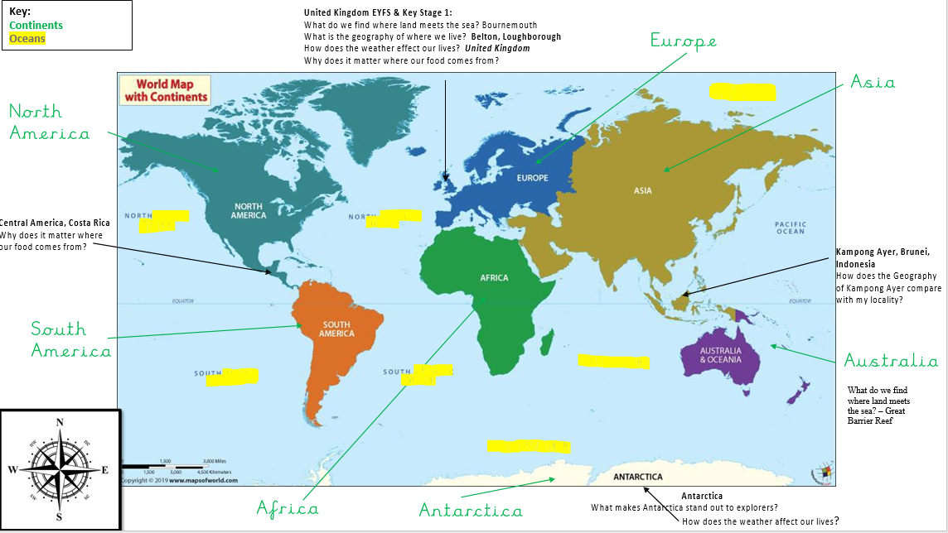

LKS2

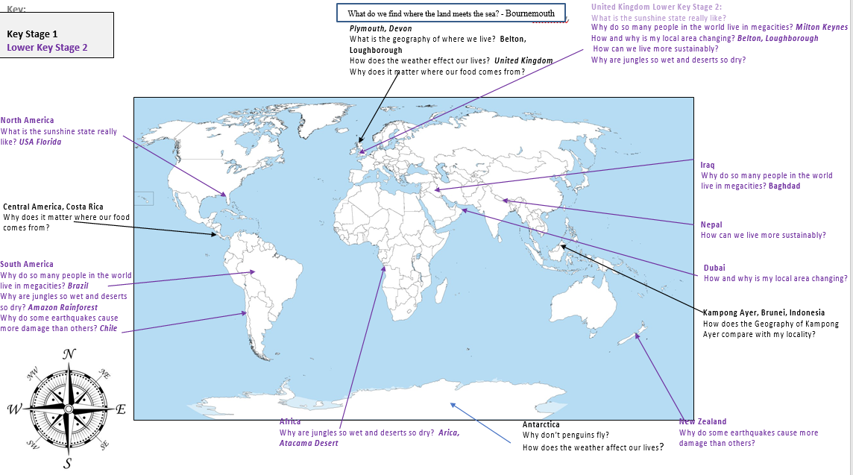

UKS2

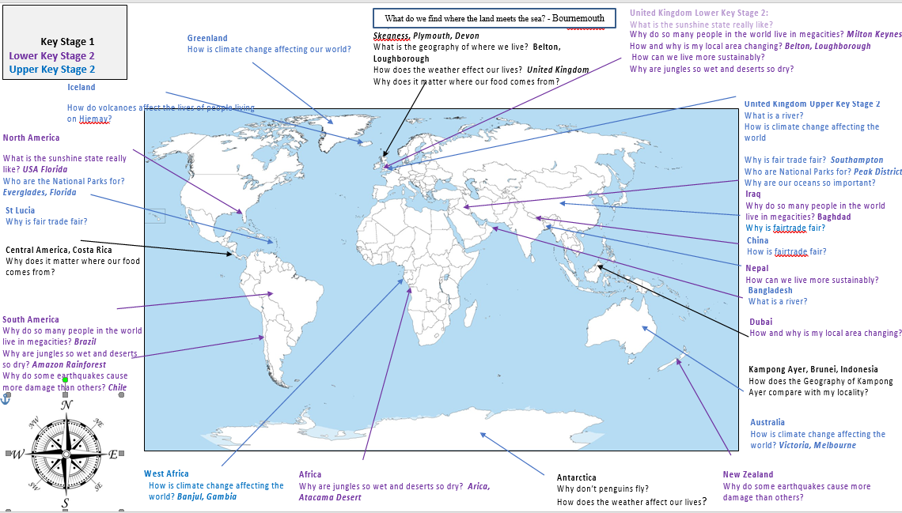



**Belton Church of England Primary School**

GEOGRAPHY Rolling Programme

EYFS

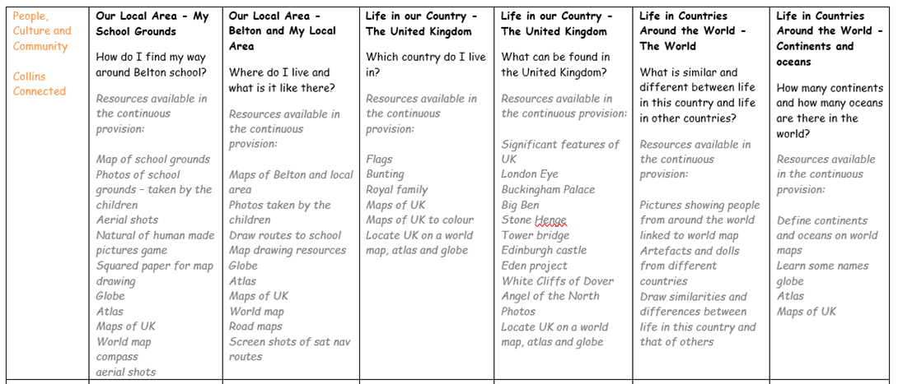

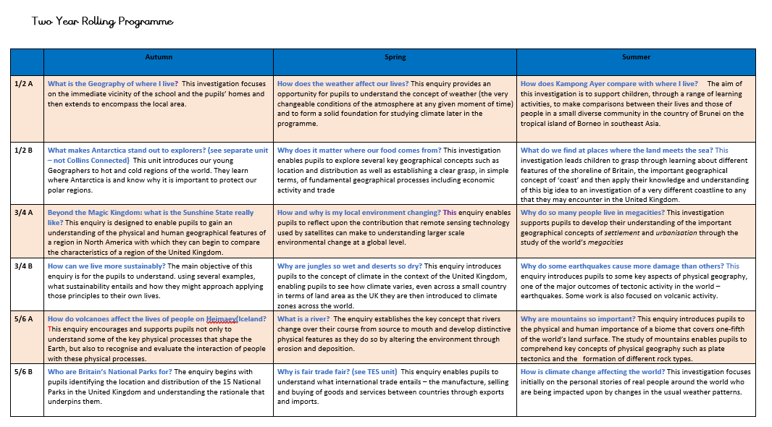

**Achieving the Best Together**

I have come that they may have life in all its fullness – John 10:10

**Achieving the Best Together**

**I have come that they may have life in all its fullness – John 10:10**

