# Maths Apps and Websites to help

**White Rose 1 minute maths (KS1)**

Please look at this resource that can be used for building your child’s mathematical ﬂuency. The App version is *free* to download on cell phones and tablets. It does not need a signup or login and can be used when oﬄine.

For mobiles and tablets

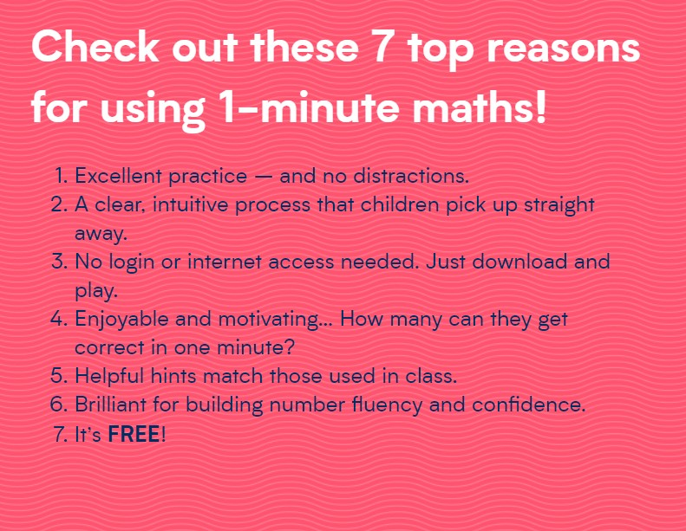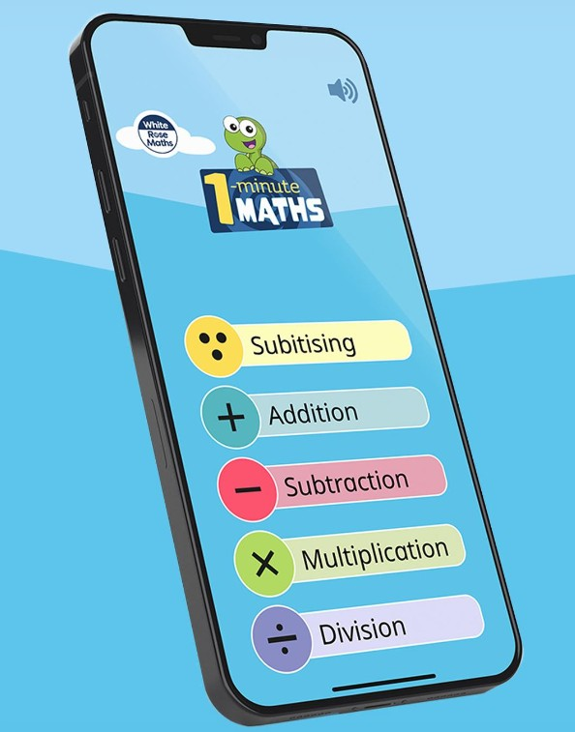

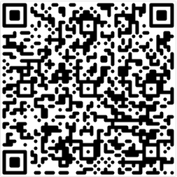

<https://play.google.com/store/apps/details?id=com.whiterosemaths.oneminutemathsks1&hl=en_US>

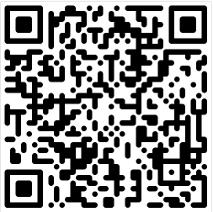

<https://apps.apple.com/br/app/1-minute-maths/id1584136366>

# Times Tables/ Numbots

# Your child has a log – in for this website. It is an expectation that all children do this as part of their homework. Please see your child’s teacher if your child can’t log-in.

# <https://ttrockstars.com/?lang=en>

# Numbots – KS1 + Year 3 – ensuring quick recall of number bonds.

# KS2 + Year 2 – TTRockstars for quick recall of tables

# 

[**https://www.mathswithamouse.co.uk/home**](https://www.mathswithamouse.co.uk/home)

**Videos to help with understanding of Maths concepts such as addition, division etc. Games to play for Times Tables. SATS revision site and arithmetic. All free.**





**To help with arithmetic. Upper Key Stage Two have a log-in for this.**



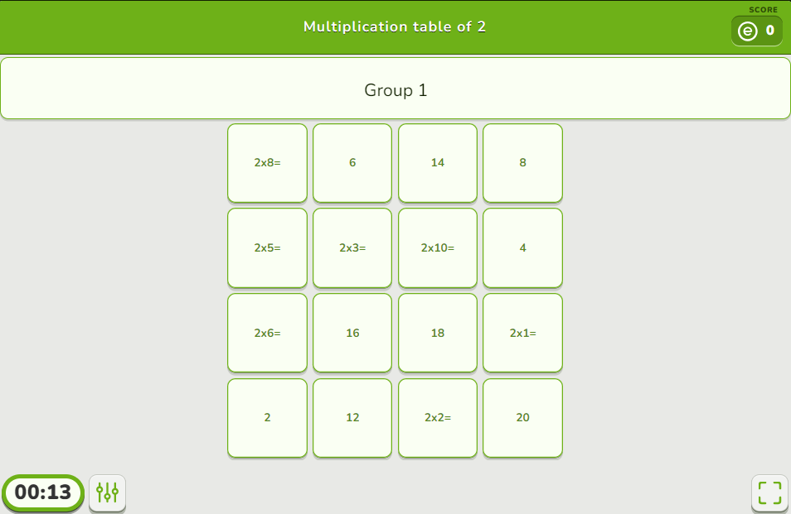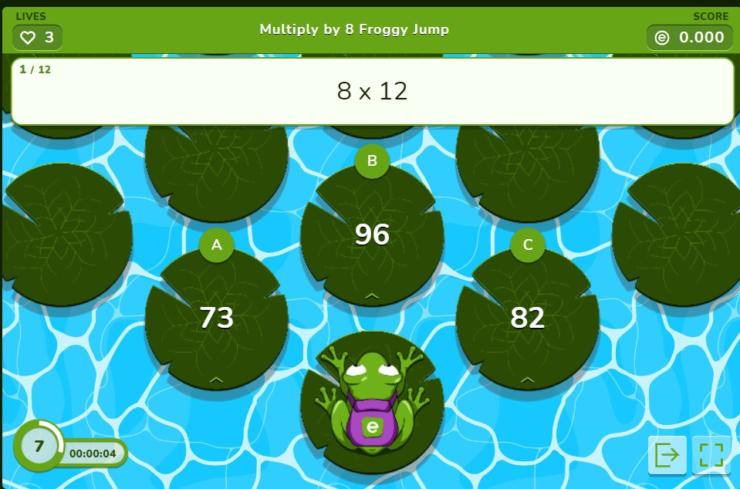

[**https://www.educaplay.com/learning-resources/?q=math&ageMax=12&areas=9**](https://www.educaplay.com/learning-resources/?q=math&ageMax=12&areas=9)



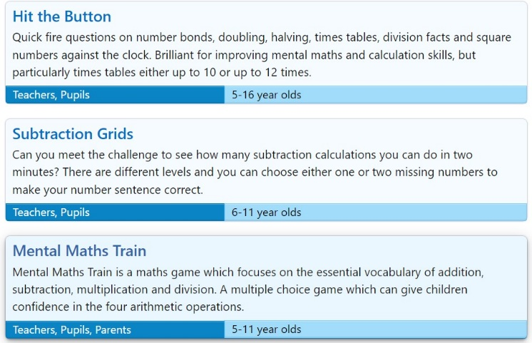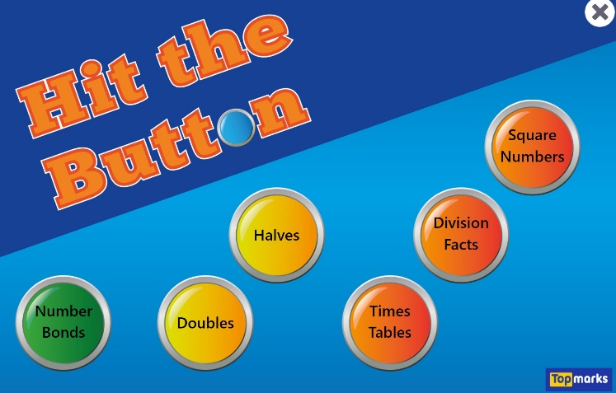

[**https://www.topmarks.co.uk/Search.aspx?Subject=16&AgeGroup=3**](https://www.topmarks.co.uk/Search.aspx?Subject=16&AgeGroup=3)



[**https://mathsframe.co.uk/en/resources/category/22/most-popular**](https://mathsframe.co.uk/en/resources/category/22/most-popular)

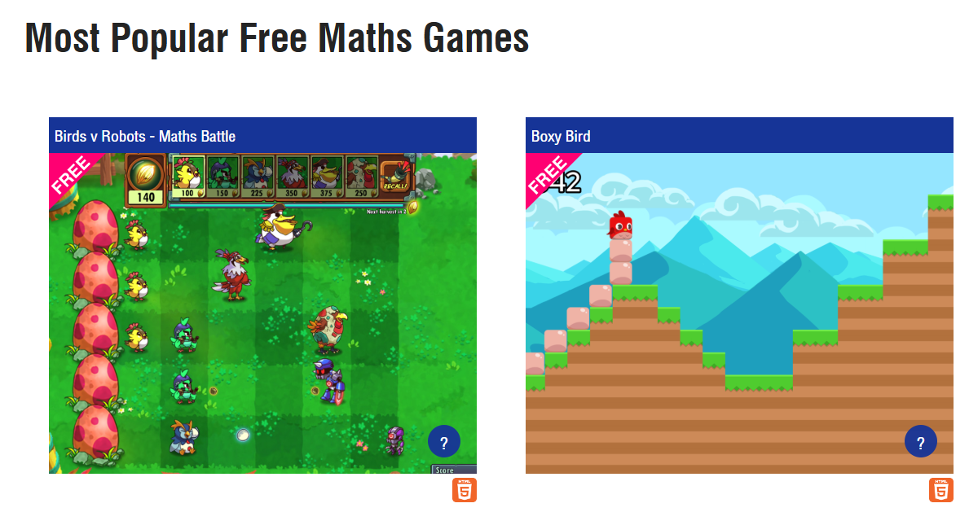

[**https://www.mathplayground.com/fraction_forest_part1.html**](https://www.mathplayground.com/fraction_forest_part1.html)

