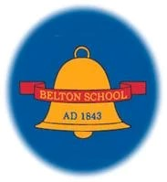

**Belton Church of England Primary School**

READING CURRICULUM STATEMENT

Achieving the Best Together

I have come that they may have life in all its fullness – John 10:10

# Curriculum Vision

# Intent

At Belton CE Primary School reading is one of our main priorities and our curriculum reflects a sharp focus upon early reading from the very start of school, as it is the ability to read and understand that opens up learning to children. We aim to provide all children with a high-quality education in English that will teach pupils to speak, read and write fluently so that they can communicate their ideas and emotions to others effectively.

All children will read widely across both fiction and non-fiction to develop their knowledge of themselves and the world in which they live, to establish an appreciation and love of reading, to gain knowledge across the curriculum and develop their comprehension skills. It is our intention to ensure that, by the end of their primary education, all pupils are able to read fluently, and with confidence, in any subject in their forthcoming secondary education.

At Belton CE Primary we use appropriate quality texts for children to read covering all genres. Books are book banded in order to ensure progression and challenge right through to the end of key stage 2. The children’s ability to recognise graphemes and common exception words and their ability to blend and segment are all assessed and tracked. Children are also assessed using PM Benchmarking to ensure they read appropriately challenging books. The children are also assessed termly using NFER papers.

# Implementation

At Belton CE Primary School children begin their reading journey by adopting our schools love of books and shared stories. In EYFS it is here learners are introduced to phonemes/sounds and graphemes/letters systematically. Through daily phonics sessions they also learn to develop and apply blending and segmenting skills for reading using *Twinkl Phonics*. This is also mirrored in Key Stage 1 with daily phonics sessions. All classes have Reading Records which are used to record how often children read to an adult in school and home. Focus children are heard read at least daily by an adult. Adults within the class support the children to choose appropriate text types for the children supported by the Bug Club scheme (see appendix 1). Children throughout school are given the opportunity to take home a book every day from our Bug Club reading scheme. Teachers allocate children with phonetically decodable books at the appropriate level for each child. Whole class guided reading sessions take place three times a week in EYFS and Key Stage 1 with a focus on vocabulary, sequencing and inference. In Key Stage 2 whole class guided reading sessions are taught daily using high quality texts from a range of genres (see rolling programme – Appendix 2). The skills taught in Key Stage 1 are built upon with a focus on vocabulary, retrieval and explanation, summarising and inference. A different reading skill is taught each day, while developing their pace, fluency, expression and general book talk.

# Impact

Children’s progress in phonics is continually reviewed through periodic phonic assessments and evidence from their reading and writing. Through these, teachers identify the graphemes that need to be addressed which then informs groupings. In June, the National Phonics Screening Check is undertaken to confirm that the children have learned to decode to an age appropriate standard and determines what level of provision they will require the following year. In Key Stage One and Key Stage Two, regular assessment of the children’s decoding and comprehension is undertaken through PM Benchmarking. Reading judgements are secured through the triangulation of test data, evidence from the pupil and the curriculum. Our test data comes from NFER, SATs and PM Benchmarking.

# SEN Statement

We believe that reading opens the door to learning and therefore it is vital that we as educators do everything we possibly can to ensure that EVERY child will learn to read. We are determined to teach every single child to read, regardless of their background, need or abilities.

By the time children leave Belton CE Primary they are able to read for enjoyment as well as understanding what they are reading so that they can have a successful life

How we support reading at Belton:

* Give children books that they can decode and build their confidence
* Expose children to higher lever texts through teacher voice to improve their comprehension and vocabulary
* Children have access to interventions and pre and post teaching
* The assessment of pupil’s phonics progress is sufficiently frequent and detailed to identify any pupil who is falling behind the programmes pace
* The lowest 20% from Years Reception – Year 2 have small group interventions
* All teachers and support staff are trained in Phonics and have ongoing training to ensure that they can adapt their teaching to children’s needs
* Progress for each child/group is what we focus on

# British Values

At Belton the reading curriculum is designed to embed core British values, including democracy, the rule of law, individual liberty, mutual respect, and tolerance of different faiths and beliefs. A democratic approach is encouraged through activities like voting for books to read as a class, giving students a voice in their learning and fostering an understanding of democratic processes. The curriculum includes a diverse selection of books that represent various cultures, religions, and perspectives, promoting mutual respect and tolerance. By reading stories from different backgrounds, students gain insights into the lives and experiences of others, fostering empathy and a broader worldview. The rule of law is reinforced through narratives that highlight the importance of rules and fairness, helping students understand the significance of laws in maintaining order and justice. Additionally, themes of individual liberty are explored by encouraging children to express their thoughts and opinions freely, within a respectful and safe environment. Overall, the primary reading curriculum aims to cultivate well-rounded individuals who appreciate diversity, understand democratic principles, and respect the rights and beliefs of others

# Storytime and Reading for Pleasure

Storytime is one of the most pleasurable parts of the school day. A time where everyone comes together, where the pace slows down, and the focus is on sharing a book together.

Making time, each day, to read to children is vital. It’s a time where we can share books that children would otherwise be unable to read themselves. Consequently, they experience plot lines and narrative structures more complex than the ones they’d find in their own books. And as written language tends to use vocabulary in more complex and creative ways than most oral language, reading aloud to children immerses them in rich vocabulary and complex grammatical structures. Storytime is also a space where they hear fluent and expressive reading that they can aspire to recreate. Furthermore, when we read aloud to children, the books we choose are more likely to explore themes, emotional literacy and ideas that young children are unlikely to meet in their graded and decodable texts alone. Each class also look forward to their weekly time slot in our well stocked school library where they are encouraged to sit and share a book with a friend.



**Belton Church of England Primary School**

READING PROGRESSION STATEMENT

Achieving the Best Together

I have come that they may have life in all its fullness – John 10:10

Reading Progression

**Reading Progression in EYFS:**

The EYFS framework is structured very differently to the national curriculum as it is organised across seven areas of learning rather than subject areas.

This document demonstrates which early years outcomes are prerequisite skills for reading within the national curriculum. The table below outlines the most relevant early years outcomes from 3-4 year olds, Reception to ELG brought together from different areas of the Early Years Foundation Stage to match the programme of study for reading.

The most relevant early years outcomes for reading are taken from the following areas of learning

* Communication and Language
* Literacy
* Expressive Arts and Design

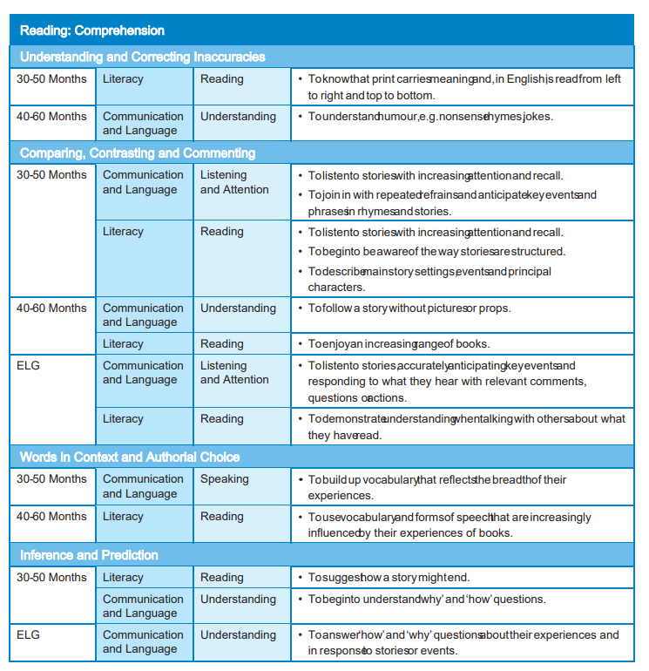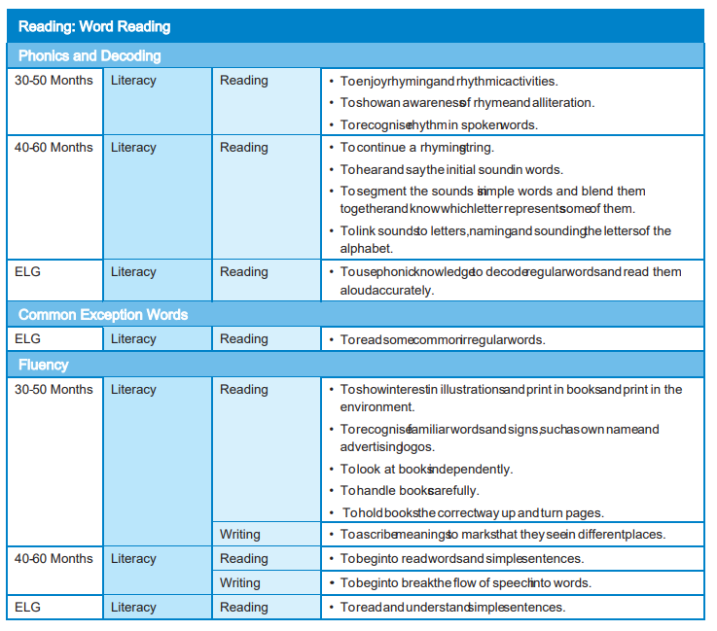

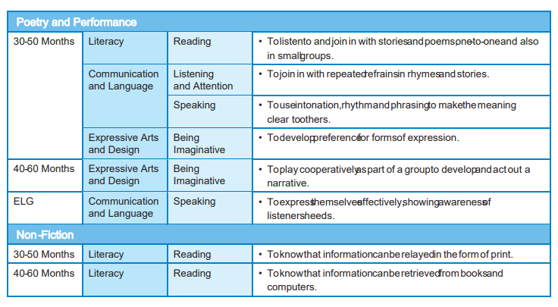

**Reading Progression in Key Stage 1 and Key Stage 2**

**Reading Progression - Retrieval**

**(Bold objectives/grey boxes = key indicators for National Curriculum for year group)**

|  |  |  |  |  |  |  |
| --- | --- | --- | --- | --- | --- | --- |
| Skills for  Retrieval | Year 1 | Year 2 | Year 3 | Year 4 | Year 5 | Year 6 |
| National curriculum statements | Becoming very familiar with key stories and retelling them explain clearly their understanding of what is read to them | Becoming increasingly familiar with and retelling a wider range stories answering and asking questions  Discussing the sequence of events in books and how items of information are related | Increasing their familiarity with a wide range of books and retelling some of these orally  Asking questions to improve their understanding of a text Identifying main ideas drawn from more than one paragraph and Summarising these  Retrieve and record information from non-fiction | | Asking questions to improve their understanding  Summarising the main ideas drawn from more than one paragraph, identifying key details to support the main ideas  Retrieve, record and present information from non- fiction | |
| *Range of texts/genres* | *Age appropriate texts: Reading for themselves key stories, fairy stories and traditional tales*  *Listening to a wide range of poems, stories and non-fiction at a level beyond that at which they can read independently* | *Age appropriate texts: Reading for themselves a wider range of stories, fairy stories and traditional tales Listening to a wide range of contemporary and classic poetry stories and non-fiction at a level beyond that at which they can read independently* | *Age appropriate texts:*  *Reading for themselves a wide range of books, including fairy stories, myths and legends*  *listening to a wide range of fiction, poetry, plays, non-fiction and reference books or textbooks*  *Reading books that are structured in different ways and reading for a range of purposes* | | *Age appropriate texts:*  *Reading for themselves an increasingly wide range of fiction, poetry, plays, non-fiction and reference books or textbooks reading books that are structured in different ways and reading for a range of purposes*  *a wide range of books, including myths, legends and traditional stories, modern fiction, fiction from our literary heritage, and books from other cultures and traditions* | |
| Retelling | * Retell story read or heard, parts of a story using props e.g. puppets/ small world/   series of pictures | * Orally retelling a wider range of stories using actions and visual cues from the story | * Retell a wide range of stories orally using actions and visual cues | * Retell a wide range texts orally which is balanced and clear | See Summarising and sequencing boxes | |
| Sequencing | * Sequence pictures for the beginning, middle and end of a story read | * Sequence events from a story, explaining reasons for choices | * Sequence pictures or texts from a story or non-fiction text read justifying reasons for choices | * Show understanding of the text by sequencing a selection of unknown text so that they make sense as a whole, justifying reasons for choices | * Sequence sections/ outlines of unknown texts based upon knowledge of genre features | * Manipulate sections of stories to create and explore more complex narratives e.g. dual narration, flash back |
| Answering find it questions | * Answer simple questions about characters, setting and key events in a story | * Answer questions about characters, setting/s and key events * Answer find it questions about key information in a non-fiction text | * Find and select the word/s in a section of a text to answer find it questions | * Find and select words and phrases to answer find it questions from different sections of unknown texts | * Find and select words and phrases from across a whole text to answer find it questions | * Find, select and combine relevant words and phrases from more than one text/source to support answers to find   it questions |
| Summarising and note  making | * Identify and discuss the setting and names of the characters in a story | * Explain and discuss the key information from what is seen or read | * Summarise orally and in writing the main points from a paragraph using | * Summarise orally and in writing the main points from several paragraphs | * Identify the main ideas from several paragraphs and provide key | * Identify the main idea from across several paragraphs or sections |

|  |  |  |  |  |  |  |
| --- | --- | --- | --- | --- | --- | --- |
| Skills for  Retrieval | Year 1 | Year 2 | Year 3 | Year 4 | Year 5 | Year 6 |
|  |  | (link to sequencing). | a wider range of prompts | or sections of a text | additional information from a section of the text to support this | of the text and provide key additional information from the text to support this   * Summarise the themes or viewpoints for different texts |
| Recasting |  |  | * Produce an annotated story/visual map to represent a text that has been read | * Produce an annotated drawing/diagram to represent/summarise a section of a text (non- fiction) * Complete diagrams, tables and charts to summarise information | * Summarise in different ways including key information e.g. written summary, key words, pictures/ diagrams, charts and making notes for presentations | * Summarise in different ways for different audiences and purposes |
| Skimming and scanning |  | * Scan text to find given words and phrases | * Skim and scan to identify and use headings and sections in books (glossaries, indexes, contents) to retrieve information | * Scan different sections of unknown texts (fiction and non-fiction) to find missing information | * Scan different texts to find evidence to support answers to questions * Speed read or skim the text to gain the gist or main idea | * Appropriately select and apply skimming and scanning skills to a range of other texts across the curriculum   e.g. history and geography |
| Asking find it questions |  | * Ask relevant questions about a story or on- fiction text | * Generate find it questions for a section of fiction and non- fiction texts (which are relevant) | * Generate relevant find it questions from different sections of fiction and non-fiction texts | * Ask relevant find it questions which explore the detail of a text or which require comparison across fiction and non-fiction | * Generate find it questions relevant to different sections of a non-fiction text * Ask relevant find it questions about different sections of a   story read |
| Note making skills |  |  |  |  | * Retrieve and record information, producing a set of notes to support   a presentation | * Make notes for presentations to different audiences |
| Determining validity and importance |  |  |  |  | * Prior to reading, select from a range of texts/ sources of information with a key question or   heading in mind. | * Appraise a text quickly, deciding on its value, quality or usefulness |

**Reading Progression - Inference**

**(Bold objectives/grey boxes = key indicators for National Curriculum for year group)**

|  |  |  |  |  |  |  |
| --- | --- | --- | --- | --- | --- | --- |
| Skills for  inference | Year 1 | Year 2 | Year 3 | Year 4 | Year 5 | Year 6 |
| National curriculum statements | Explain clearly their understanding of what is read to them  Predicting what might happen on the basis of what has been read so far  Discussing the significance of the title and events, making inferences on the basis of what  is being said and done | Making inferences on the basis of what is being said and done  Answering and asking questions  Predicting what might happen on the basis of what has been read so far | Checking that the text makes sense to them, discussing their understanding and explaining the meaning of words in context Predicting what might happen from details stated and implied Drawing inferences such as inferring characters’ feelings, thoughts and motives from their actions, and justifying inferences with evidence  Asking questions to improve their understanding of a text | | Checking that the book makes sense to them, discussing their understanding and exploring the meaning of words in context Asking questions to improve their understanding  drawing inferences such as inferring characters’ feelings, thoughts and motives from their actions, and justifying inferences with evidence  Predicting what might happen from details stated and implied Distinguish between statements of fact and opinion  Provide reasoned justifications for their views | |
| *Range of texts/genres* | *Age appropriate texts: Reading for themselves key stories, fairy stories and traditional tales*  *Listening to a wide range of poems, stories and non-fiction at a level beyond that at which they can read independently* | *Age appropriate texts: Reading for themselves a wider range of stories, fairy stories and traditional tales Listening to a wide range of contemporary and classic poetry stories and non-fiction at a level beyond that at which they can read independently* | *Age appropriate texts:*  *Reading for themselves a wide range of books, including fairy stories, myths and legends*  *listening to a wide range of fiction, poetry, plays, non-fiction and reference books or textbooks*  *Reading books that are structured in different ways and reading for a range of purposes* | | *Age appropriate texts:*  *Reading for themselves an increasingly wide range of fiction, poetry, plays, non-fiction and reference books or textbooks reading books that are structured in different ways and reading for a range of purposes*  *a wide range of books, including myths, legends and traditional stories, modern fiction, fiction from our literary heritage, and books from other cultures and traditions* | |
| Predicting | * Predict whether a book will be story or non- fiction based upon the cover and title * Predict what might happen based on what has been read so far | * Make predictions prior to reading based upon the title, cover and skim reading of illustrations * Make predictions based upon events in the text so far * Make predictions using experience of reading books based on other familiar texts | * Make predictions prior to reading based upon the title, cover and skim reading of illustrations, contents page and headings * Make predictions based upon events and actions of characters so far in a story * Make predictions drawing upon knowledge from other texts * Make predictions based upon background knowledge of the topic | * Make predictions prior to reading about the likely type of characters or events in a story based upon the front cover, title, knowledge of the author and different genres of writing * Make plausible predictions based upon events and actions of characters so far in a story – identifying evidence in the text * Make predictions drawing upon knowledge from other   texts | * Make predictions about characters based upon reading so far – identifying a range of evidence within and beyond the text to support opinion * Categorise predictions as likely/unlikely based upon what has been read so far | * Make predictions about characters, plots and themes of stories based upon knowledge of fiction genres and other books by the same author * Make predictions using evidence stated and implied |
| Cause and |  | * Begin to describe (in book talk) cause and | * Identify the cause of an event | * Identify the multiple causes of an event | * Infer and comment on the possible causes of | * Infer, comment on and make links between the |

|  |  |  |  |  |  |  |
| --- | --- | --- | --- | --- | --- | --- |
| Skills for  inference | Year 1 | Year 2 | Year 3 | Year 4 | Year 5 | Year 6 |
| Effect |  | effect e.g. the effect a  character’s actions have on other characters. | * Infer an effect of a specific event or action | * Infer and comment on a range of possible effects of a specific event or action | events and actions   * Identify which causes are most/least likely based upon evidence in the text and beyond | cause and effects of events and actions   * Evaluate the impact of different causes and effects on people and   places |
| Identifying evidence to support and justify opinion | * Make links to personal experiences * Make inferences about character types based on actions E.g. infer stock character types (good/bad/evil /hero etc.) based upon their actions * Explain clearly what is read to them | * Draw upon personal experiences when commenting on a text * Draw upon knowledge of the topic outside of the book including other similar books * Make simple inferences about character feelings based upon their actions and speech | * Justify inferences with evidence * Infer characters’ feelings, thoughts and motives | * Justify inferences with evidence from within the text and experiences and/or reading beyond the text * Infer characters’ feelings, thoughts and motives from their actions at different points in a story | * Justify inferences backed by one type of textual evidence from across the text * Infer and explain how a character’s thoughts, feelings or motives have changed over the course of the text * Identify statements of fact and opinion. | * Justify inferences backed by a range of types of evidence from across the text * Infer and compare   different characters’ thoughts, feelings and motives at the same points in a story   * Distinguish between statements of fact and opinion using evidence   to justify. |
| Drama/ writing in role | * Explore characters through roleplay and drama | * Take on the role of a character e.g. speech bubbles, notes from one character to another or other drama techniques | * Explore characters’ actions and feelings through role play such as hot seating * Create short improvisations in role | * Explore characters’ actions, feelings and motives through role play such as hot seating * Demonstrate appropriate empathy through expression | * Explore contrasting characters’ feelings,   thoughts, actions and motives through role play such as hot seating   * Create improvisations in role e.g. creating a new   or alternative scenes | * Create improvisations in role e.g. for a different point in time to that in the text * Present ideas in role as an expert authority e.g. debate |
| Asking and answering inference questions |  | * Ask and answer simple relevant inference/ detective questions about a story or simple non-fiction text (no evidence needed) | * Ask and answer inference/ detective relevant questions about a story or non- fiction text which begins to develop character’s feelings and actions | * Ask and answer inference/ detective relevant questions about a story or non- fiction text which begins to develop character’s feelings, actions and motives | * Ask and answer relevant inference/ detective questions for a range of fiction and non-fiction texts * In discussion and role ask/answer relevant inferences/ detective questions about   characters’ feelings, actions, thoughts and motives | * Ask find it inference/ detective questions which explore the detail of a text or which require comparison across the text |

**Reading Progression - Text Structure**

**(Bold objectives/grey boxes = key indicators for National Curriculum for year group)**

|  |  |  |  |  |  |  |
| --- | --- | --- | --- | --- | --- | --- |
| Skills for Text  structure | Year 1 | Year 2 | Year 3 | Year 4 | Year 5 | Year 6 |
| National curriculum statements | Becoming very familiar with key stories, fairy stories  and traditional tales and considering their particular characteristics | Being introduced to non- fiction books that are structured in different ways | Recognising some different forms of poetry Retrieve and record information from non-fiction  Identifying how structure, and presentation contribute to meaning  Reading books that are structured in different ways and  reading for a range of purposes | | Reading books that are structured in different ways and reading for a range of purposes  Identifying and discussing conventions in and across a wide range of writing  Identifying how structure and presentation contribute to  meaning | |
| *Range of texts/genres* | *Age appropriate texts: Reading for themselves key stories, fairy stories and traditional tales*  *Listening to a wide range of poems, stories and non-fiction at a level beyond that at which they can read independently* | *Age appropriate texts: Reading for themselves a wider range of stories, fairy stories and traditional tales Listening to a wide range of contemporary and classic poetry stories and non-fiction at a level beyond that at which they can read independently* | *Age appropriate texts:*  *Reading for themselves a wide range of books, including fairy stories, myths and legends*  *listening to a wide range of fiction, poetry, plays, non-fiction and reference books or textbooks*  *Reading books that are structured in different ways and reading for a range of purposes* | | *Age appropriate texts:*  *Reading for themselves an increasingly wide range of fiction, poetry, plays, non-fiction and reference books or textbooks reading books that are structured in different ways and reading for a range of purposes*  *a wide range of books, including myths, legends and traditional stories, modern fiction, fiction from our literary heritage, and books from other cultures and traditions* | |
| Use and function of structural organisers | * Understand and use correctly, terms referring to conventions of print: book, cover, beginning, end, page, word, letter, line * Identify the title, blurb and author of a story or non-fiction book * Discuss the significance of the title | * Read non-fiction texts that are structured in different ways * Begin to identify and name a range of common organisers in non-fiction texts e.g. contents, headings, index, glossary | * Read fiction and non- fiction texts that are structured in different ways * Name and describe the function of a range of common organisers in non-fiction texts (Y2: contents, headings, index, glossary + Y3: sub- headings, diagrams) * Use a range of structural organisers (see previous bullet point) to retrieve information from non- fiction texts | * Read fiction and non- fiction texts that are structured in different ways * Name, use and describe the function of a wider range of common organisers in non-fiction texts (Y2/3: contents, headings, index, glossary, sub-headings, diagrams + Y4: captions and labels, bibliography) * Use a range of structural organisers (see previous bullet point) to retrieve information from non- fiction texts * Identifying how structure and presentation contribute to meaning (e.g. more independently and on   Y4 texts) | * Read fiction and non- fiction texts that are structured in different ways * Identify structural organisers and make comparisons within and across books * Explain why the author has chosen to structure/present the text in particular way or use a particular structural organiser | * Read fiction and non- fiction texts that are structured in different ways * Identify structural organisers and make comparisons within and across books * Discuss the effectiveness of different structures/ presentations of fiction and non-fiction |

|  |  |  |  |  |  |  |
| --- | --- | --- | --- | --- | --- | --- |
| Skills for Text  structure | Year 1 | Year 2 | Year 3 | Year 4 | Year 5 | Year 6 |
| Features of different text types | * Recognise some typical characters and settings of fairy stories and traditional tales (book work) * Understand the difference between fiction and non-fiction * Begin to describe the overall structure of a story e.g. being about to answer: “What is the problem in the story?” | * Recognise and describe some typical features, similarities and differences between fiction and non-fiction texts * Describe the overall structure of a story, e.g. including how the beginning introduces story and the ending concludes the action | * Recognise and name some different forms of poetry * Compare and contrast features of stories read   e.g. characters, settings, themes | * Recognise and describe the typical features of a wider range of forms of poetry * Recognise and describe some features of fiction genres * Refer to parts of stories, dramas, and poems when writing or speaking about a text, using terms such as chapter, scene, and stanza | * Identify, compare and contrast the features of a range of poetry, non- fiction and fiction genres | * Identify, compare and contrast the features of a range of fiction genres * Explain major differences between text types |
| Audience and purpose |  |  | * Begin to read for a range of purposes e.g. research, pleasure, locate specific information * Recognise the intended audience and purpose of some non-fiction genres | * Read for a range of purposes e.g. research, pleasure, locate specific information | * Read for a range of purposes e.g. research, pleasure, locate specific information, gain an overview | * Read for a range of purposes e.g. research, pleasure, locate specific information, gain an overview, compare and contrast |
| Supporting meaning |  |  | * Recognise that pictures/photographs can give as much information as the text * Describe how each successive parts of a text builds on the meaning of earlier sections | * Recognise and explain how presentational devices impact on reading and support meaning e.g. italics, bold, diagrams, bullet points * Explain how topic sentences (first sentence of section) help cue the reader into the content of   paragraphs | * Explain how a series of chapters, scenes, or stanzas fits together to provide the overall structure of a particular story, drama, or poem | * Use text structure to help summarise the text (linked to AF2) * Analyse how a particular sentence, chapter, scene, or stanza fits into the overall structure of a text and contributes to the development of the theme, setting, or plot |

**Reading Progression - Vocabulary**

**(Bold objectives/grey boxes = key indicators for National Curriculum for year group)**

|  |  |  |  |  |  |  |
| --- | --- | --- | --- | --- | --- | --- |
| Skills for  Vocabulary | Year 1 | Year 2 | Year 3 | Year 4 | Year 5 | Year 6 |
| National curriculum statements | Recognising and joining in with predictable phrases Discussing word meanings, linking new meanings to those already known | Discussing and clarifying the meanings of words, linking new meanings to known vocabulary  Discussing their favourite words and phrases Recognising simple recurring literary language in stories and poetry | Apply their growing knowledge of root words, prefixes and suffixes to understand the meaning of new words they meet Using dictionaries to check the meaning of words that they have read  Explaining the meaning of words in context  Discussing words and phrases that capture the reader’s interest and imagination  Identifying how language contributes to meaning  Checking that the book makes sense to them, discussing their understanding and exploring the meaning of words in context | | Apply their growing knowledge of root words, prefixes and suffixes (morphology and etymology), to understand the meaning of new words that they meet  Identifying how language contributes to meaning Asking questions to improve their understanding  Discuss and evaluate how authors use language, including figurative language, considering the impact on the reader Checking that the book makes sense to them, discussing their understanding and exploring the meaning of words in context | |
| *Range of texts/genres* | *Age appropriate texts: Reading for themselves key stories, fairy stories and traditional tales*  *Listening to a wide range of poems, stories and non-fiction at a level beyond that at which they can read independently* | *Age appropriate texts: Reading for themselves a wider range of stories, fairy stories and traditional tales Listening to a wide range of contemporary and classic poetry stories and non-fiction at a level beyond that at which they can read independently* | *Age appropriate texts:*  *Reading for themselves a wide range of books, including fairy stories, myths and legends*  *listening to a wide range of fiction, poetry, plays, non-fiction and reference books or textbooks*  *Reading books that are structured in different ways and reading for a range of purposes* | | *Age appropriate texts:*  *Reading for themselves an increasingly wide range of fiction, poetry, plays, non-fiction and reference books or textbooks reading books that are structured in different ways and reading for a range of purposes*  *a wide range of books, including myths, legends and traditional stories, modern fiction, fiction from our literary heritage, and books from other cultures and traditions* | |
| Identify vocabulary | * Recognise vocabulary associated with different genres provided by the teacher | * Recognise simple recurring literary language in stories and poems e.g. repetition | * Identify patterns in language e.g. repetition, rhyme, alliteration * Identify and generate words with similar meanings or linked to a   specific focus | * Identify and generate words with similar and opposite meanings | * Identify figurative language devices | * Identify words and phrases that create a particular mood, feeling or attitude including figurative language |
| Explain the meanings of words | * Discuss word meanings, linking new meanings to those already known | * Discuss and clarify the meanings of new words, linking new meanings to known vocabulary * Begin to use a range of skills (such as morphology and word classes) to identify the meaning of unknown   words to help place | * Apply their growing knowledge of root words, prefixes and suffixes to understand the meaning of new words they meet * Explain the meaning of words in given contexts * Begin to discuss language to extend their interest in the meaning | * Apply their growing knowledge of root words, prefixes and suffixes to understand the meaning of new words they meet * Explain the meaning of words in given contexts * Discuss language to extend their interest in the meaning and origin | * Apply their growing knowledge of grammar, morphology and etymology to understand the meaning of new words that they meet in context * Ask questions about vocabulary to improve   their understanding | * Apply their growing knowledge of grammar, morphology and etymology to understand the meaning of new words that they meet in context * Ask questions to help clarify their   understanding of |

|  |  |  |  |  |  |  |
| --- | --- | --- | --- | --- | --- | --- |
|  |  | them into context | and origin of words   * Begin to use dictionaries to check the meaning of words that they have read | of words   * Use dictionaries to check the meaning of words that they have read |  | vocabulary |
| Explain the intended impact of words and phrases on the reader | * Recognise and join in with predictable phrases | * Discuss their favourite words and phrases from the text | * Discuss words and phrases that capture the reader’s interest and imagination | * Discuss words and phrases that capture the reader’s interest and imagination giving reasons for their choices * Explain why the author has used a particular word or phrase | * Discuss how language contributes to the overall meaning * Discuss how authors use figurative language and the impact of these on the reader * Compare the impact of different language devices within a text | * Explain how words and phrases create a particular mood, feeling or attitude * Consider the impact on the reader of a range of vocabulary and language devices * Compare the impact of language devices across texts |
| Recognise and explain how language is linked to audience and purpose | * Capture and apply new vocabulary in writing | * Collect and apply new vocabulary in writing | * Begin to recognise key vocabulary and language features from different genres and apply to writing. | * Recognise key vocabulary and language features from different genres and apply to writing. | * Recognise language and vocabulary used by an author for a specific genre and compare to another author, considering impact on reader. | * Recognise and compare language and vocabulary features across different text types and between authors and consider impact on reader. * Suggest how language would need to change   for different audiences |

**Reading Progression - Compare and Contrast**

**(Bold objectives/grey boxes = key indicators for National Curriculum for year group)**

|  |  |  |  |  |  |  |
| --- | --- | --- | --- | --- | --- | --- |
| Skills for Compare and  Contrast | Year 1 | Year 2 | Year 3 | Year 4 | Year 5 | Year 6 |
| National curriculum statements | Being encouraged to link what they read or hear read to their own experiences | Discussing the sequence of events in books and how items of information are related Being introduced to non- fiction books that are structured in different ways | Identifying themes and conventions in a wide range of books Reading books that are structured in different ways and reading for a range of purposes | | Making comparisons within and across books  Reading books that are structured in different ways and reading for a range of purposes  Identifying and discussing themes and conventions in and across a wide range of writing (text types)  Non statutory - Pupils should be shown how to compare  characters, settings, themes and other aspects of what they read | |
| *Range of texts/genres* | *Age appropriate texts: Reading for themselves key stories, fairy stories and traditional tales*  *Listening to a wide range of poems, stories and non-fiction at a level beyond that at which they can read independently* | *Age appropriate texts: Reading for themselves a wider range of stories, fairy stories and traditional tales Listening to a wide range of contemporary and classic poetry stories and non-fiction at a level beyond that at which they can read independently* | *Age appropriate texts:*  *Reading for themselves a wide range of books, including fairy stories, myths and legends*  *listening to a wide range of fiction, poetry, plays, non-fiction and reference books or textbooks*  *Reading books that are structured in different ways and reading for a range of purposes* | | *Age appropriate texts:*  *Reading for themselves an increasingly wide range of fiction, poetry, plays, non-fiction and reference books or textbooks reading books that are structured in different ways and reading for a range of purposes*  *a wide range of books, including myths, legends and traditional stories, modern fiction, fiction from our literary heritage, and books from other cultures and tradition.* | |
| Identify, discuss and record similarities and differences | * Understand the difference between fiction and non-fiction | * Read non-fiction books which are structured in different ways * Identify and describe some differences between fiction and non- fiction books * Compare and contrast two or more versions of the same story e.g. two versions of the same story | * Compare and contrast features of stories read   e.g. characters, settings, openings, endings   * Compare and contrast two or more versions of the same story e.g. comparing a play script of a story to the narrative | * Compare and contrast character development in a play to characterisation in stories or narrative poetry * Compare and contrast information from different sources about the same topic, identifying similarities in content and structure * Compare and contrast the themes, settings, and plots of stories | * Identify, compare and contrast the features of a range of different forms of   + Poetry   + Non-fiction   + Fiction * Compare and contrast purpose and viewpoint and evaluate the usefulness of each source * Begin to compare and contrast authors’ styles | * Identify, compare and contrast the features of a range of fiction genres (e.g. contemporary v traditional) including poetry * Compare information, ideas, values and attitudes represented within and across texts * Analyse how an author develops and contrasts the points of view of different characters or narrators in a text * Compare and contrast authors’ style, purpose   and viewpoint. |
| Identify, compare and contrast | * Begin to identify similar and repeated language which occurs in more   than one story e.g once | * Compare and contrast language within a type of story read e.g.   traditional tales – one | * Compare and contrast language within a type of story read e.g. fairy tales   and plays | * Compare and contrast language across different types of stories read e.g.   fairy tales, myths and | * Compare the language of poetry, prose and non- fiction for the same theme   or information | * Compare and contrast different language within and across books |

|  |  |  |  |  |  |  |
| --- | --- | --- | --- | --- | --- | --- |
| Skills for Compare and  Contrast | Year 1 | Year 2 | Year 3 | Year 4 | Year 5 | Year 6 |
| vocabulary | upon a time | early morning/ once upon a time |  | legends and science fiction |  |  |
| Making links | * **Link reading to personal experiences** | * **Discuss the sequence of events in stories** * Discuss how items of information are related in a book * Make links between current and prior reading | * **Identify and compare themes of fictional stories** | * **Identify and compare themes in a wider range of fiction and non- fiction** | * **Compare how a common theme is presented in a range of texts** | * **Compare and contrast themes and topics in stories of the same genre e.g. mysteries and adventure stories** * Explain the relationship between characters, plot, setting, point of   view and theme |

**Reading Progression - Reviewing and Performing**

**(Bold objectives/grey boxes = key indicators for National Curriculum for year group)**

|  |  |  |  |  |  |  |
| --- | --- | --- | --- | --- | --- | --- |
| Skills for  Reviewing and Performing | Year 1 | Year 2 | Year 3 | Year 4 | Year 5 | Year 6 |
| National curriculum statements | Participate in discussion about what is read to them, taking turns and listening to what others say  Learning to appreciate rhymes and poems, and to recite some by heart  Listening to and discussing a wide range of poems, stories and non-fiction at a level beyond that at which they can read independently | Listening to, discussing and expressing views about a wide range of contemporary and classic poetry, stories and non- fiction at a level beyond that at which they can read independently  Answering and asking questions  Continuing to build up a repertoire of poems learnt by heart, appreciating these and reciting some, with appropriate intonation to make the meaning clear  Participate in discussion about books, poems & other works that are read to them & those that they can read for themselves, taking turns  and listening to what others | Listening to and discussing a wide range of fiction, poetry, plays, non-fiction and reference books or textbooks  Preparing poems and play scripts to read aloud and to perform, showing understanding through intonation, tone, volume and action  Participate in discussion about both books that are read to them and those they can read for themselves, taking turns and listening to what others say  Asking questions to improve their understanding of a text | | Learning a wider range of poetry by heart  Preparing poems and plays to read aloud and to perform, showing understanding through intonation, tone and volume so that the meaning is clear to an audience  Asking questions to improve their understanding  Recommending books that they have read to their peers, giving reasons for their choices  Participate in discussions about books, building on their own and others’ ideas and challenging views courteously  Explain and discuss their understanding of what they have read, including through formal presentations and debates, | |

|  |  |  |  |  |  |  |
| --- | --- | --- | --- | --- | --- | --- |
| Skills for Reviewing and  Performing | Year 1 | Year 2 | Year 3 | Year 4 | Year 5 | Year 6 |
|  |  | say  Explain and discuss their understanding of books, poems and other material, both those that they listen to and those that they read for  themselves |  | |  | |
| National Curriculum Statements - spoken language  (linked to reading) | Ask relevant questions to extend their understanding and knowledge Articulate and justify answers, arguments and opinions  Use spoken language to develop understanding through speculating, hypothesising, imagining and exploring ideas Participate in discussions, presentations, performances, role play/improvisations and debates  Consider and evaluate different viewpoints, attending to and building on the contributions of others | | | | | |
| *Range of texts/genres* | *Age appropriate texts: Reading for themselves key stories, fairy stories and traditional tales*  *Listening to a wide range of poems, stories and non-fiction at a level beyond that at which they can read independently* | *Age appropriate texts: Reading for themselves a wider range of stories, fairy stories and traditional tales Listening to a wide range of contemporary and classic poetry stories and non-fiction*  *at a level beyond that at which they can read independently* | *Age appropriate texts:*  *Reading for themselves a wide range of books, including fairy stories, myths and legends*  *listening to a wide range of fiction, poetry, plays, non-fiction and reference books or textbooks*  *Reading books that are structured in different ways and reading for a range of purposes* | | *Age appropriate texts:*  *Reading for themselves an increasingly wide range of fiction, poetry, plays, non-fiction and reference books or textbooks reading books that are structured in different ways and reading for a range of purposes*  *a wide range of books, including myths, legends and traditional stories, modern fiction, fiction from our literary heritage, and books from other cultures and tradition.* | |
| Discussing and debating | * Participate in discussion about what is read to them (stories, poems and non-fiction at a level beyond which they can read independently), * Take turns and listen to what others say | * Listen to, discuss and express views about a wide range of contemporary and classic poetry, stories and non-fiction at a level beyond that at which they can read independently * Participate in discussion about books, poems & other works that they can read for themselves, * Take turns and listen to what others say * Explain their understanding of books poems and other materials that they have read and which have   been read to them | * Discuss a range of fiction, poetry, plays, non-fiction and reference books or textbooks that they have read themselves and which have been read to them * Take turns, listen to what others say * Discuss specific events, characters or sections of a text * Discuss words and phrases which captures the readers interest and imagination | * Discuss a wide range of fiction, poetry, plays, non-fiction and reference books or textbooks that they have read themselves and which have been read to them * Take turns, listen to what others say and ask follow up questions to contributions made by others * Identify and discuss the purpose of a text and the intended impact on the reader * Identify and discuss the difference between fact and opinion * Discuss the impact | * Participate in discussions about books, building on their own   and others’ ideas   * Ask questions to clarify others’ opinions * Explain and discuss their understanding of what they have read * Provide reasoned justifications for their views * Identify and discuss themes and points of view within and across texts | * Participate in discussions about books, building on their own and others’ ideas * Challenge views courteously * Explain and discuss their understanding of what they have read through formal debates * Provide reasoned justifications and a wider range of evidence to support their views * Comment on the overall impact of a text on the reader |

|  |  |  |  |  |  |  |
| --- | --- | --- | --- | --- | --- | --- |
| Skills for Reviewing and  Performing | Year 1 | Year 2 | Year 3 | Year 4 | Year 5 | Year 6 |
|  |  |  |  | words and phrases which capture the readers interest and  imagination |  |  |
| Evaluating and Reviewing | * State whether they like a story or poem | * State whether they like a story and characters within the story * State which text they prefer and give a reason to support their opinion | * Write structured reviews of a text, stating which were their favourite parts and why | * Write structured reviews of a text, evaluating the overall text as well as reviewing specific elements | * Recommend to their peers orally and in writing books that they have read * Give reasons for recommendations * Write independent reviews of a text | * Recommend books that they have read to wider audiences e.g. on-line, local library * Write independent reviews and give reasons for specific   recommendations |
| Presenting and performing | * Recognise and join in with predictable phrases * Recite some poems and rhymes by heart * Retell key fairy stories and traditional tales verbally. | * Continue to build up a repertoire of poems learnt by heart, reciting some, with appropriate intonation to make the meaning clear * Retell a wider range of fairy stories and traditional tales verbally | * Prepare poems and play scripts to read aloud and to perform, showing understanding through volume and action | * Prepare poems and play scripts to read aloud and to perform, showing understanding through intonation, tone, volume and action | * Learn a range of poetry by heart * Prepare poems and plays to read aloud and to perform, showing understanding through intonation, tone and volume so that the meaning is clear to an audience * Explain their understanding by presenting some of their   ideas to others | * Learn a wider range of poetry by heart * Prepare poems and plays to read aloud and to perform, showing understanding through intonation, tone and volume so that the meaning is clear to an audience * Explain and discuss their understanding of what they have read through   formal presentations |

**Achieving the Best Together**

I have come that they may have life in all its fullness – John 10:10

