

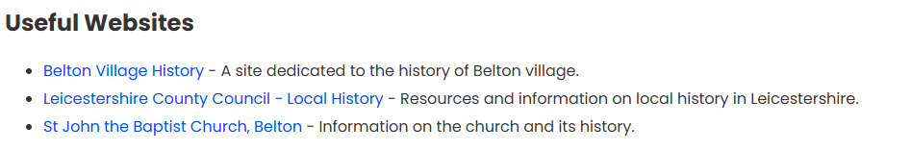

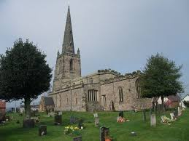

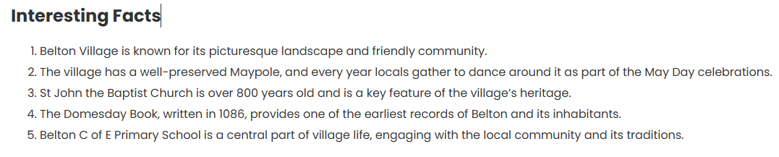

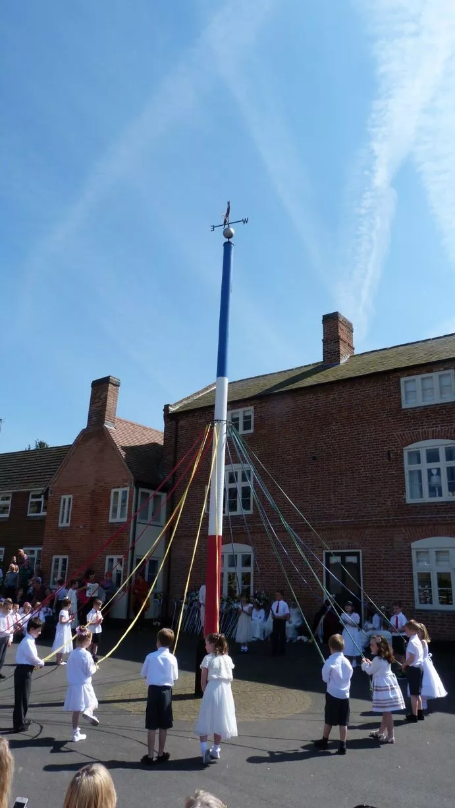

**Lesson sequence**

**Lesson1** – What was my school like a long time ago?

**Lesson 2** – How has Long Street changed over time?

**Lesson 3** – Which shops/buildings have disappeared from out the village?

**Lesson 4** – Why is the Maypole so important for our community?

**Lesson 5** – What can we learn from our local church?

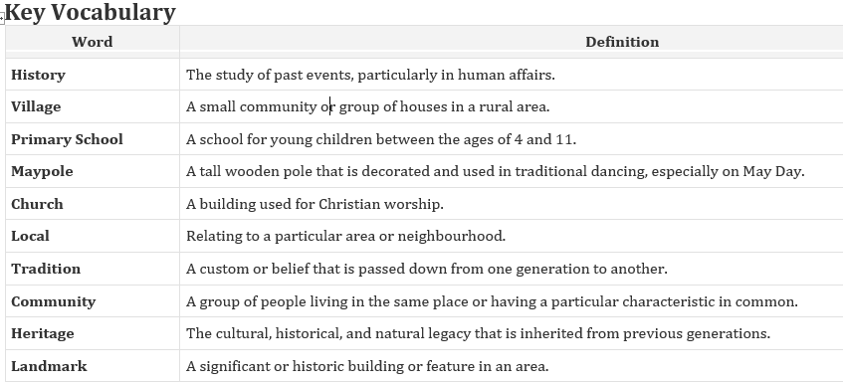

Foxes: History: Local History