As writers…

We are going to be reading the story of Freddie and his magic pebble, finding out where it transports him to and how he gets home. We will then be using our imaginations as we create our own home-away-home stories.

Following on from that we will be getting in the summer spirit by exploring postcards from the seaside.

As scientists…

We are focusing on Animals including Humans – life cycles. We will be thinking about how we have changed since we were babies and how we will continue to grow and develop. We will also be looking at the life cycles of chickens, butterflies and frogs.

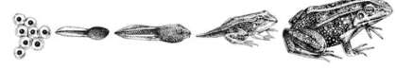

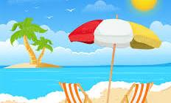

As mathematicians…

(Year 1)

This term we are going to be continuing with our work on addition and subtraction.

We will also be looking at multiplication and division, counting in 2’s,5’s, and 10’s. We will be grouping objects, making arrays, doubling and sharing.

We will then begin to explore fractions, focusing on halves and quarters.

(Year 2)

We will be recapping our work on addition and subtraction, making sure we have a good recall of our number facts.

We will then be looking a wide range of fractions, recognising, comparing equivalent fractions and understanding unit and non-unit fractions.

We will then be recapping our work with multiplication and division.

Fantastic Foxes

Summer 1

2024

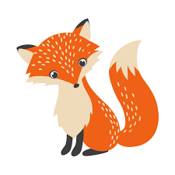

As unique individuals…

We will be developing our understanding of how we are similar yet different to others and how we can care for the needs of others. We will also look at how we care for animals.

We will also be thinking about how we belong to the school community and the rules we follow.

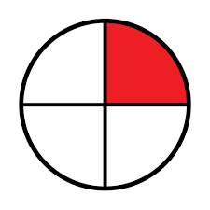



As people of faith…

We are going to be thinking about how Christians spread good news. We will look at the story of Matthew the Tax Collector and why Jesus chose him to become a disciple.

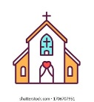

As musicians…

We will be exploring how we can use technology

to create music.







As geographers…

We will be developing our knowledge of the wider world, learning the names of the continents and the oceans. We will then be comparing Belton to Kampong Ayre in Brunei, looking at how their natural environment, transport, houses and schools compare.



As artists…

We are going to be working with clay, exploring how we can manipulate clay and create different effects. We will look at the work of Ranti Bam and use his ideas to create our own pinch pots. We will then be looking at the work of Rachel Whiteread and making our own clay tiles based on houses.

