# Belton C of E Pupil Premium Strategy Statement 2024-2025- 2027-2028 with review 2023-24 (3 years)



## This statement details our school’s use of pupil premium (and recovery premium for the 2023 to 2024 academic year) funding to help improve the attainment of our disadvantaged pupils.

## It outlines our pupil premium strategy, how we intend to spend the funding in this academic year and the effect that last year’s spending of pupil premium had within our school.

## School overview

|  |  |
| --- | --- |
| **Detail** | **Data** |
| School name | Belton C of E Primary |
| Number of pupils in school | 78 |
| Proportion (%) of pupil premium eligible pupils | 18% |
| Academic year/years that our current pupil premium strategy plan covers **(3 year plans are recommended)** | 2024/2025  2025/2026  2026/2027 |
| Date this statement was published | December 2024 |
| Date on which it will be reviewed | December 2025 |
| Statement authorised by | J Scott |
| Pupil premium lead | J Scott |
| Governor | D Boulton |

**Funding overview**

|  |  |
| --- | --- |
| **Detail** | **Amount** |
| Pupil premium funding allocation this academic year | £21030 |
| Recovery premium funding allocation this academic year | £0 |
| Pupil premium funding carried forward from previous years | £0 |
| **Total budget for this academic year**  If your school is an academy in a trust that pools this funding, state the amount available to your school this academic year | £21030 |
|  |  |

# Part A: Pupil premium strategy plan

## Statement of intent

|  |
| --- |
| At Belton Primary School we target the use of Pupil Premium Grant funding to ensure that our disadvantaged pupils receive the highest quality of education to enable them to become active, socially responsible citizens of the future. We recognise that disadvantaged children can face a wide range of barriers which may impact on their learning.  Our ultimate objectives are to:   * Remove barriers to learning created by poverty, family circumstance and background * Narrow the attainment gaps between disadvantaged pupils and their non-disadvantaged counterparts both within school and nationally * Ensure ALL pupils are able to read fluently and with good understanding to enable them to access the breadth of the curriculum * Develop confidence in their ability to communicate effectively in a wide range of contexts * Enable pupils to look after their social and emotional wellbeing and to develop resilience. * Access a wide range of opportunities to develop their knowledge and understanding of the world   Achieving our objectives: In order to achieve our objectives and overcome identified barriers to learning we will:   * Provide all teachers with high quality CPD to ensure that pupils access effective quality first teaching * Provide targeted intervention and support to quickly address identified gaps in learning including the use of small group work, 1:1 tuition * Target funding to ensure that all pupils have access to trips, residentials, first hand learning experiences. * Provide opportunities for all pupils to participate in enrichment activities including sport and music * Provide appropriate nurture support (ELSA) to enable pupils to access learning within and beyond the classroom.   This is not an exhaustive list and strategies will change and develop based on the needs of individuals.  Key Principles: We will ensure that effective teaching, learning and assessment meets the needs of all pupils through the rigorous analysis of data. Class teachers will identify through the class pupil premium plan, specific intervention and support for individual pupils which will be reviewed at least termly. Alongside academic support, we will ensure that those pupils who have social, emotional and mental health needs will access high quality provision from appropriately trained adults (eg. ELSA) |

## Challenges

This details the key challenges to achievement that we have identified among our disadvantaged pupils.

|  |  |
| --- | --- |
| **eligible** | **Detail of challenge** |
| 1 | **Social/ Emotional/ Mental Health needs**  SEMH issues (eg Attachment and low self-esteem) for many of our pupils eligible for PP are having a detrimental effect on their learning and academic progress as they aren’t always ‘ready to learn’. |
| 2 | **Narrowing the attainment gap across Reading, Writing, Maths and Science**  Entry baseline in basic English and Maths; as well as poor oral skills. These are poorer in some PP students than others. This has slowed academic progress in subsequent years, especially reading.  Some of our PP children are also SEND (50%) including dyslexia  Their SEND complexities impact academic progress. |
| 3 | **Attendance**  Attendance for a small group of PP children is lower than 90 % |
| 4 | **Wider opportunities to participate in learning beyond the school day.**  A smaller number of PP eligible pupils have fewer opportunities to participate in learning beyond the school day. |

## Intended outcomes

This explains the outcomes we are aiming for **by the end of our current strategy plan**, and how we will measure whether they have been achieved.

|  |  |
| --- | --- |
| **Intended outcome** | **Success criteria** |
| Progress in Reading, Writing and Mathematics.  Disadvantaged pupils maintain at least the standard of achievement they achieved the previous year.  To ensure fallen behind children receive targeted high-quality intervention.  Children in need of dyslexia assessments to be given them and outcomes actioned | Achieve national average progress scores in KS2 Reading/ Writing and Maths  Teacher Assessments (end of Summer 2027) will show that most of the disadvantaged children have made expected progress from the previous summer. 10 – 20% of disadvantaged children will have made accelerated progress.  Any dyslexia assessments recommendations to be in place  Analysis of Interventions will show that interventions have had positive impact on the disadvantage children’s learning and has helped with accelerating their progress.  White Rose and Dyslexia Gold show impact |
| Pupils and families with identified SEMH needs are well supported by school staff so that needs are removed or alleviated. | SENCO/ ELSA/ Headteacher identify and support families and children, working with them to alleviate barriers to learning.  Vulnerable disadvantaged children will have access to a trained ELSA who will provide support and alleviate barriers.  Melsa will be embedded into school life  Pupil and parent questionnaires will show that parents/ children of disadvantaged families feel supported and additional barriers alleviated where possible. |
| Improved attendance of pupils with attendance under 90% so they are in school ready to lead | Trends monitored, identified and acted upon.  Reduction in absence and % have an upward trend to 90%+  Good relationships between parents and attendance officer maintained. |
| Improved attitudes to learning and ‘ready to learn’ strategies  School will deliver an engaging, broad and varied curriculum | Positive comments on Pupil Voice  Pupil observation by class teacher  Children will be exposed to a wide range of social, cultural, enrichment and sporting experiences within the school day.  Teachers and support staff will plan a wide range of visits/ WOW experiences to inspire/ enhance learning and make it more memorable. |
| More opportunities to participate in ASC | Positive comments on Pupil Voice  All children to partake in at least one ASC  Children will be exposed to a wide range  of social, cultural, enrichment and sporting activities outside the school day that will enable SEMH. |

## Activity in this academic year

This details how we at Belton C of E Primary School intend to spend our pupil premium (and recovery premium funding) **this academic year** to address the challenges listed above.

### Teaching

Budgeted cost: £6120

|  |  |  |
| --- | --- | --- |
| **Activity** | **Evidence that supports this approach** | **Challenge number(s) addressed** |
| Targeted support staff Training on MELSA | We want to ensure that PP who have SEMH are supported successfully in order for them to be able to access their learning. | 1 |
| Working with Subject Leaders to improve/ enhance the teaching and learning within every subject. Triaging curriculum | <https://sandbox.educationendowmentfoundation.org.uk>  /education-evidence/teaching-learning-toolkit | 2 |
| Targeted Support | Quality first teaching with rapid intervention tailored to educational needs will be put in where necessary.  New interventions of Dyslexia Gold and White Rose are in their infancy. Impact is still to be measured.  These need to continue | 2 |

**Targeted academic support**

Budgeted cost: £ 9910

|  |  |  |
| --- | --- | --- |
| **Activity** | **Evidence that supports this approach** | **Challenge number(s) addressed** |
| Improved Maths and English core skills with Interventions to be monitored and evaluated by CT/ HT on a termly basis. | Some of the students need targeted support to catch up.  EEF Toolkit suggests that targeted support matched to pupils with particular needs can be effective.  PP children who have SEMH needs are supported successfully in order for them to be able to access their learning. | 2 |
| Split Maths class in Yr ½ with CT for QFT | Ensuring that all learners have the chance of QFT in a supportive environment.  Small groups have been known to benefit children with SEMH needs. | 1, 2 |
| Access to Oakfield resources and staff | Develop confidence in the classroom and with peers.  Build self-esteem.  Appropriate behaviours and strategies being learnt. | 1,2 |
| 1:1 LSA’s | To develop and implement strategies for confidence in classroom with peers.  Build self-esteem.  Appropriate behaviours and strategies being learnt. | 1, 2, 3 |
| Funding to cover forest School sessions – provide training and resources for forest schools teacher. | Forest school is proven to work for SEMH children, it encourages independent learning and pupils gain confidence and resilience.  <https://www.forestresearch.gov.uk/>  search/?s=forest+schools+report | 1,2,3,4 |

**Wider strategies**

Budgeted cost: £ 5000

|  |  |  |
| --- | --- | --- |
| **Activity** | **Evidence that supports this approach** | **Challenge number(s) addressed** |
| Trained ELSA time for all PP/ PP+ children if deemed necessary by HT and staff.  CPD for ELSA to ensure they are kept up to date with current developments. | Children continue to have emotional needs, and worries and fears well into secure placements often testing the security and boundaries around them.  Children seeing the positives in what they do will ensure that they are more confident within the classroom environment.  https://www.elsanetwork.org/wp-content/uploads/2017/11/Impact-of-ELSA-on-Children-in-Care-Spring-2018.pdf | 1 |
| Wide variety of ASC for children to access.  New playground equipment bought | If children’s attitudes to learning are poor due to confidence and resilience, if they have no inspiration/ aspiration to learn then it is a challenge to improve attainment.  If children have no interest in the clubs on offer, then they won’t attend.  Attitude is as important as ability as we want to inspire the children to want to learn and want to succeed. | 1,3,4 |
| Financial support on trips and visits and uniform. | Enable all pupils to access residential visits for outdoor and adventurous learning and team building.  Ensure no pupil is disadvantaged in terms of uniform, sports kit or equipment. | 1 ,3 |
| Social Skills groups and Circle of Friends intervention to support SEMH needs | Social skills groups are small groups (typically two to eight children) led by an adult who teaches the children how to interact appropriately with others their age. They can help children learn conversational, friendship, and problem-solving skills.  **Benefits**   * Children negotiating with others to achieve tasks. * Improve confidence and resilience * Positive relationships with children in their peer group. | 1,2,3 |
| Calm boxes, nurture areas and resources to support children to regulate themselves. | Nurture areas are consciously  planned and arranged: ‘’to create an educational experience that is rooted in feelings of emotional security’’ | 1 |
| Sensory circuits | We have found this as a good way to give children back a sense of routine so they are mentally and physically prepared for the day ahead. | 1 |
| Breakfast Club | To ensure that children start the day with a nutritional breakfast and allow a smooth transition into school. | 1,2,3 |
| Cool Milk | This will help with cognitive development and support their growth. | 1,2,3 |
| Equipment to use at home e.g. pencils | This will help children to be able to access study at home more easily | 1,2,3 |

**Total budgeted cost: £**21030

JSCOTT December 2024

# Part B: Review of outcomes in the previous academic year

## Pupil premium strategy outcomes

This details the impact that our pupil premium activity had on pupils in the 2023 to 2024 academic year.

|  |  |  |
| --- | --- | --- |
| **Activity** | **Evidence that supports this approach** | **Challenge number(s) addressed** |
| Staff training on challenging behaviour and attitudes to learning | PP pupils who are unable to take responsibility/ control of their behaviour will have access to learning. | 4 |
| Staff Training on Mental Health and Well-being.  Senior Leader for Mental Health training (grant)  Trauma training | We want to ensure that PP who have SEMH are supported successfully in order for them to be able to access their learning. | 1, 4 |
| Improved Oracy | All teachers will be trained in practices that provide opportunities for children to use and apply their Oracy skills and knowledge across the curriculum. | 3 |
| Working with Subject Leaders to improve/ enhance the teaching and learning within every subject. | <https://sandbox.educationendowmentfoundation.org.uk>  /education-evidence/teaching-learning-toolkit | 2, 4 |
| Targeted Support | Quality first teaching with rapid intervention tailored to educational needs will be put in where necessary. | 2 |

|  |  |  |  |  |
| --- | --- | --- | --- | --- |
| **Activity** | **Evidence that supports this approach** | **Challenge number(s) addressed** | **Impact** | **Lessons learnt**  **(and whether to continue with this approach)** |
| Staff training on challenging behaviour and attitudes to learning | PP pupils who are unable to take responsibility/ control of their behaviour will have access to learning. | 4 | The revised behaviour policy which combines restorative practice with consequences created in collaboration with all staff was introduced in Autumn 2024.  PP pupils understand the new process and improving behaviour is seen in all pupils.  Staff are challenging low level behaviour.  There has been a reduction of behaviour incidents recorded on CPOMS. | Revised Behaviour policy is working well and will continue with this approach.  Staff feel they are able to tackle low level behaviour.  Parents and pupils report that they feel confident low level behaviour is tackled quickly and less incidents reported. |
| Staff Training on Mental Health and Well-being.  Senior Leader for Mental Health training (grant)  Trauma training | We want to ensure that PP who have SEMH are supported successfully in order for them to be able to access their learning. | 1, 4 | SML in place with training implemented  Action plan in place and disseminated to staff  Trauma training for key adults implements | Action plan completed.  Senior Leader for Mental Health training to remain in place.  Refresh mental health and wellbeing training annually. |
| Improved Oracy – SIP and CDP priority | All teachers will be trained in practices that provide opportunities for children to use and apply their Oracy skills and knowledge across the curriculum. | 3 | Oracy opportunities are provided throughout the curriculum.  Tier 1 vocabulary is used.  Tier 2 and 3 vocabulary is planned for all subjects. | Oracy needs to be explicitly planned for in all subjects. |
| Working with Subject Leaders to improve/ enhance the teaching and learning within every subject. | <https://sandbox.educationendowmentfoundation.org.uk>  /education-evidence/teaching-learning-toolkit | 2, 4 | Staff have triaged most of the curriculum and in those subjects staff are clear about what they want children to know and remember. This has led to an improvement in teaching and learning.  Continuing to work with local collaborate through moderation, subject leader meets and CPD has strengthened subject leaders further | ongoing  Completion of the final triaging of foundation subjects required. |
| Targeted Support | Quality first teaching with rapid intervention tailored to educational needs will be put in where necessary. | 2 | Progression has been made and been tailored to specific needs.  Dyslexia Gold and White Rose intervention have been introduced in September 2024. | The new interventions need to continue and impact measured. |

|  |  |  |  |  |
| --- | --- | --- | --- | --- |
| **Activity** | **Evidence that supports this approach** | **Challenge number(s) addressed** | **Impact** | **Lessons learnt**  **(and whether to continue with this approach)** |
| Improved Maths and English core skills with a specialist Intervention Teacher/ CT  Interventions to be monitored and evaluated by CT/ HT on a termly basis. | Some of the students need targeted support to catch up.  EEF Toolkit suggests that targeted support matched to pupils with particular needs can be effective.  PP children who have SEMH needs are supported successfully in order for them to be able to access their learning. | 2,3 | PP children with SEMH needs have a secure and individualised timetable to meet their specific needs  Pupils made small step progress. | New interventions of Dyslexia Gold and White Rose are in their infancy. Impact is still to be measured.  These need to continue. |
| Split Maths class in Yr ½ with CT for QFT | Ensuring that all learners have the chance of QFT in a supportive environment.  Small groups have been known to benefit children with SEMH needs. | 1, 2, 3, 4 | In September 2024 the maths lead introduced mixed age white Rose planning across the school. At half term review leaders and teachers found that it was not meeting the needs of pupils in year 1 /2. This was changed back to single year group planning and additional teacher added to teach the other year group. | Continue to work with White Rose to feedback the impact of the mixed age planning. Mixed age planning was new this year and is in its infancy.  Mixed age planning is working in years 3 / 4 and 5/6 |
| Access to Oakfield resources and staff | Develop confidence in the classroom and with peers.  Build self-esteem.  Appropriate behaviours and strategies being learnt. | 1 | Self esteem has developed and there has been a reduction in negative behaviour | This approach and relationship needs to continue as the process evolves |
| 1:1 LSA’s | To develop and implement strategies for confidence in classroom with peers.  Build self-esteem.  Appropriate behaviours and strategies being learnt. | 1, 2, 3, 4 | Two LSA’s have recently attended MeLSA (Mediating Learning Support Assistant)  training.  MeLSAs are trained in how to help a child or young person become an independent learner. MeLSAs learn mediating learning skills to help them work with children and young people. | The training needs to be completed and impact measured. |
| Funding to cover forest School sessions – provide training and resources for forest schools teacher. | Forest school is proven to work for SEMH children, it encourages independent learning and pupils gain confidence and resilience.  <https://www.forestresearch.gov.uk/>  search/?s=forest+schools+report | 1, 4 | A new forest school lead has been in place since September 2024.  SEMH children are having the opportunity to be spiritual and creative. This improves mental health in the long term. | Approach needs to continue and continue to be embedded into Belton school life, reflecting the children in the school and the needed cultural capital |

## Externally provided programmes

*Please include the names of any non-DfE programmes that you purchased in the previous academic year. This will help the Department for Education identify which ones are popular in England*

|  |  |
| --- | --- |
| **Programme** | **Provider** |
| TTRS | TT Rockstars |
| Dyslexia Gold | Dyslexia Gold |
| White Rose intervention Program | White Rose Education |

## Service pupil premium funding (optional)

*For schools that receive this funding, you may wish to provide the following information:*

|  |  |
| --- | --- |
| **Measure** | **Details** |
| How did you spend your service pupil premium allocation last academic year? | N/A |
| What was the impact of that spending on service pupil premium eligible pupils? | N/A |

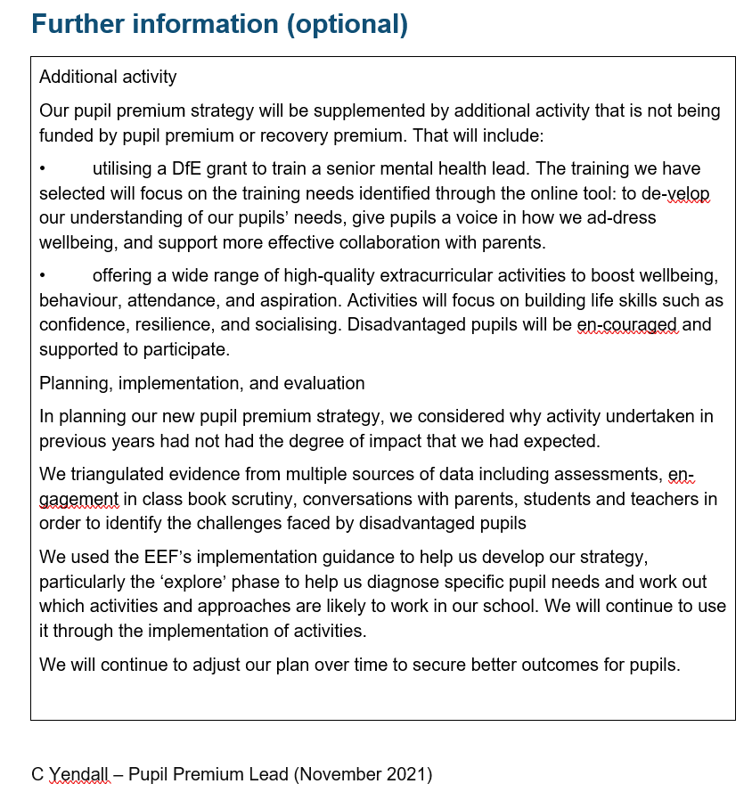

Reviewed December 2024 S Gray