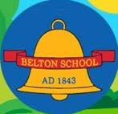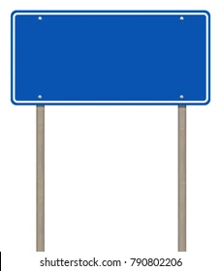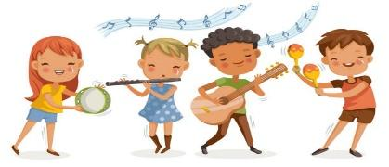

How does faith help people when life gets hard?

For Christians, what kind of king is Jesus?

What do Christians believe Jesus did to ‘save’ people?

U2 - How can following God bring freedom and justice.

Why do Christians believe Jesus was the Messiah?

Why do some people believe in God and some people not?

Why is the Torah so important to Jewish people?



Year 7

What does it mean to be Hindu in Britain today?

What do Christians learn from the Creation story?

What is the ‘Trinity’ and why is it important for Christians?



UKS2 (B)

What matters most to Humanists and Christians?

Creation and science: conflicting or complementary?

What does it mean to be a Muslim in Britain today?

What difference does the resurrection make to Christians.

Why do Hindus want to be good?

What does it mean if Christians believe God is holy and loving?

U2.4 Christians and how to live: ‘What would Jesus do?’

For Christians, when Jesus left, what was the impact of Pentecost?

What do Hindus believe God is like?

How and why do people mark the significant events of life?

How do festivals and family life show what matters to Jewish people?

What is it like for someone to follow God?

Why do Christians call the day Jesus died ‘Good Friday’?

How and why do people try to make the world a better place?

How do festivals and worship show what matters to a Muslim?

What makes some places sacred to believers?

What does it mean to belong to a faith community?

Who is a Muslim and how do they live?

How should we care for the world and for others, and why does it matter?

What is the ‘good news’ Christians believe Jesus brings?

Why does Easter matter to Christians?

Who is a Muslim and how do they live?

What do Christians believe God is like?

Who is Jewish and how do they live?

KS1 (A)

F6 What times/stories are special and why?

F5 What places are special and why?

F3 Why is Easter special to Christians? Christians?

Belton C of E Primary School: Road to Success

Religious Education – 2 Year plan

F2 Why is Christmas special for Christians?

EYFS

KS1 (B)

Who do Christians say made the world?

F4 Being special: where do we belong?

LKS2 (B)



LKS2 (A)



UKS2 (A)

Who is Jewish and how do they live?

Why does Christmas matter to Christians?

F1 Why is the word ‘God’ so important to Christians?

What kind of world did Jesus want?