PSHE Progression Map

Intent:

What do we intend children to learn?

At Belton C of E Primary School, our PSHE and RSE curriculum is part of our wider whole school approach to children’s personal development. It is important that our children develop the knowledge, skills, attitudes and understanding they need to fulfil their potential. Good relationships are fundamental to our ethos and our success in being a happy, caring and safe school. Relationships and Sex Education (RSE) is lifelong learning about relationships, emotions, looking after ourselves, different families, sex, sexuality and sexual health. We aim for the children in our school to acquire the appropriate knowledge, develop their skills and form positive beliefs, values and attitudes. RSE has a key part to play in the personal, social, moral and spiritual development of young people.

Implementation:

How do we teach PSHE / RSE?

At Belton C of E Primary School, we have chosen the Kapow Primary mixed-age scheme of work to teach our children the important skills required in Personal, Social and Health Education (PSHE) as well as Relationships Education, Relationships and Sex Education (RSE). The Kapow Primary scheme of work fulfils the statutory requirements for Relationships and Health Education set out by the Department for Education. It also fulfils the National Curriculum requirement to teach PSHE (‘All schools should make provision for personal, social, health and economic education ) and goes beyond the statutory requirements by referring to the PSHE Association Programme of Study (recommended by the Department for Education.)
We cover the government’s Education for a connected world -2020 edition through our RSE and PSHE scheme of work in conjunction with our Computing scheme of work.

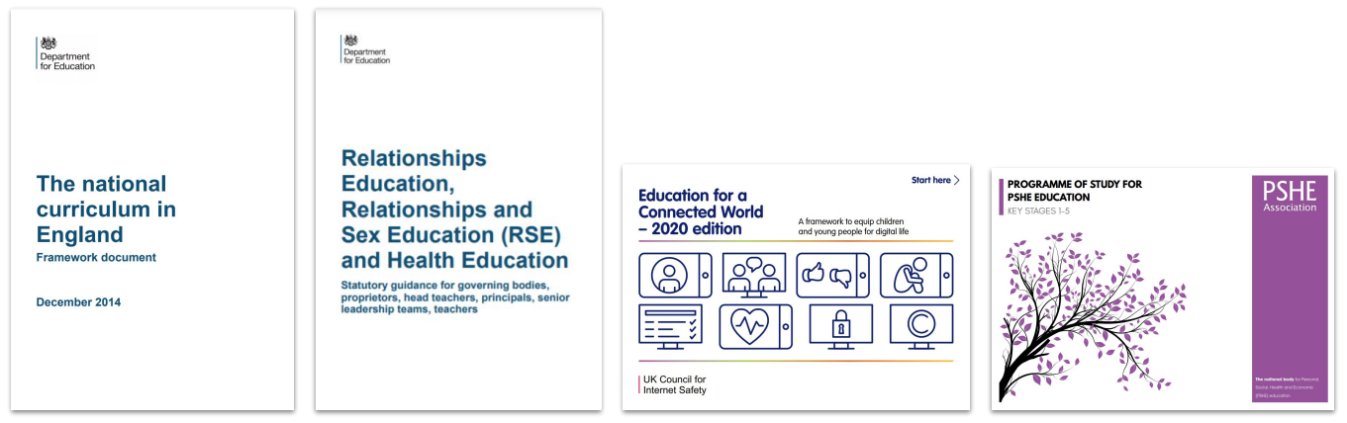

Our RSE and PSHE scheme of work is organised into six key areas.

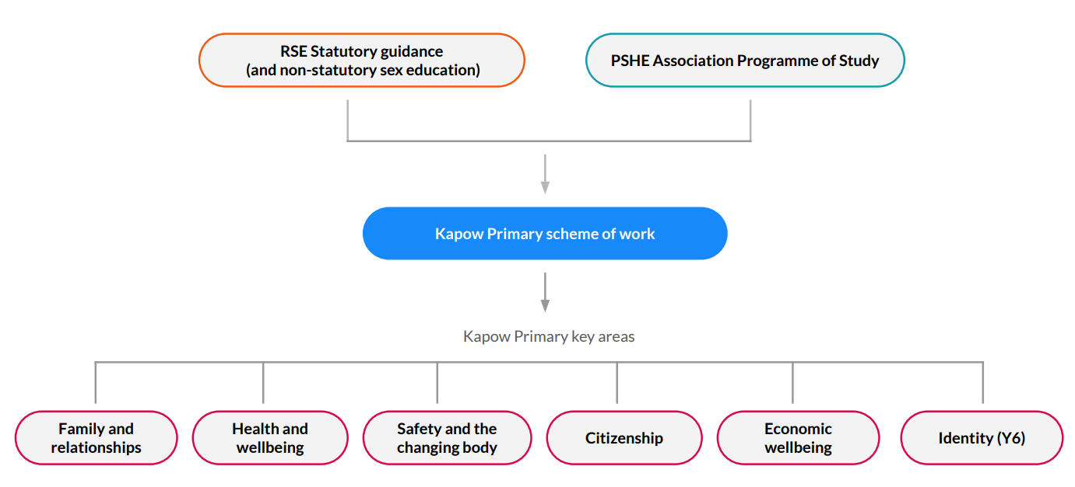
Five of the key areas are returned to each year, building on pupils’ prior and future learning. The key area of ‘Identity’ is taught in year six only.

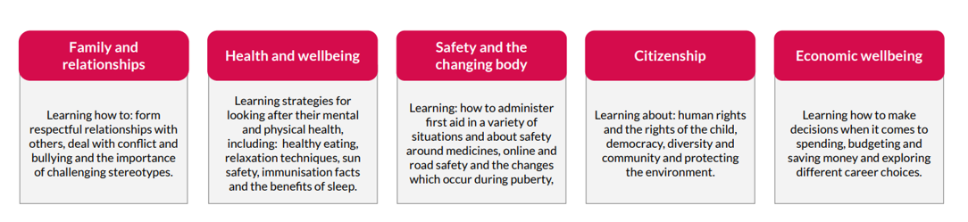
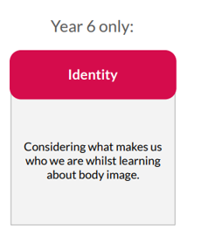

The RSE and PSHE curriculum is designed as a spiral curriculum which allows pupils to revisit the five key areas throught key stages 1 and 2. Depth in learning and maturity is increased each time a key area is revisited. Each time a key area is revisited, prior knowledge is utilised so pupils can build on previous foundations, rather than starting again.
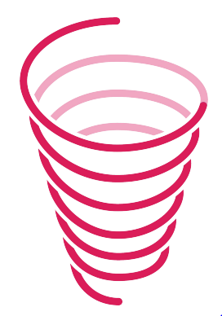

Sex Education

Sex education is not compulsory in primary schools, beyond what is laid out in the National Curriculum for Science:
● Year 1: Identify, name, draw and label the basic parts of the human body and say which part of the body is associated with each sense.
● Year 2: Notice that animals, including humans, have offspring which grow into adults
● Year 5: Describe the life process of reproduction in some plants and animals; describe the changes as humans develop to old age [They
should learn about the changes experienced in puberty.]

The RSE statutory guidance states that:
Where a maintained primary school chooses to teach aspects of sex education (which go beyond the national curriculum for science), the school must set this out in their policy and all schools should consult with parents on what is to be covered. Primary schools that choose to teach sex education must allow parents a right to withdraw their children. Unlike sex education in RSE at secondary, in primary schools, head teachers must comply with a parent’s wish to withdraw their child from sex education beyond the national curriculum for science.

At Belton C of E Primary school, our curriculum includes two Year 6 lessons which parents have the opportunity to withdraw their children from all/part of the lesson:
Safety and the changing body:
Lesson 5: Conception and Lesson 6: Pregnancy and birth.
We consult with parents about the content of these lessons prior to teaching them, to provide them time to consider the content
and to withdraw their child if they so wish.
Mixed-age Teaching
Our curriculum for years 1-6 is organised in a two year rolling cycle, with increased differentiation to help extend and support pupils with the wider ranging abilities that mixed age teaching brings. In some areas, though, we felt that it was important that pupils had the
opportunity to develop their understanding each year, rather than once in a two-year period, so the lessons have been written, with clear
guidance, activities, differentiation and assessment information for each year group. In these instances, teachers teach the same lesson each year, but pupils have a different experience in the lesson depending on whether they are the younger or older cohort. This means that even with a two-year cycle, you can be reassured that your pupils are progressing year-on-year as they develop in emotional
maturity.
Our EYFS curriculum is on a one year rolling cycle due to the nature of the single year group class.

 | Autumn 1 | Autumn 2 | Spring 1 | Spring 2 | Summer 1 | Summer 2
EYFS | Self-regulation: My Feelings  Identifying my feelings  feeling jars  coping strategies  Describing feelings  facial expressions  creating a calm corner | Building Relationships: Special Relationships  My family  Special People  Sharing  I am Unique  My interests  Similarities and differences | Managing self: Taking on challenges  Why do we have rules  Building towers  Team den building  Grounding  Team races  Circus skills | Self regulation: Listening and following instructions | Building relationships: My family and friends | Managing self: Happy head, happy heart

Year A | Autumn 1 | Autumn 2 | Spring 1 | Spring 2 | Summer 1 | Summer 2
Year 1 / 2 | Families and Relationships  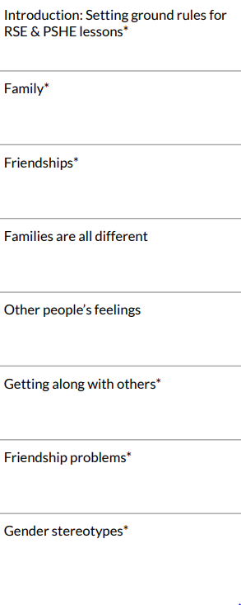 | Health and Wellbeing  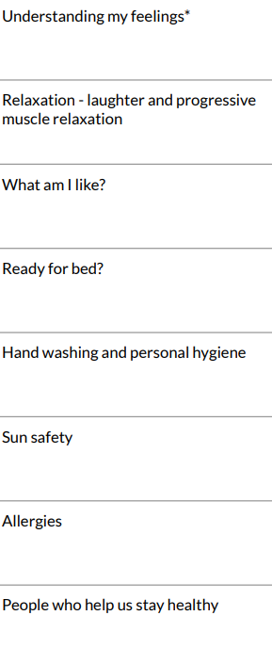 | Safety and the Changing Body  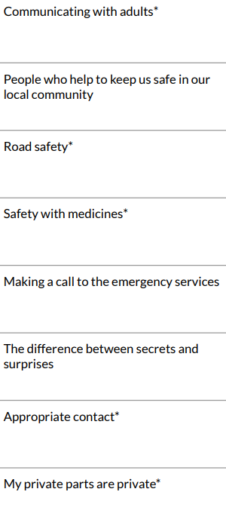 | Citizenship  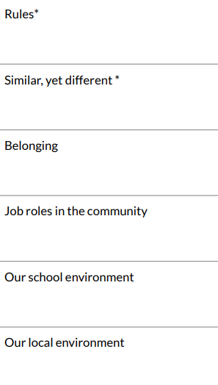 | Economic Wellbeing  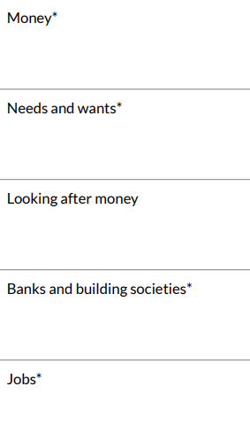 | Transition  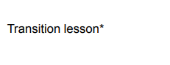
Year 3 / 4 | Families and Relationships  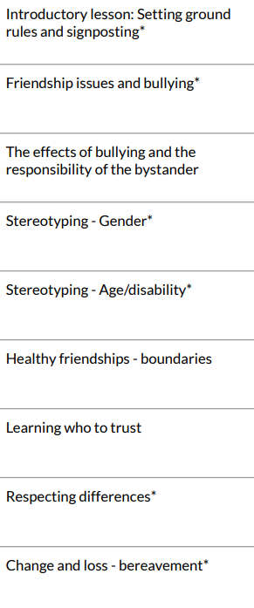 | Health and Wellbeing  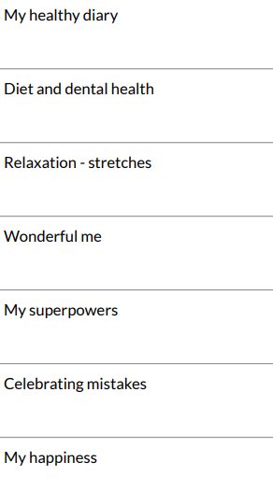 | Safety and the Changing Body  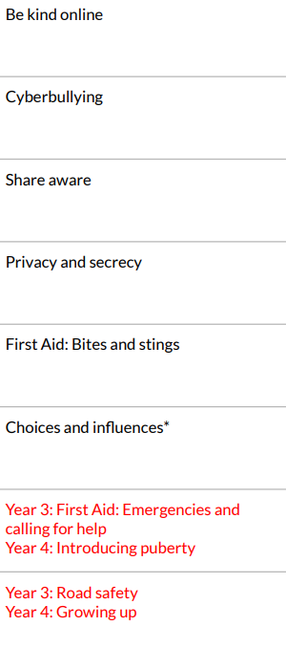 | Citizenship  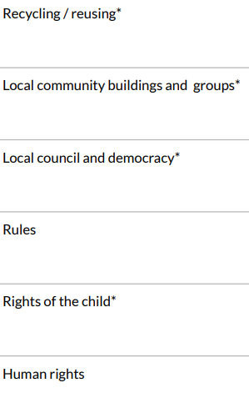 | Economic Wellbeing  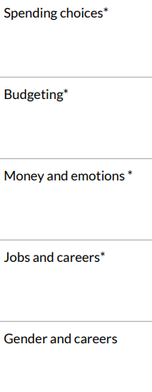 | Transition  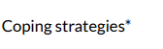
Year 5 / 6 | Families and Relationships  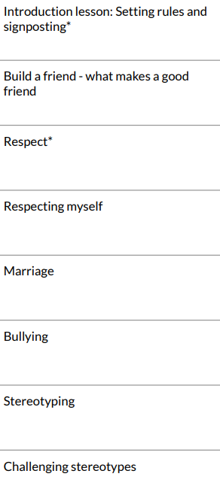 | Health and Wellbeing  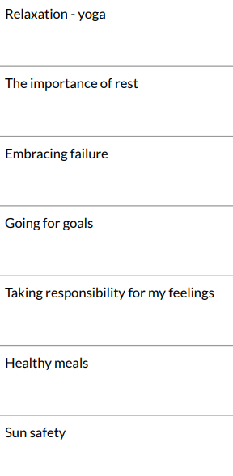 | Safety and the Changing Body  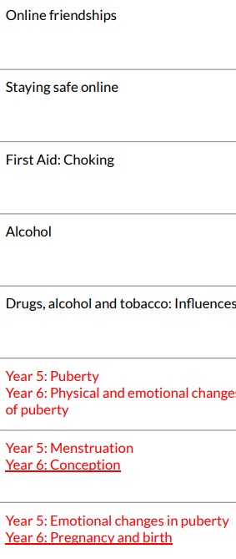 | Citizenship  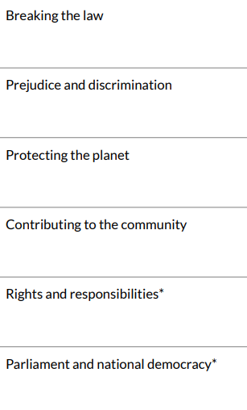 | Economic Wellbeing  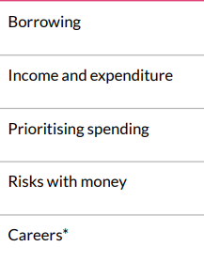 | Identity and Transition  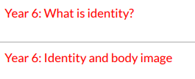  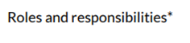

Year B | Autumn 1 | Autumn 2 | Spring 1 | Spring 2 | Summer 1 | Summer 2
Year 1 / 2 | Families and Relationships  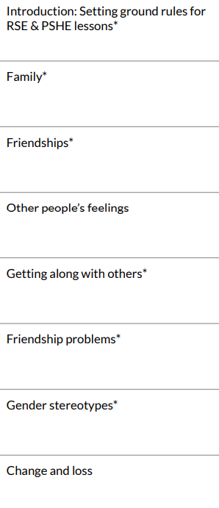 | Health and Wellbeing  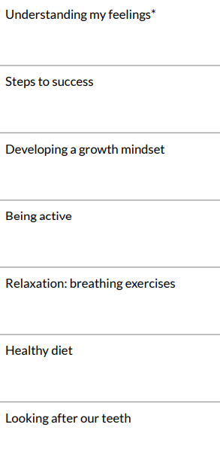 | Safety and the Changing Body  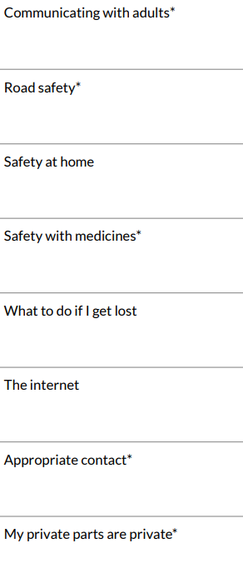 | Citizenship  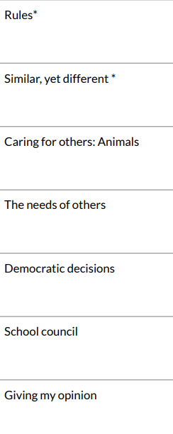 | Economic Wellbeing  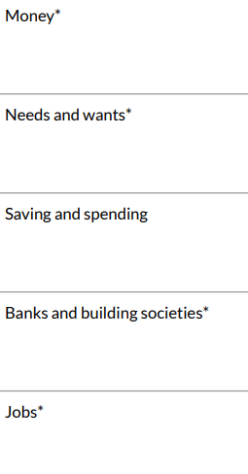 | Transition  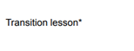
Year 3 / 4 | Families and Relationships  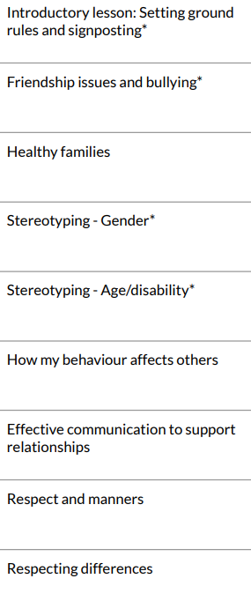 | Health and Wellbeing  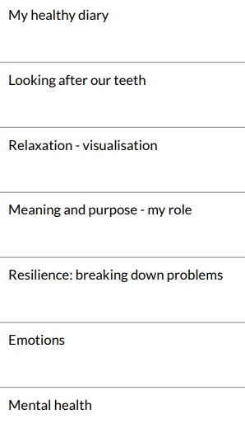 | Safety and the Changing Body  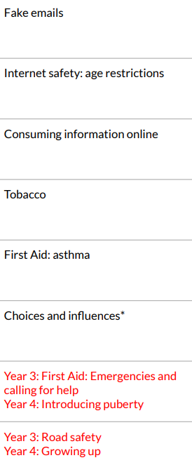 | Citizenship  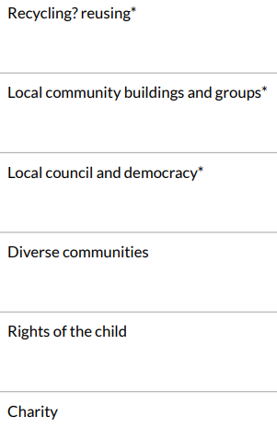 | Economic Wellbeing  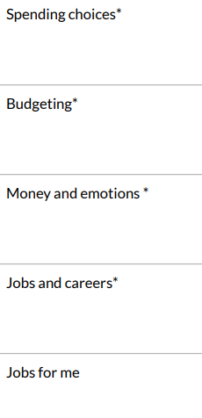 | Transition
Year 5 / 6 | Families and Relationships  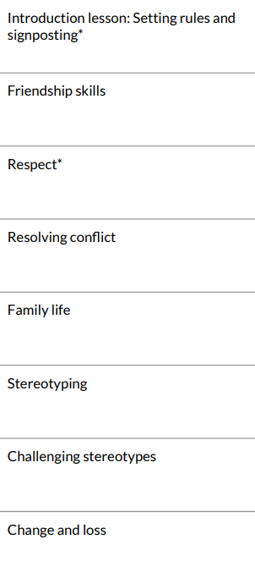 | Health and Wellbeing  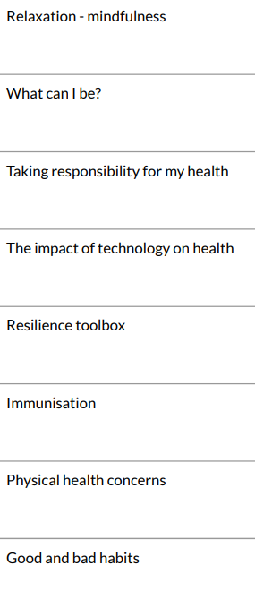 | Safety and the Changing Body  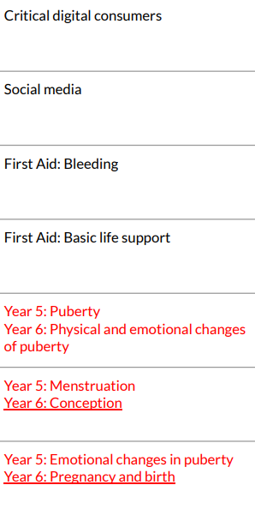 | Citizenship  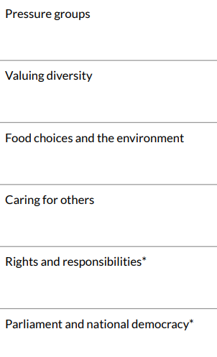 | Economic Wellbeing  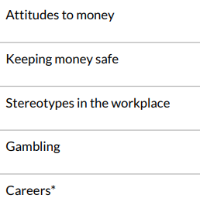 | Identity and Transition  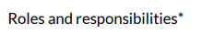

Progression of Knowledge and Skills
Our progression of skills shows the skills that are taught within each year group and how these skills develop year on year to ensure attainment targets are securely met by the end of each key stage.
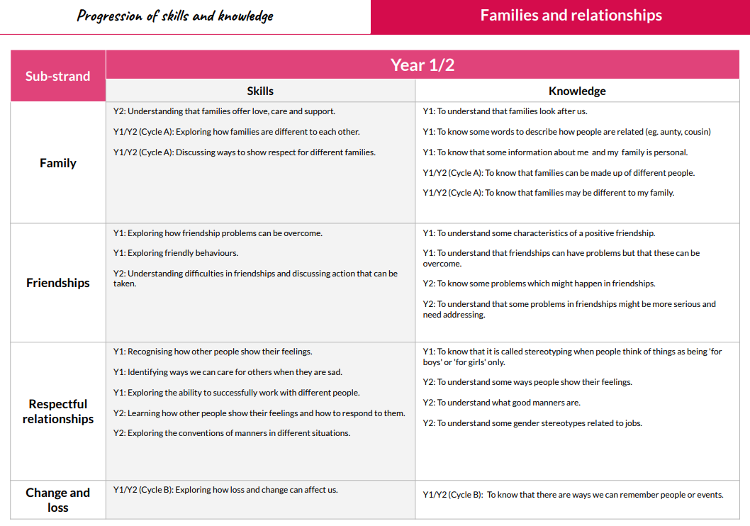

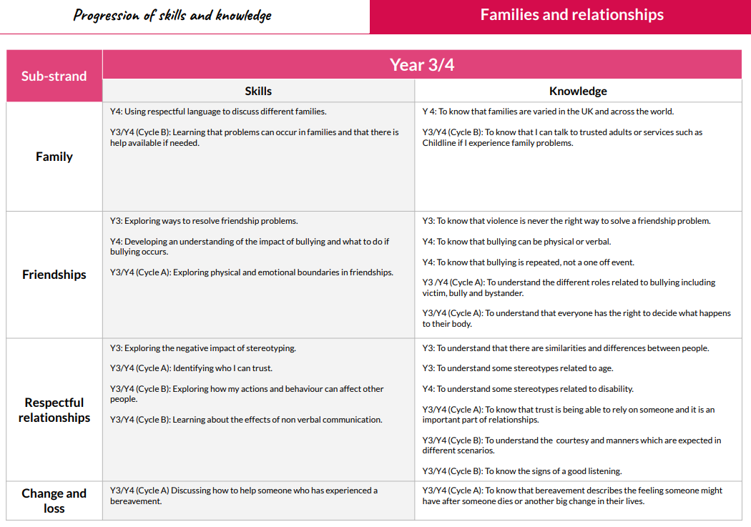

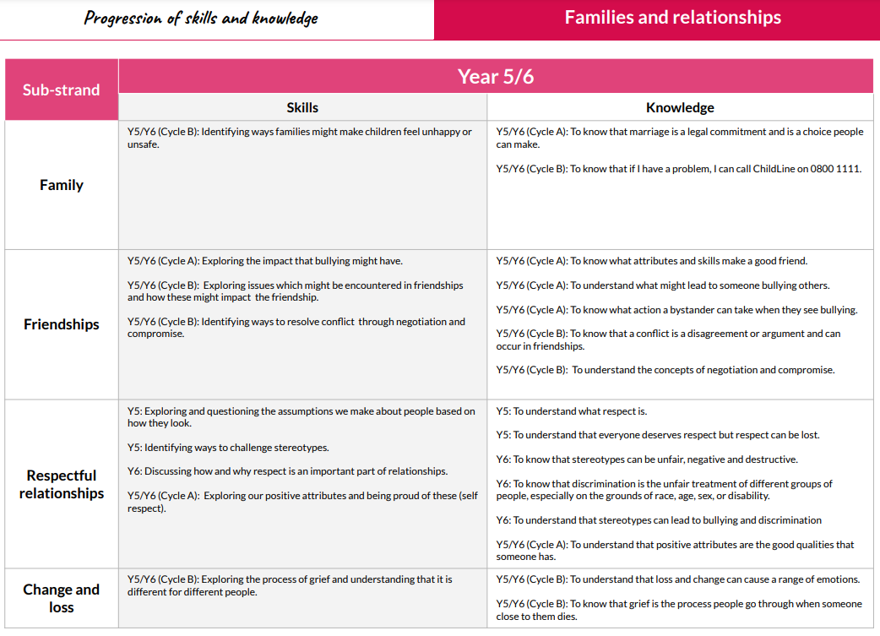
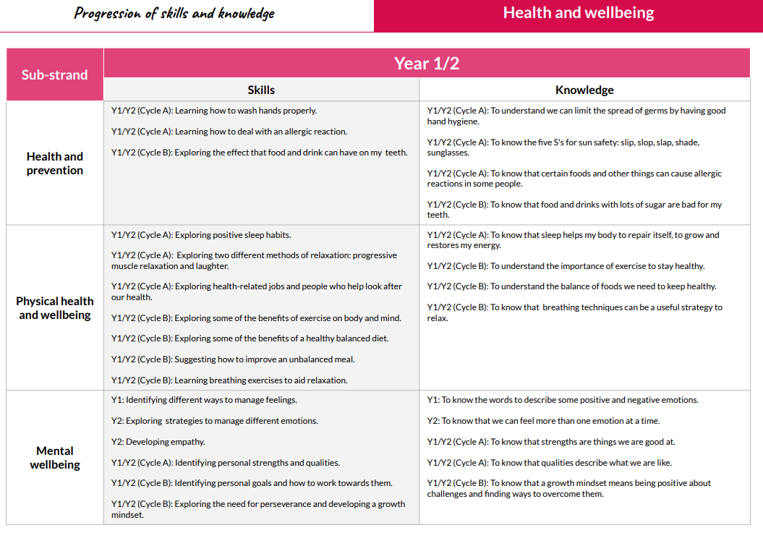

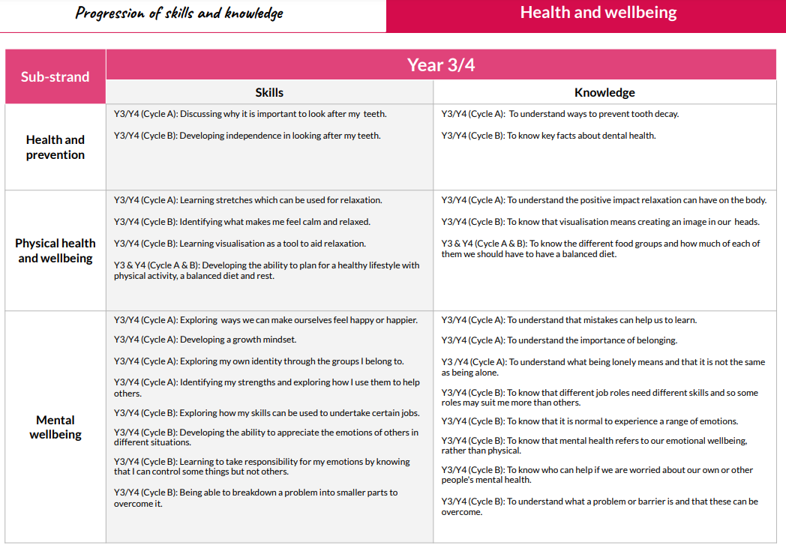

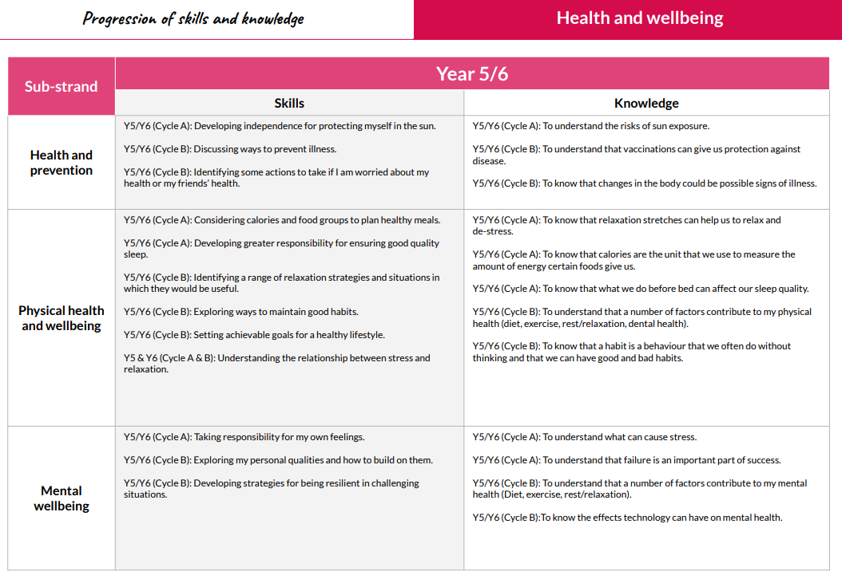

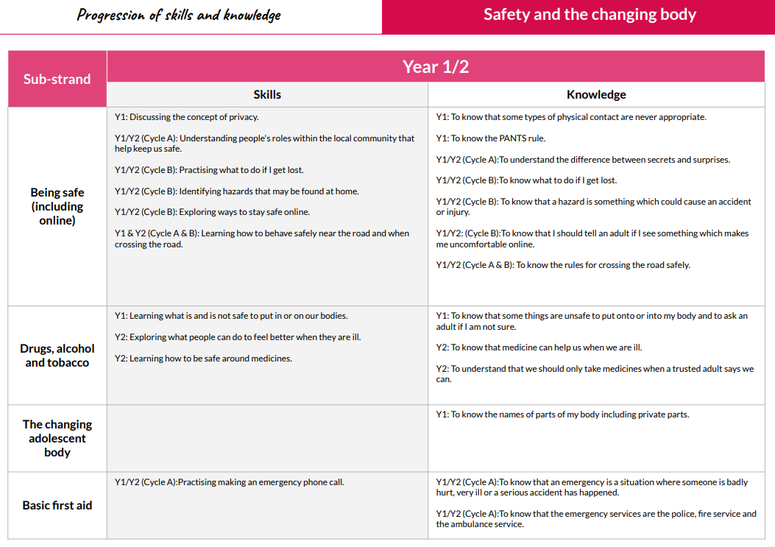

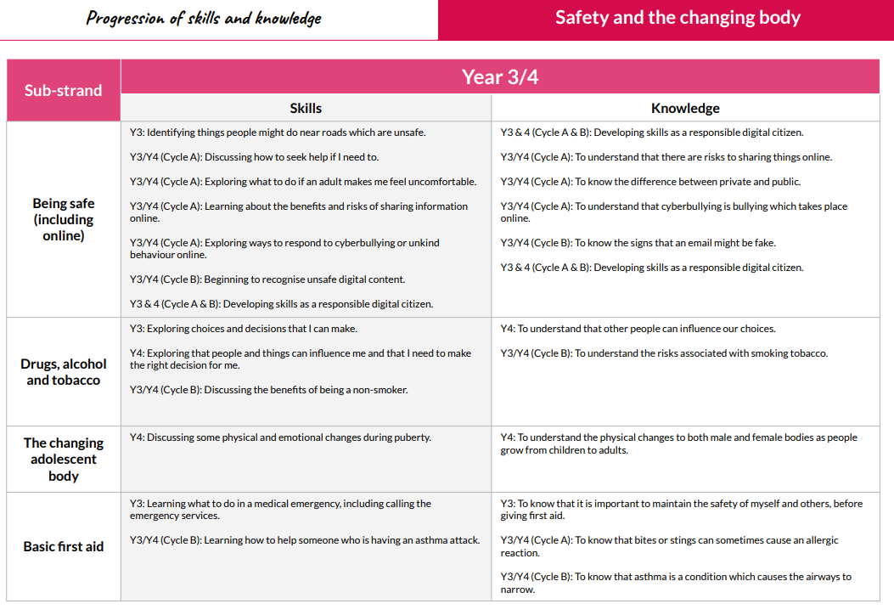

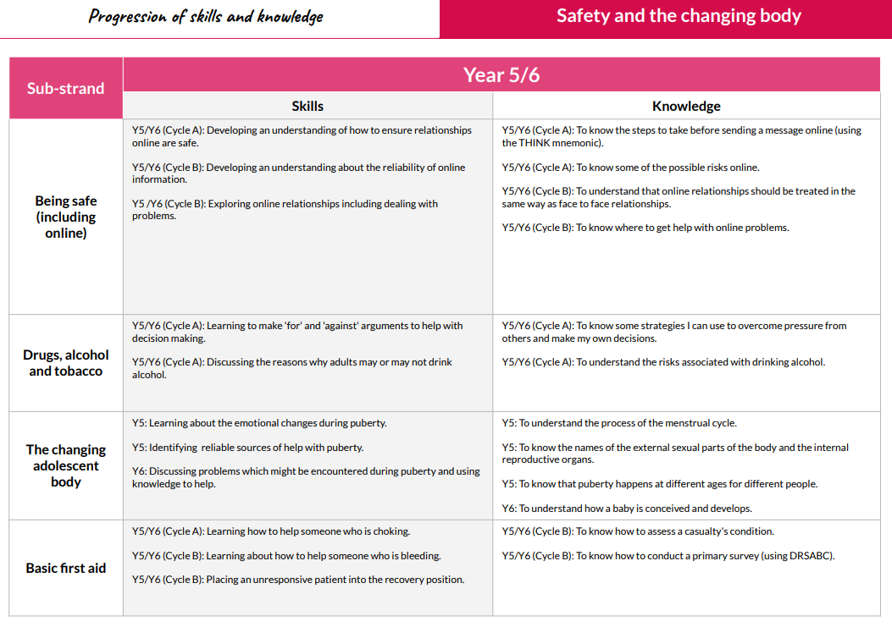

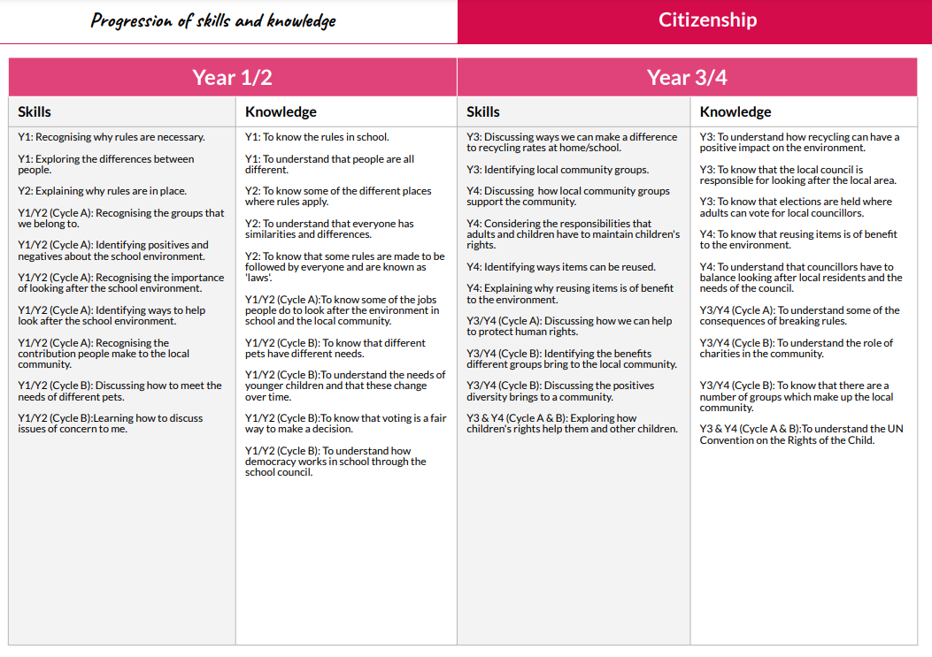

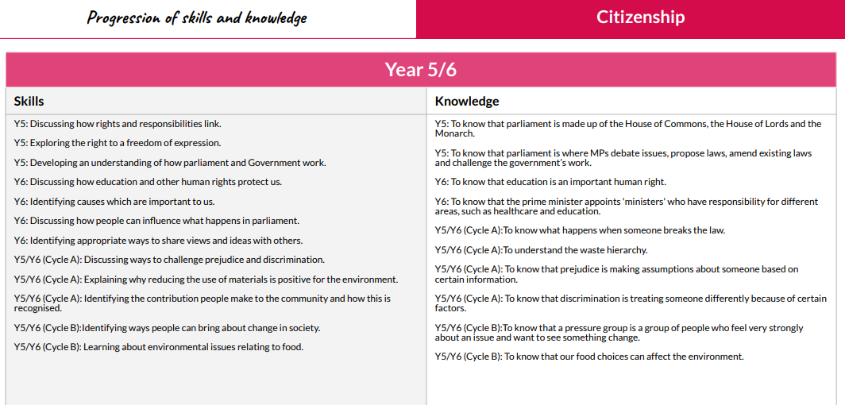

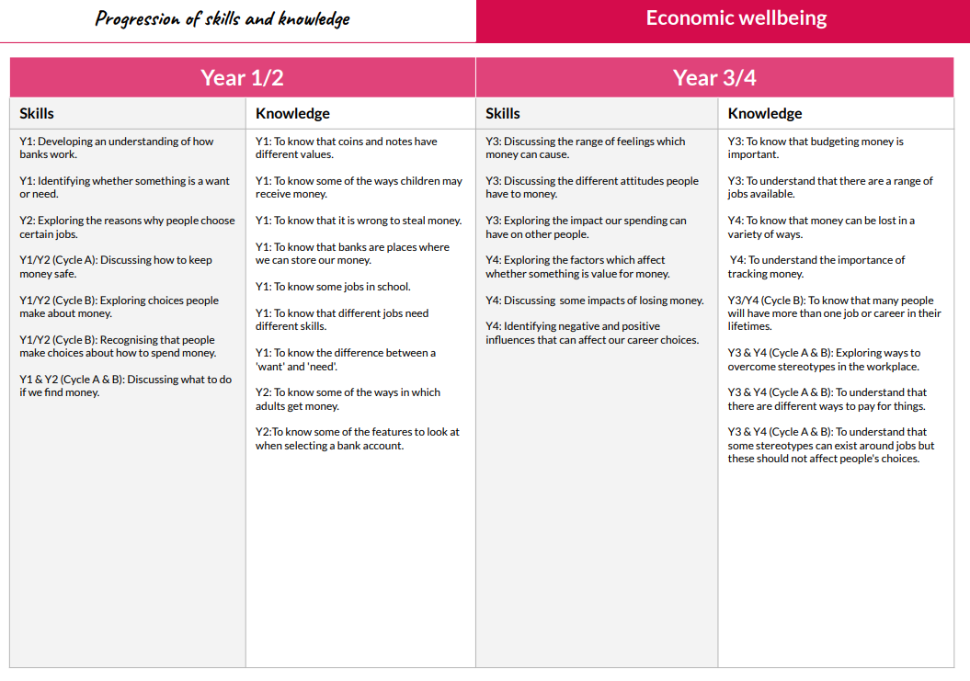

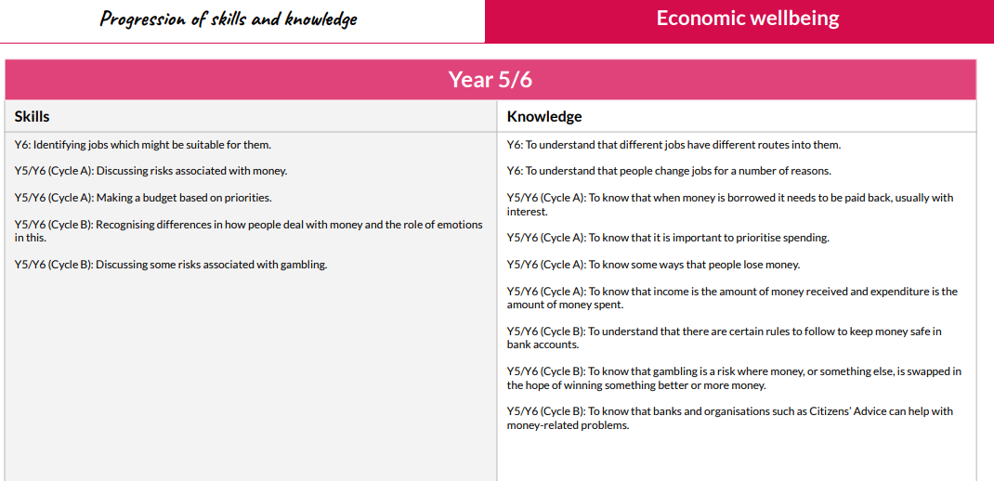

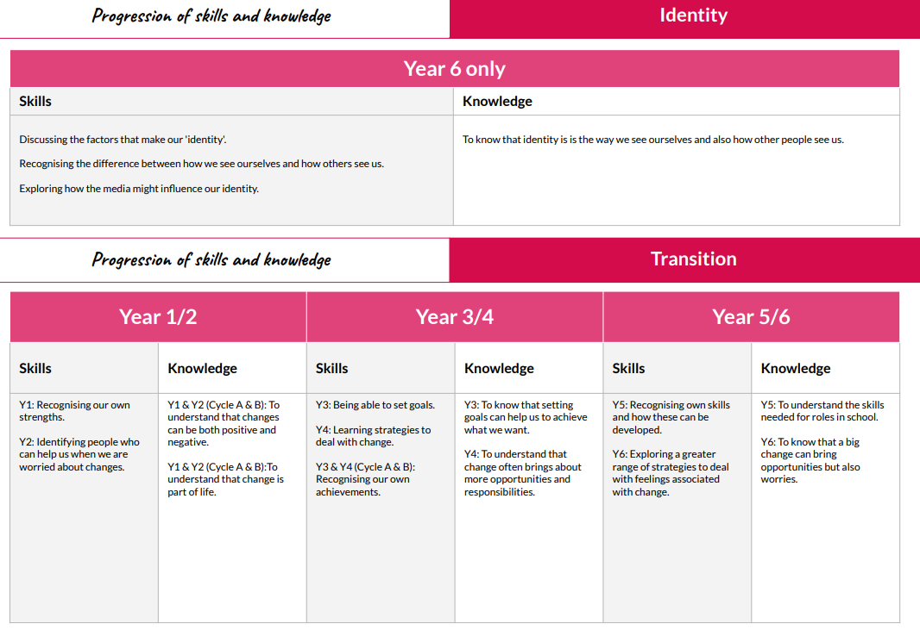

Impact:
How do we know how well our pupils are doing?

Each unit of work has a knowledge organiser which teachers use to help the children become familiar with the curriculum content and enable them to take responsibility for their own learning. A copy of each unit’s knowledge organiser is sent home to parents too.

Each unit has an end of unit assessment (quiz) which is completed and documented in the children’s foundation subject books.

Work created during each lesson, for example on a computer, is printed and evidenced in a floor books for each class. This is used alongside teachers’ observations and formative assessment in class to assess children’s understanding and skill progression using the Kapow PSHE and RSE assessment grid.

We will know how well our pupils are doing because learning in PSHE and RSE will be meaningful and enjoyed across the whole school. Standards of attainment across the school will meet or exceed those which are expected of our children nationally. All children will have a good understanding of the complexities of relationships and be able to demonstrate this within their own friendships. They will have a secure knowledge and skills base to navigate their way through these, now and in the future. Through our PSHE and RSE curriculum, we believe we can enhance children’s education and help them to become confident individuals who have positive body awareness, an in-depth knowledge of how to keep themselves safe and healthy and who will, through respect, tolerance and understanding, forge and maintain positive relationships with a diverse range of family and friendship groups.

