Computing Progression Map

Intent:

What do we intend children to learn?

At Belton C of E Primary School we aim to instil a sense of enjoyment around using technology and to develop pupil’s appreciation of its capabilities and the opportunities technology offers to create, manage, organise and collaborate. Tinkering with software and programs forms part of the ethos of our curriculum. It helps to develop pupils’ confidence when encountering new technology, which is a vital skill in the ever evolving and changing landscape of technology. Through our curriculum, we intend for pupils not only to be digitally competent and have a range of transferable skills at a suitable level for the future workplace, but also to be responsible online citizens.

Implementation:

How do we teach computing?

At Belton C of E Primary School children obtain the prerequisite skills for computing through the Early Years Foundation stage. At this young age children are encouraged to operate simple equipment through carefully selected resources available within the continuous provision. Playing with old style telephones, typewriters and mechanical toys as well as familiarity with tablets, laptops, cameras and voice recorders are all part and parcel of building a solid foundation in computing. Giving instructions, understanding arrows and direction and categorising data are all taught in a practical and fun way without a screen in sight! By allowing children time to regularly access technological equipment independently, they will develop a much deeper understanding.
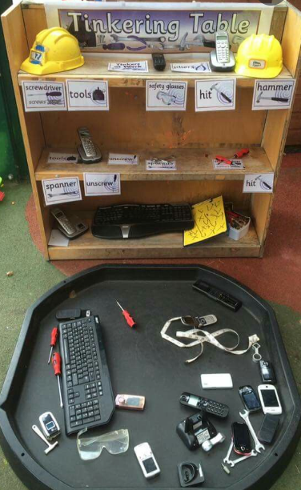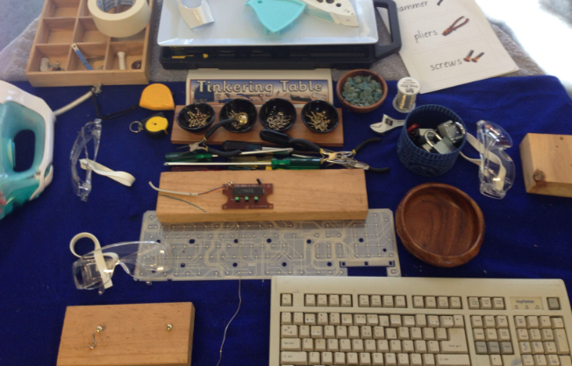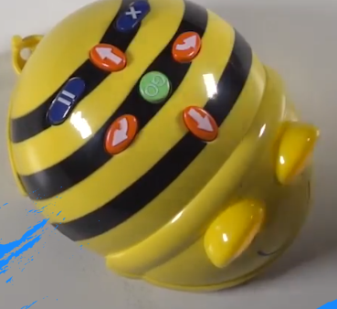

In years one to six, this solid foundation is quickly built upon through the teaching of the Kapow Primary computing scheme of work which enables pupils to meet the end of Key Stage Attainment targets outlined in the National curriculum

The National curriculum purpose of study states:
The core of computing is computer science, in which pupils are taught the principles of information and computation, how digital systems work, and how to put this knowledge to use through programming. Building on this knowledge and understanding, pupils are equipped to use information technology to create programs, systems and a range of content. Computing also ensures that pupils become digitally literate – able to use, and express themselves and develop their ideas through, information and communication technology – at a level suitable for the future workplace and as active participants in a digital world.

Therefore, our curriculum is designed with three strands which run throughout:

- Computer science
- Information Technology
- Digital Literacy

Our curriculum is organised into five key areas, creating a cyclical route through which pupils can develop their computing knowledge and skills by revisiting and building on previous learning:

- Computer systems and networks
- Programming
- Creating Media
- Data Handling
- Online Safety

Our progression of skills shows the skills that are taught within each year group and how these skills develop year on year to ensure attainment targets are securely met by the end of each key stage.

Computing Progression – Computer Science
Computer Science | EYFS | Key Stage 1 |  | Key Stage 2
 | Foundation Stage | Year 1 | Year 2 | Year 3 | Year 4 |  | Year 5 | Year 6
National Curriculum |  | Understand what algorithms are; how they are implemented as programs on digital devices; and that programs execute by following precise and unambiguous instructions. |  | Design, write and debug programs that accomplish specific goals, including controlling or simulating physical systems; solve problems by decomposing them into smaller parts.
 | Children know how to operate simple equipment and select appropriate technology depending on its purpose. | Children begin to understand that an algorithm is a set of instructions used to solve a problem or achieve an objective. They know that an algorithm written for a computer is called a program. | Children can explain that an algorithm is a set of instructions to complete a task. When designing simple programs, children show an awareness of the need to be precise with their algorithms so that they can be successfully converted into code. | Children can turn a simple real-life situation into an algorithm for a program by deconstructing it into manageable parts. Their design shows that they are thinking of the desired task and how this translates into code. Children can identify an error within their program that prevents it following the desired algorithm and then fix it. | When turning a real life situation into an algorithm, the children’s design shows that they are thinking of the required task and how to accomplish this in code using coding structures for selection and repetition. Children make more intuitive attempts to debug their own programs. | Children may attempt to turn more complex real-life situations into algorithms for a program by deconstructing it into manageable parts. Children are able to test and debug their programs as they go and can use logical methods to identify the approximate cause of any bug but may need some support identifying the specific line of code. |  | Children can turn a complex programming task into an algorithm by identifying the important aspects of the task and then decomposing them logically using their knowledge of coding structures and applying skills from previous programs. Children test and debug their program and use logical methods to identify the cause of bugs, demonstrating a systematic approach to identify a particular line of code causing a problem.
Computer Science | EYFS | Key Stage 1 |  | Key Stage 2
 | Foundation Stage | Year 1 | Year 2 | Year 3 | Year 4 |  | Year 5 | Year 6
National Curriculum |  | Create and debug simple programs. |  | Use sequence, selection and repetition in programs; work with variables and various forms of input and output.
 | Children know how to operate simple equipment and select appropriate technology depending on its purpose. | Children can work out what is wrong with a simple algorithm when the steps are out of order, e.g. The Wrong Sandwich in Purple Mash and can write their own simple algorithm, e.g. Colouring in a Bird activity. Children know that an unexpected outcome is due to the code they have created and can make logical attempts to fix the code, e.g. Bubbles activity in 2Code. | Children can create a simple program that achieves a specific purpose. They can also identify and correct some errors, e.g. Debug Challenges: Chimp. Children’s program designs display a growing awareness of the need for logical, programmable steps. | Children demonstrate the ability to design and code a program that follows a simple sequence. They experiment with timers to achieve repetition effects in their programs. Children are beginning to understand the difference in the effect of using a timer command rather than a repeat command when creating repetition effects. Children understand how variables can be used to store information while a program is executing. | Children’s use of timers to achieve repetition effects are becoming more logical and are integrated into their program designs. They understand ‘if statements’ for selection and attempt to combine these with other coding structures including variables to achieve the effects that they design in their programs. As well as understanding how variables can be used to store information while a program is executing, they are able to use and manipulate the value of variables. Children can make use of user inputs and outputs such as ‘print to screen’. e.g. 2Code. | Children can translate algorithms that include sequence, selection and repetition into code with increasing ease and their own designs show that they are thinking of how to accomplish the set task in code utilising such structures. They are combining sequence, selection and repetition with other coding structures to achieve their algorithm design. |  | Children translate algorithms that include sequence, selection and repetition into code and their own designs show that they are thinking of how to accomplish the set task in code utilising such structures, including nesting structures within each other. Coding displays an improving understanding of variables in coding, outputs such as sound and movement, inputs from the user of the program such as button clicks and the value of functions.

Computer Science | EYFS | Key Stage 1 |  | Key Stage 2
 | Foundation Stage | Year 1 | Year 2 | Year 3 | Year 4 |  | Year 5 | Year 6
National Curriculum |  | Use logical reasoning to predict the behaviour of simple programs. |  | Use logical reasoning to explain how some simple algorithms work and to detect and correct errors in algorithms and programs.
 | Children know how to operate simple equipment and select appropriate technology depending on its purpose. | When looking at a program, children can read code one line at a time and make good attempts to envision the bigger picture of the overall effect of the program. Children can, for example, interpret where the turtle in 2Go challenges will end up at the end of the program. | Children can identify the parts of a program that respond to specific events and initiate specific actions. For example, they can write a cause and effect sentence of what will happen in a program. | Children’s designs for their programs show that they are thinking of the structure of a program in logical, achievable steps and absorbing some new knowledge of coding structures. For example, ‘if’ statements, repetition and variables. They make good attempts to ‘step through’ more complex code in order to identify errors in algorithms and can correct this. e.g. traffic light algorithm in 2Code. In programs such as Logo, they can ‘read’ programs with several steps and predict the outcome accurately | Children’s designs for their programs show that they are thinking of the structure of a program in logical, achievable steps and absorbing some new knowledge of coding structures. For example, ‘if’ statements, repetition and variables. They can trace code and use step-through methods to identify errors in code and make logical attempts to correct this. e.g. traffic light algorithm in 2Code. In programs such as Logo, they can ‘read’ programs with several steps and predict the outcome accurately. | When children code, they are beginning to think about their code structure in terms of the ability to debug and interpret the code later, e.g. the use of tabs to organise code and the naming of variables. |  | Children are able to interpret a program in parts and can make logical attempts to put the separate parts of a complex algorithm together to explain the program as a whole.

Computer Science | EYFS | Key Stage 1 |  | Key Stage 2
 | Foundation Stage | Year 1 | Year 2 | Year 3 | Year 4 |  | Year 5 | Year 6
National Curriculum |  |  |  | Understand computer networks, including the internet; how they can provide multiple services, such as the World Wide Web, and the opportunities they offer for communication and collaboration.
 |  |  |  | Children can list a range of ways that the internet can be used to provide different methods of communication. They can use some of these methods of communication, e.g. being able to open, respond to and attach files to emails using 2Email. They can describe appropriate email conventions when communicating in this way. | Children recognise the main component parts of hardware which allow computers to join and form a network. Their ability to understand the online safety implications associated with the ways the internet can be used to provide different methods of communication is improving. | Children understand the value of computer networks but are also aware of the main dangers. They recognise what personal information is and can explain how this can be kept safe. Children can select the most appropriate form of online communications contingent on audience and digital content, e.g. 2Blog, 2Email, Display Boards |  | Children understand and can explain in some depth the difference between the internet and the World Wide Web. Children know what a WAN and LAN are and can describe how they access the internet in school.

Computing Progression – Information Technology

Information technology | EYFS | Key Stage 1 |  | Key Stage 2
 | Foundation Stage | Year 1 | Year 2 | Year 3 | Year 4 |  | Year 5 | Year 6
National Curriculum |  | Use technology purposefully to create, organise, store, manipulate and retrieve digital content. |  | Use search technologies effectively, appreciate how results are selected and ranked, and be discerning in evaluating digital content.
 | Children know how to operate simple equipment and select appropriate technology depending on its purpose. | Children are able to sort, collate, edit and store simple digital content e.g. children can name, save and retrieve their work and follow simple instructions to access online resources, use Purple Mash 2Quiz example (sorting shapes), 2Code design mode (manipulating backgrounds) or using pictogram software such as 2Count. | Children demonstrate an ability to organise data using, for example, a database such as 2Investigate and can retrieve specific data for conducting simple searches. Children are able to edit more complex digital data such as music compositions within 2Sequence. Children are confident when creating, naming, saving and retrieving content. Children use a range of media in their digital content including photos, text and sound. | Children can carry out simple searches to retrieve digital content. They understand that to do this, they are connecting to the internet and using a search engine such as Purple Mash search or internet-wide search engines. | Children understand the function, features and layout of a search engine. They can appraise selected webpages for credibility and information at a basic level. . | Children search with greater complexity for digital content when using a search engine. They are able to explain in some detail how credible a webpage is and the information it contains. |  | Children readily apply filters when searching for digital content. They are able to explain in detail how credible a webpage is and the information it contains. They compare a range of digital content sources and are able to rate them in terms of content quality and accuracy. Children use critical thinking skills in everyday use of online communication.

Information technology | EYFS | Key Stage 1 |  | Key Stage 2
 | Foundation Stage | Year 1 | Year 2 | Year 3 | Year 4 |  | Year 5 | Year 6
National Curriculum |  |  |  | Select, use and combine a variety of software (including internet services) on a range of digital devices to design and create a range of programs, systems and content that accomplish given goals, including collecting, analysing, evaluating and presenting data and information.
 |  |  |  | Children can collect, analyse, evaluate and present data and information using a selection of software, e.g. using a branching database (2Question), using software such as 2Graph. Children can consider what software is most appropriate for a given task. They can create purposeful content to attach to emails, e.g. 2Respond. | Children are able to make improvements to digital solutions based on feedback. Children make informed software choices when presenting information and data. They create linked content using a range of software such as 2Connect and 2Publish+. Children share digital content within their community, i.e. using Virtual Display Boards. | Children are able to make appropriate improvements to digital solutions based on feedback received and can confidently comment on the success of the solution. e.g. creating their own program to meet a design brief using 2Code. They objectively review solutions from others. Children are able to collaboratively create content and solutions using digital features within software such as collaborative mode. They are able to use several ways of sharing digital content, i.e. 2Blog, Display Boards and 2Email. |  | Children make clear connections to the audience when designing and creating digital content. The children design and create their own blogs to become a content creator on the internet, e.g. 2Blog. They are able to use criteria to evaluate the quality of digital solutions and are able to identify improvements, making some refinements.

Computing Progression – Digital Literacy

Digital Literacy | EYFS | Key Stage 1 |  | Key Stage 2
 | Foundation Stage | Year 1 | Year 2 | Year 3 | Year 4 |  | Year 5 | Year 6
National Curriculum |  | Recognise common uses of information technology beyond school.
 | Children recognise that a range of technology is used in places  such as homes and schools. | Children understand what is meant by technology and can identify a variety of examples both in and out of school. They can make a distinction between objects that use modern technology and those that do not e.g. a microwave vs. a chair. | Children can effectively retrieve relevant, purposeful digital content using a search engine. They can apply their learning of effective searching beyond the classroom. They can share this knowledge, e.g. 2Publish example template. Children make links between technology they see around them, coding and multimedia work they do in school e.g. animations, interactive code and programs.

Digital Literacy | EYFS | Key Stage 1 |  | Key Stage 2
 | Foundation Stage | Year 1 | Year 2 | Year 3 | Year 4 |  | Year 5 | Year 6
National Curriculum |  | Use technology safely and respectfully, keeping personal information private; identify where to go for help and support when they have concerns about content or contact on the internet or other online technologies. |  | Use technology safely, respectfully and responsibly; recognise acceptable/ unacceptable behaviour; identify a range of ways to report concern about content and contact.
 | Children recognise that a range of technology is used in places  such as homes and schools. | Children understand the importance of keeping information, such as their usernames and passwords, private and actively demonstrate this in lessons. Children take ownership of their work and save this in their own private space such as their My Work folder on Purple Mash. | Children know the implications of inappropriate online searches. Children begin to understand how things are shared electronically such as posting work to the Purple Mash display board. They develop an understanding of using email safely by using 2Respond activities on Purple Mash and know ways of reporting inappropriate behaviours and content to a trusted adult. | Children demonstrate the importance of having a secure password and not sharing this with anyone else. Furthermore, children can explain the negative implications of failure to keep passwords safe and secure. They understand the importance of staying safe and the importance of their conduct when using familiar communication tools such as 2Email in Purple Mash. They know more than one way to report unacceptable content and contact. | Children can explore key concepts relating to online safety using concept mapping such as 2Connect. They can help others to understand the importance of online safety. Children know a range of ways of reporting inappropriate content and contact. | Children have a secure knowledge of common online safety rules and can apply this by demonstrating the safe and respectful use of a few different technologies and online services. Children implicitly relate appropriate online behaviour to their right to personal privacy and mental wellbeing of themselves and others. |  | Children demonstrate the safe and respectful use of a range of different technologies and online services. They identify more discreet inappropriate behaviours through developing critical thinking, e.g. 2Respond activities. They recognise the value in preserving their privacy when online for their own and other people’s safety.

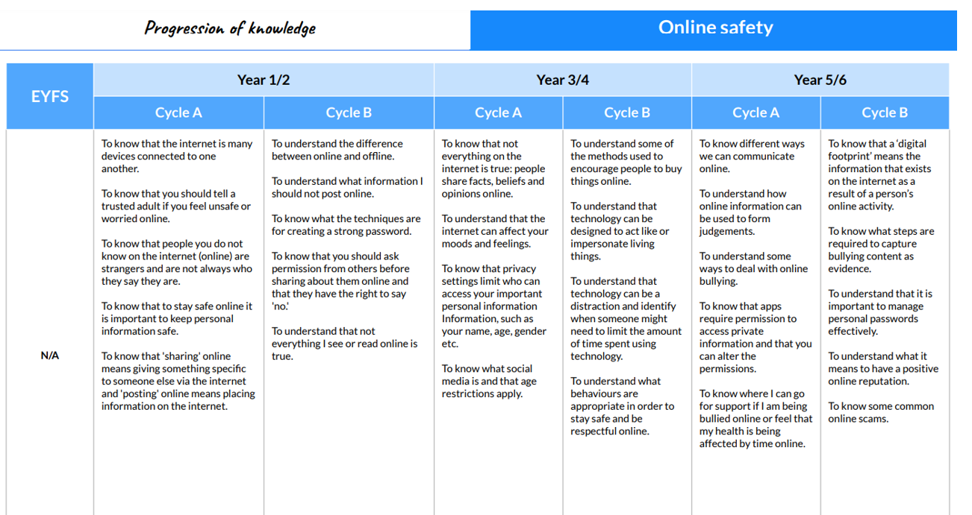

The computing curriculum is taught to our mixed age classes in a rolling two year program with the units as follows.

Year A | Autumn 1 | Autumn 2 | Spring 1 | Spring 2 | Summer 1 | Summer 2
Year 1 / 2 |  | Computing Systems and Networks  Improving Mouse Skills  Computing Systems and Networks  What is a computer? |  | Programming 1  Algorithms Unplugged |  | Programming  Algorithms and debugging
Year 3 / 4 | Computing Systems and Networks  Networks and the internet | Computing Systems and Networks  Collaborative Learning |  |  | Programming  Programming: Scratch | Programming 1  Further coding with Scratch
Year 5 / 6 | Computing systems and networks  Search Engines |  | Computing systems and Networks  Bletchley Park | Programming Programming Music |  | Programming  Intro to Python

Year B | Autumn 1 | Autumn 2 | Spring 1 | Spring 2 | Summer 1 | Summer 2
Year 1 / 2 | Programming 2  Bee-Bot  Data Handling  Introduction to data |  | Data Handling  International Space Station |  | Skills Showcase  Rocket to the Moon
Year 3 / 4 | Computing systems and Networks  Journey inside a computer | Creating Media  Video Trailers |  |  | Programming  Computational Thinking | Skills Showcase  HTML
Year 5 / 6 | Data Handling  Mars Rover 1 |  | Data Handling  Big Data 1 | Creating media  History of Computers |  | Skills Showcase  Inventing a product

There are three units entitled Skills Showcase which all children will have the opprtunity to take part in across the two year rolling plan. The Skills Showcase gives the children the chance to combine and apply skills and knowledge gained from a range of the five key areas to produce a specific outcome.
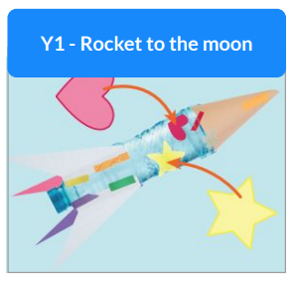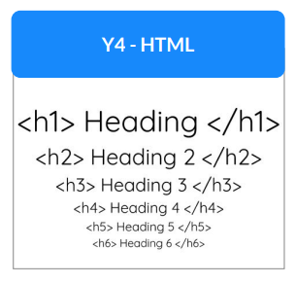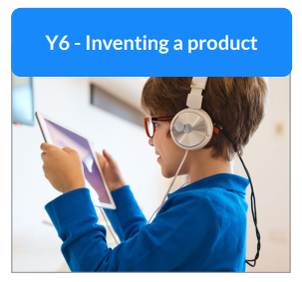

Spiral Curriculum
Our curriculum is designed as a spiral curriculum therefore its cyclical nature ensures the children revisit the five key areas throughout key stages 1 and 2. Each time a key area is visited it is covered with greater complexity. Upon returning to each key area, prior knowledge is utilised so the children can build on previously laid foundations.
Online Safety
It is essential that our pupils have the knowledge and skills to be able to keep themselves safe online. This key area is covered in detail throughout the curriculum and is a common theme that runs through every unit.

Also on Safer Internet Day in February each year we have a dedicated online safety day where the online safety units are taught across the whole school. Giving online safety the importance that it requires we also have a school E-safety committee who are made up of children from years 1-6. They meet frequently to discuss relevant issues including the importance of the online safety curriculum and are on hand to promote online safety across the school.

Impact:
How do we know how well our pupils are doing?

Each unit of work has knowledge organiser which teachers use to help the children become familiar with the curriculum content and enable them to take responsibility for their own learning. A copy of each unit’s knowledge organiser is sent home to parents too.

Each unit has an end of unit assessment which is completed and documented in the children’s foundation subject books.

Work created on a computer and online is filed on the shared drive under the unit title and additional work is created is printed and evidenced in the children’s foundation subject books in key stage 2 and in a floor book in key stage 1. This is used alongside teachers’ observations and formative assessment in class to assess children’s understanding and skill progression using the Kapow Computing assessment grid.

Learning in computing will be meaningful and enjoyed across the whole school. Children will use digital and technological vocabulary accurately alongside progression of their technical skills. They will be confident using a range of hardware and software and will produce high-quality purposeful work showing readiness for the next stage of their education. Children will be familiar with the digital world which will extend beyond school and will be confident and respectful digital citizens going on to lead happy and healthy digital lives.

